Account Reconciliation Process

  - Major Steps
- General Information (Page 1)
- Review support for transactions and perform reconciliation (Page 1)
- Run queries and combine query results to obtain transaction list (Page 2)

General Information

- Months typically close on the 5th working day of the following the month.
- Reconciliations are to be performed within two months of the close of the month.
- Records Retention Schedule notes that reconciliation should be kept for current fiscal year + three years.
- UT System Audit Office has reviewed this process and has determined that it is an acceptable reconciliation process.

Review Support for Transactions and Perform Reconciliation

- Review source documentation for all transactions on file.
- Verify that all expenses were authorized for payment against cost center.
- Verify that all revenue was posted to the appropriate cost center.
- Verify all appropriate employees are listed and salary and other payroll payments are reasonable (to be completed once Payroll Related report has been received).
- Save all queries and reports used for reconciliation/review.
- After review, sign account reconciliation coversheet and maintain for your records in accordance with records retention schedule.

Run Queries and Combine Results

  - Menu Navigation:

- For cost centers, “begins with” field with UTZ_DEPT_RECON and for Grant projects with UTZ_PROJ_RECON
- Search
- List of queries will be displayed – Cost Centers
  - UTZ_DEPT_RECON_AP – Accounts Payable Module (vouchers and pro card)
  - UTZ_DEPT_RECON_EX – Travel and Expense Module (authorization and expense sheets)
  - UTZ_DEPT_RECON_GL – General Ledger Module (items posted via journal entry excluding payroll, AP & TE)
- List of queries will be displayed – Grant Projects - Expenses
  - UTZ_PROJ_RECON_EXP – All expense modules
- List of queries will be displayed – Capital Projects
  - UTZ_DEPT_RECON_AP_PC
  - UTZ_DEPT_RECON_EX_PC
  - UTZ_DEPT_RECON_GL_PC

- Click “Add to Favorites” in the far right column for each query. When you return to this screen, these queries will display on a My Favorite Queries table.
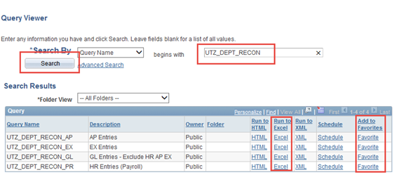

- Run each query by selecting “Excel” as the format. At the prompts, provide the following information:
- Unit: Ex. UTTYL
- Dept: Ex. 1XXXXX
- Begin Date: Choose the first day of the month to reconcile even if it is a weekend day
- End Date: Choose the last day of the month to reconcile even if it is a weekend day
- Select View Results - The information may take a few seconds to run and cache. When prompted, open the Excel File. Save each query result on a separate tab (AP/EX/GL) of the Reconciliation File.
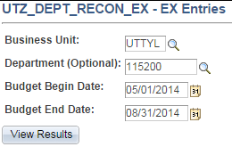

- Review query transactions and match with related documentation (invoices, receipts, and etc.).

For assistance, contact Budget and Financial Reporting Office at budget@uttyler.edu.

