Creating an Expense Report
Navigate to Travel and Expenses > Travel and Expense Center > Expense Report > Created/Modify
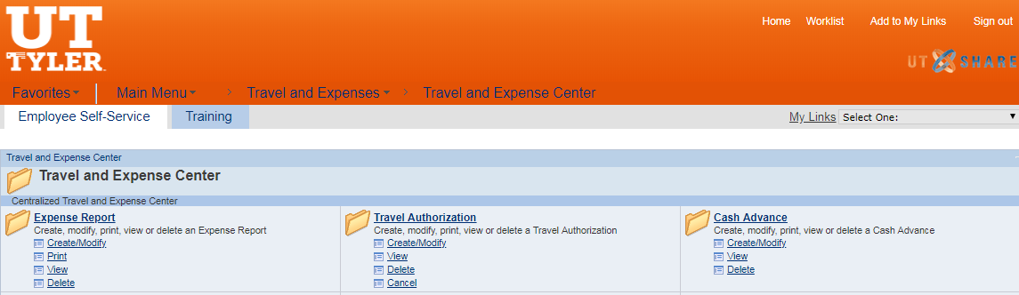

Enter the Empl ID – Click Add OR Click on the Search icon and enter the last name and click on Look Up – Choose the correct Employee – Click Add
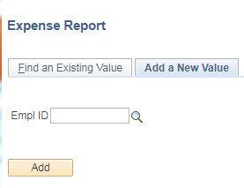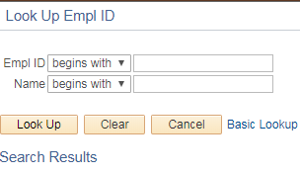

On the Create Expense Report Screen:
- Select the Business Purpose (drop down)
- Enter a Report Description
- Enter a Reference (Travel Authorization number)
- Enter Comments (optional)
- Choose a Default Location (city traveled to)
- Add any required attachments to the Attachments hyperlink.

Option 1 – Quick Fill procedures

- Click on the Quick Fill hyperlink
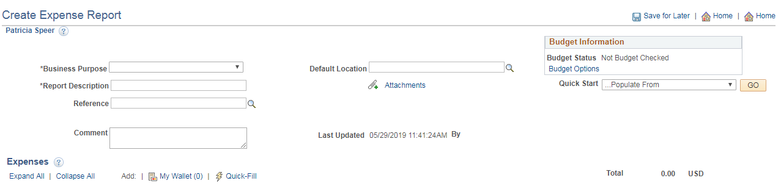

- Enter the Date Range of the travel receipts
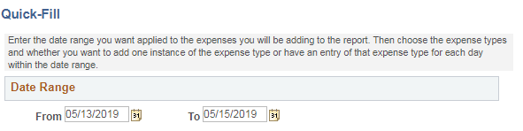

- Scroll down and select all of the expense types for which the traveler has expenses, choosing either One Day or All Days. Once complete, click on the OK button.
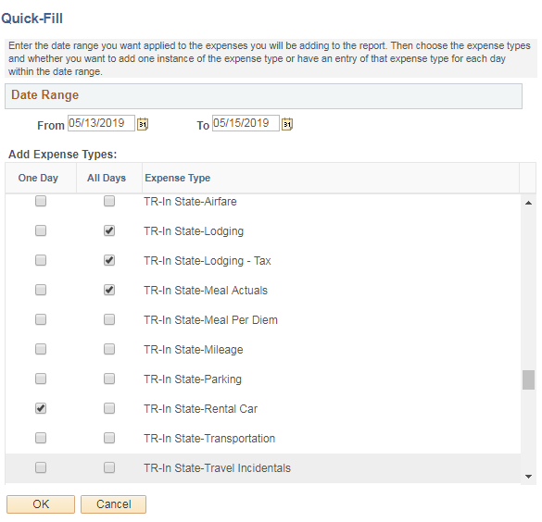

For example: rental car would be One Day because of one charge and Meals would be All Days.
- The original page now has populated all of the requested entries.
- Continue with instructions found on page 4 – “Options 1 and 2

Option 2 standard procedures

- Enter the Date the expense occurred
- Select an Expense Type (drop down)

Options 1 and 2

- Enter a Description (purpose for the expense)
- Select the Payment Type (drop down)
- Enter the Amount of the expense
- Enter the Cost Center or Project number in the Speed Chart
- Click on the + plus sign to add more lines or the – minus sign to remove a line

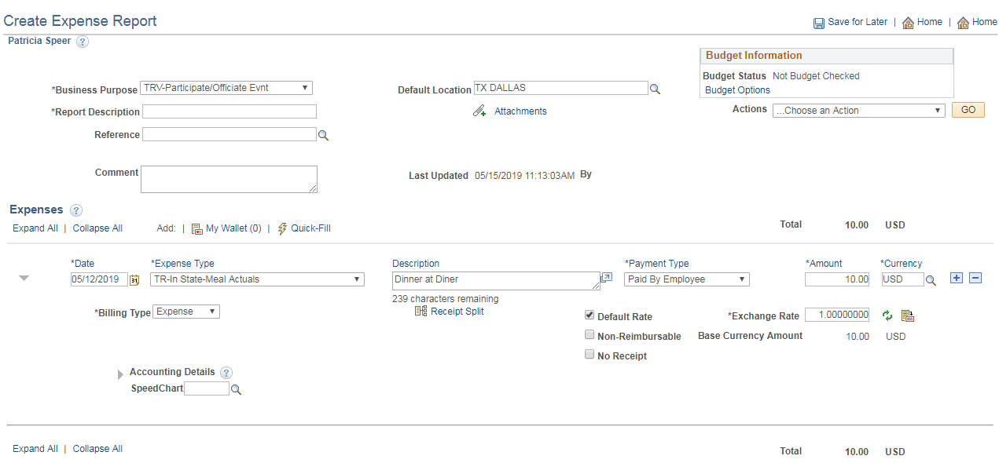

To see the full Chartfield string click on the arrow in front of Accounting Details.
If the Accounting Details have been set for the traveler to the correct cost center etc., then the speed chart may not be needed.
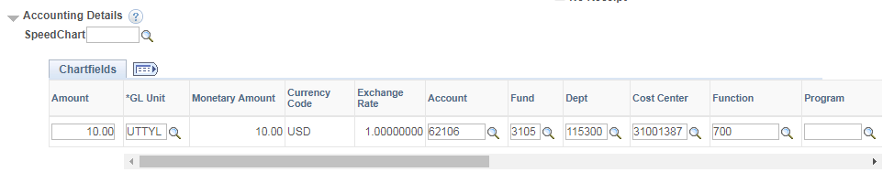

After all lines have been entered, click on Save for Later and a Report number will be assigned and the document status will show “Pending”.
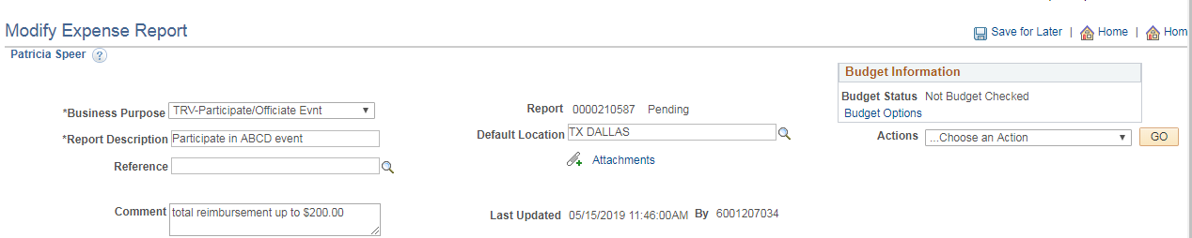

If not enough information has been entered, the screen will display red boxes that still need information.
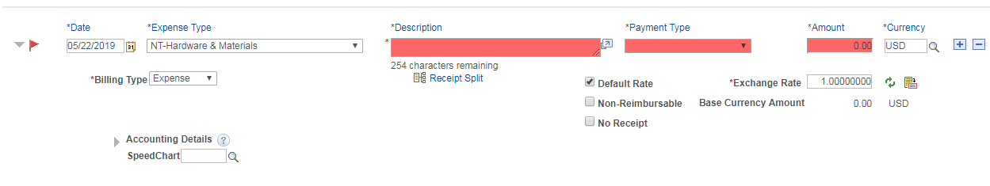

Click on the Budget Options hyperlink. A commitment control Screen will open.
Click on the Budget Check button to run the process.
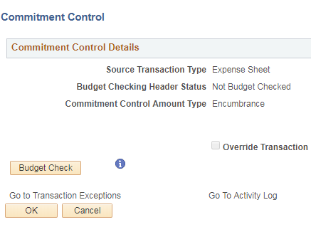

The screen will show a status of “Valid” or “Exception”
If the budget check process results in a Valid status, click the OK button at the bottom of the page.
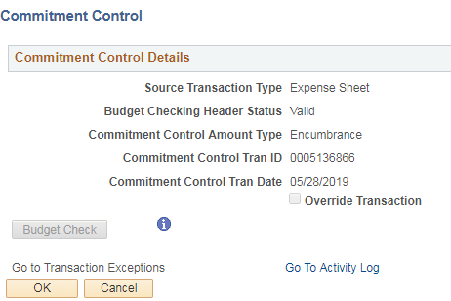

If the Budget Check process results in an Exception message
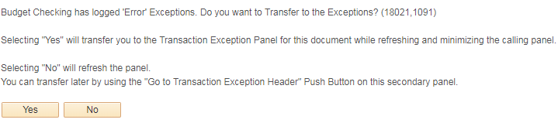
Determine whether the chart fields are all correct and fix, or contact the Budget team (budget@uttyler.edu) for assistance.
After Budget Error has been resolved, rerun the Budget checking process and when Budget Check is complete, click on the OK button.

Click on the Summary and Submit hyperlink to review and submit the expense report. The report is now titled “Modify Expense Report”

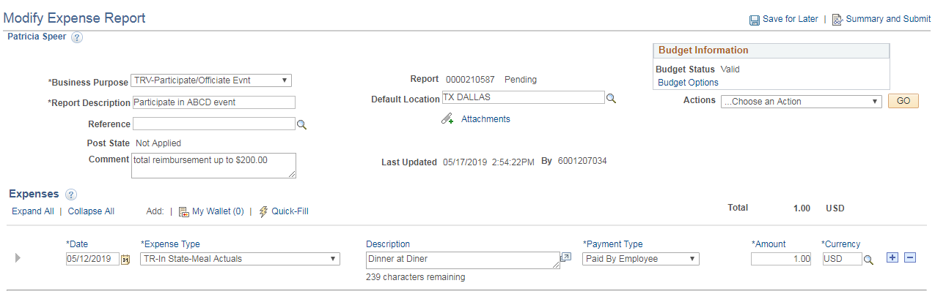

If changes need to be made, then click on the Expense Details hyperlink and the previous page is shown. Make the necessary changes, Save for Later, re-Budget Check, re-Submit.
When complete, click on the Submit Expense Report button to finalize the report.
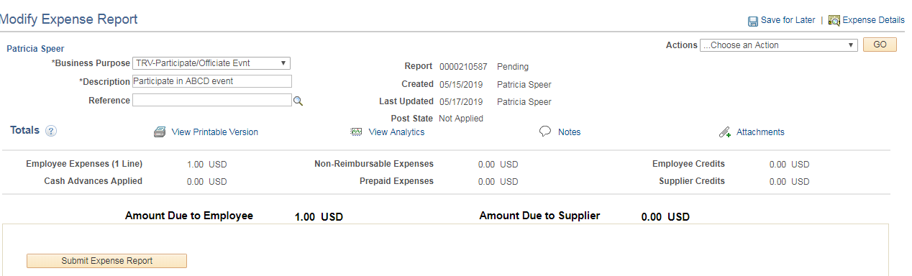

Click the OK button to complete or click the Cancel button to return to the Expense Report to make any needed changes.
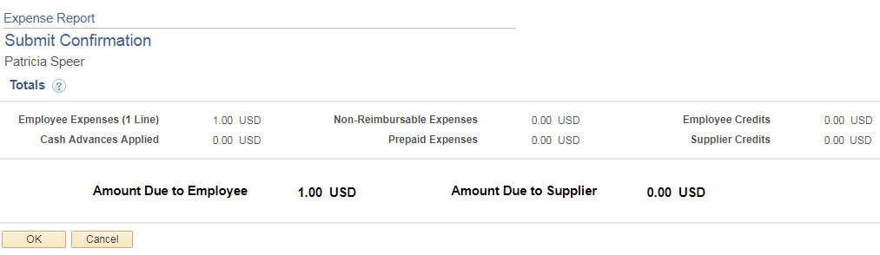

If the OK button was clicked then he Expense Report is submitted for approval.

Click on the Refresh Approval Status button to see the Approval History
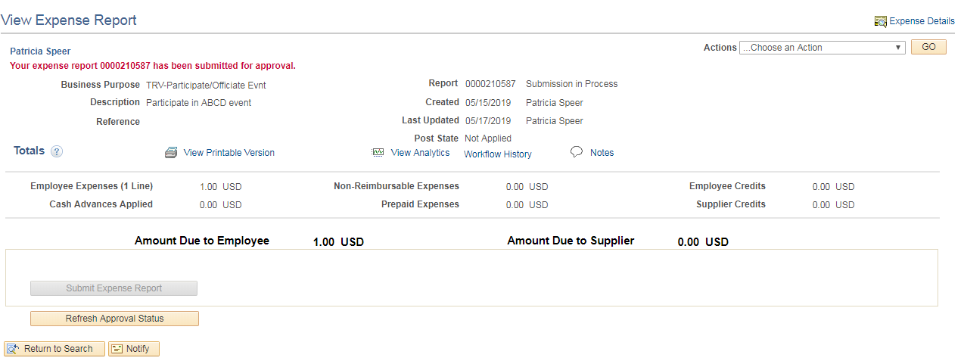

The Approval History shows whose workflow the report is waiting on.
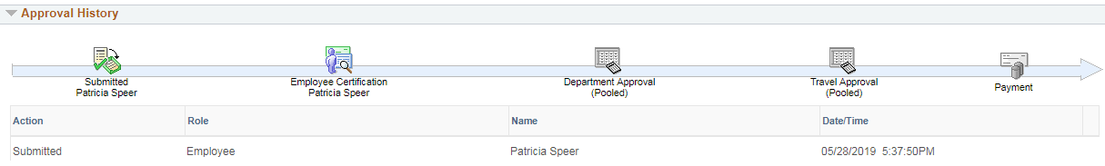

Clicking the Withdraw Expense Report button will open the report back up and make any needed changes or add attachments. This can be done any time before the approvals have started.
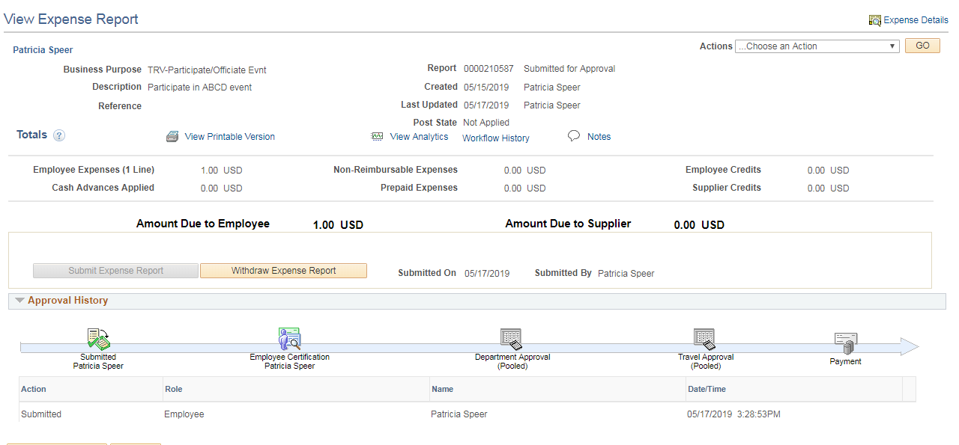

Click the Refresh Approval Status button until the Approval History displays the Action of Withdrawn
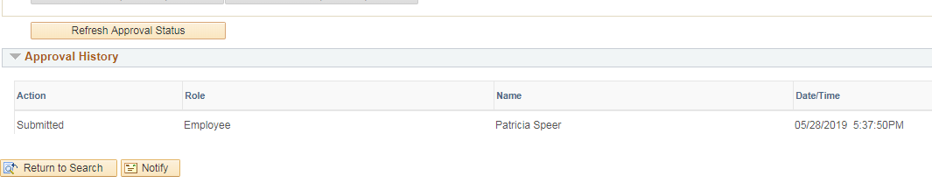
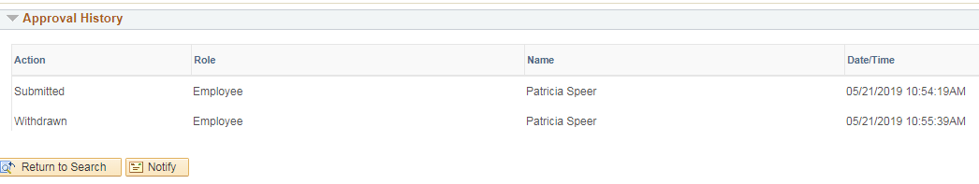

Navigate back to Expense Report > Create/Modify > Find an Existing Value and key in the Report ID. The report is now open for changes to be made.
Once all changes are complete, follow the same steps as were used when creating the Expense Report: Save for Later – Budget Options - Budget Check – OK – Summary and Submit – Submit Expense Report – OK and the expense report is once again submitted for approval.

