UT Share / PeopleSoft Non-PO Vouchers

For use when paying for items which do not require a Purchase Order (such as: memberships, registration, direct billed hotels and direct-billed entertainment expenses).

Navigation: Main Menu>Accounts Payable>Vouchers>Add/Update>Regular Entry

For a new voucher, click on the Add a New Value tab.

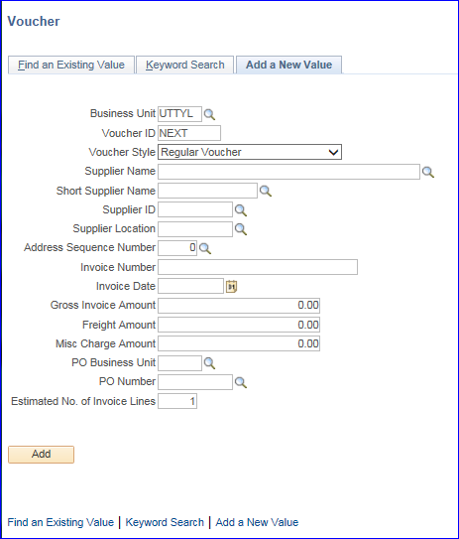

Under the Add a New Value tab, the Business Unit should default to UTTYL, Voucher ID should default to Next and Voucher Style should default to Regular Voucher.
To begin:

- Click on the search icon beside Supplier Name or Short Supplier Name. On the resulting pop up window, change the search type Name 1 to “contains” then enter some part of your Supplier name and click the Look Up button. Select the Supplier Name that matches your bill or Invoice. You may also search by Supplier ID if you know it or have it available from previous activity.

- If there is no default Supplier Location, then click on the search icon beside Supplier Location and select UTTYL or UTSHR if UTTYL is not available.
- Click the search icon beside Address Sequence Number, verify that the address associated with that number is the Remit To address shown on the Supplier Invoice. If it is not the address, then select the appropriate Remit To address.

- Enter the Supplier Invoice number into the Invoice Number field. The Invoice Number must be entered exactly as shown on the Supplier’s invoice.

- In the Invoice Date field, enter the date the invoice was received, which is the date the department stamped on the invoice as received by the university.

- Enter the total amount due shown on your bill or Invoice in the Gross Invoice Amount.

- Enter a number of transactions lines you anticipate needing for your voucher in the Estimated No. of Invoice Lines.

- Do not enter anything in the Freight Amount or Misc Charge Amount fields. All transaction information will be entered separately on the Voucher itself.

- Since this is Non-PO Voucher, do not enter anything in the PO Business Unit and PO Number fields.

- Click the ADD button.

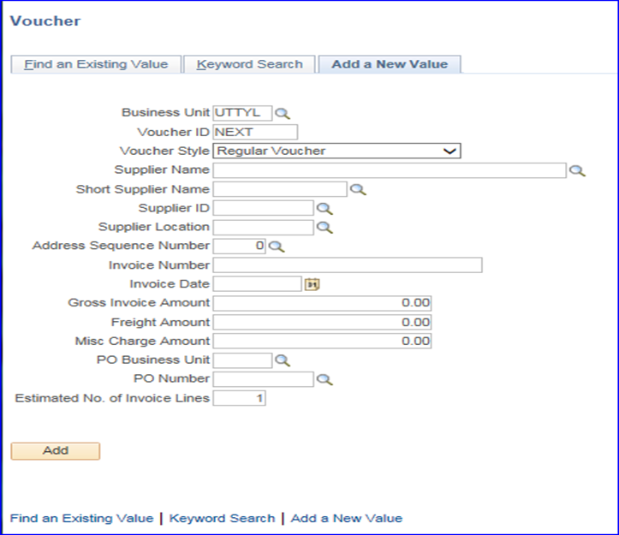

The result will be that the Invoice Information tab has populated with basic information.

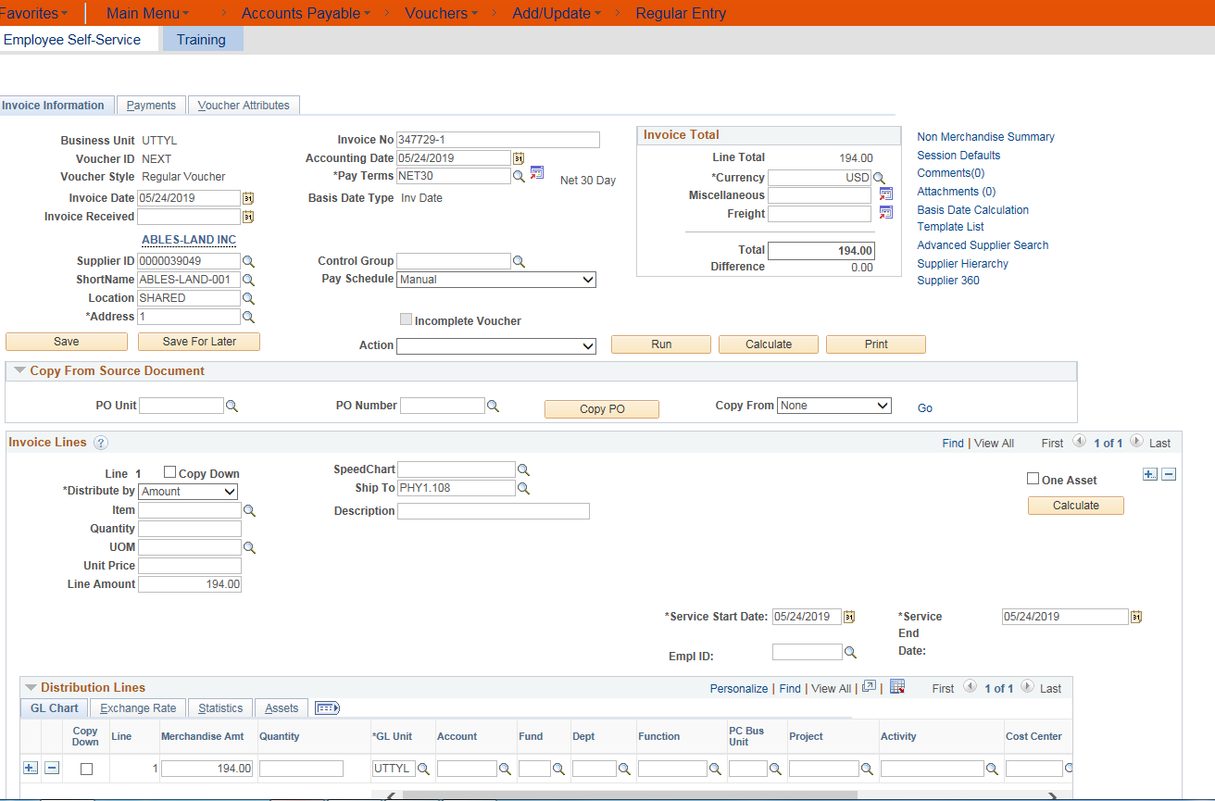

The 9.2 UT Share/PeopleSoft software upgrade includes a “Save for Later” feature. However, the following minimum steps must be completed in order to Save for Later.
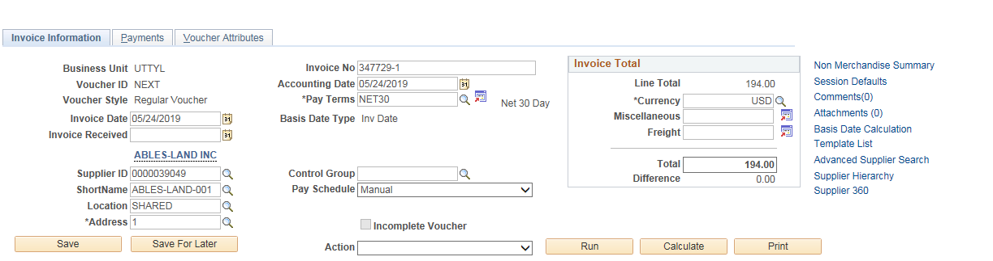

1. Click on the Basis Date Calculation hyperlink.

You will be directed to the Date Calculation screen.

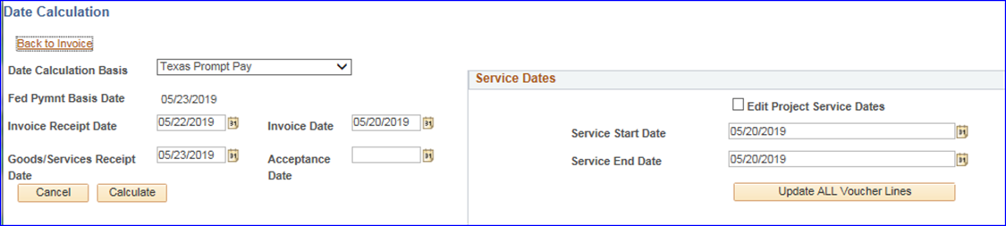

The Date Calculation screen is made up of two parts.

The section on the left is used to calculate the State of Texas Prompt Payment Date which generates a date on the Payments tab.

- The Invoice Receipt Date is the date that the University actually gets the Supplier Invoice by email or U.S. mail. Enter the actual or select the date the Supplier Invoice was received.

- The Invoice Date is the date the Supplier generated their form. This can be the same day the University actually gets the Invoice IF the Invoice was emailed. If the Invoice came in U.S. mail it will not be the same day as the Invoice Receipt Date.

- The Goods/Services Receipt Date is the date the University actually gets the tangible items ordered OR it is the last date of a service related contract or membership for example. Rarely is this the same date as the Invoice Receipt Date.

- The Acceptance Date is optional. The date may be used for example when testing is required of a piece of equipment before the University will agree to take ownership.

When the dates on the left side of the screen have been entered, then click the Calculate button.
The section on the right of the Date Calculation screen labeled Service Dates is used by the monthly and fiscal year end accounting processes.

- When tangible goods are purchased, enter the Date Received in both the Service Start Date and Service End Date.
- When contracted services, maintenance agreements, or memberships are purchased, enter the actual Service Start Date and Service End Date.

At the bottom of the Service Dates section, click the Update ALL Voucher Lines button to insure the service dates are populated on each Distribution Line.

When all dates have been entered and both buttons clicked, then click the Back to Invoice hyperlink.

2. In the Invoice Lines section enter your cost center or project number in the SpeedChart field or click on the search icon and select your cost center from the drop down list.

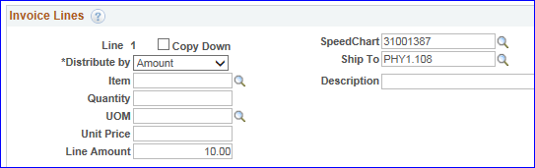

After these first two steps, you may now click the Save For Later button!

Please note that there are TWO Save and Save For Later buttons. The first set is located in the top section of the Invoice Information tab. The second set is found at the bottom of the screen below the Invoice Lines/Distribution Lines section.

If you do click the Save For Later button after the two preceding steps, a Voucher ID number will be assigned. Notate the Voucher ID in your documentation in order to return to the voucher to complete it.

In addition, the voucher will be marked as an Incomplete Voucher until the Save button is clicked.

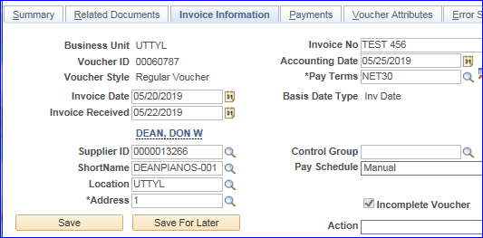

Please note: On the Invoice Information tab there is a Withholding hyperlink which is used for IRS reporting. The data contained within the hyperlink reflects what is set up on the UTTYL Supplier Record. DO NOT click on the hyperlink and make changes to any of the fields within the “Withholding Information” screen. If you have questions about “Withholding” and your supplier or voucher please email Accounts_payable@uttyler.edu. | 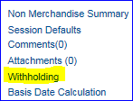

Whether you choose to complete your voucher in one sitting or Save For Later and then complete it later, continue as follows:

On the Invoice Information tab in the Invoice Lines section of the screen, enter the Line Amount and Description for each Invoice Line.

Verify that the Service Dates are correct for each Invoice Line.

Review the chartfield data for your payment. If it needs to be split into one or more other chartfields, click the “+” sign on the right side of the Invoice Lines section. Each individual Invoice Line has its own SpeedChart field. If you need to split the cost of any one Invoice Line, then you will need to add Distribution Lines by clicking the “+” under the Distribution Lines. This action will split the Invoice Lines and the chartfield will need to be entered manually on each distribution line added.

Enter the correct expense Account code to each Distribution Line. In general the Account code should begin with a “6” for expenses on voucher payments. If you have questions about expense Account codes contact Accounts Payable.

On the Voucher Invoice Information tab under the Invoice Lines section, click the Calculate button.
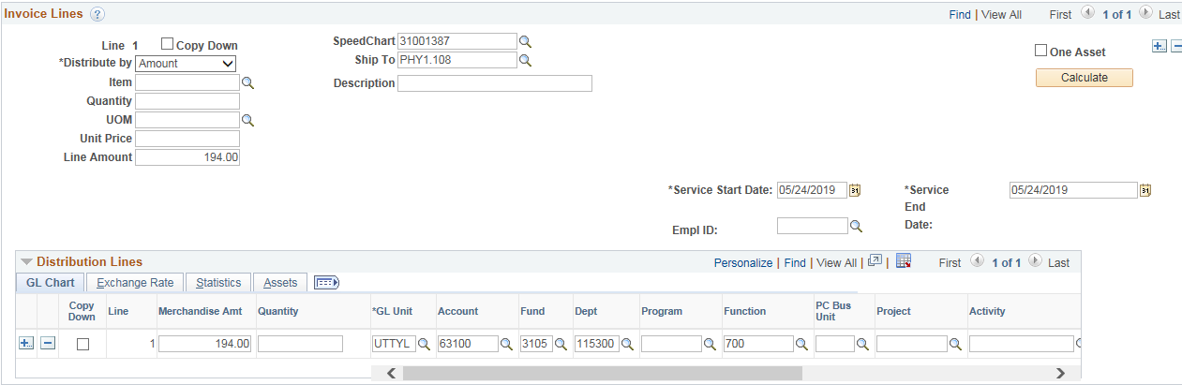

Carefully review the voucher for any error messages or red marked sections and correct the voucher accordingly.

Click the Save or Save For Later button at the bottom of the Invoice Information screen.

If this is the first time you’ve clicked the Save or Save For Later buttons, the Voucher ID field at the top of the Invoice Information screen will change from “NEXT” and populate the document with the Voucher ID number. Notate the Voucher ID in your documentation for future reference.

Before Saving | After Saving
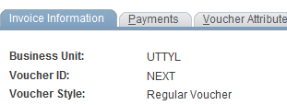 | 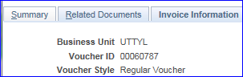

The Invoice referenced on the Voucher must be attached to the Voucher. In addition, also attach all other relevant supporting documentation (for example, executed contract with special payment terms, Substantiation of Business Meeting Expense form, email documentation related to the purchase).

On the Invoice Information tab, click on the Attachment hyperlink.
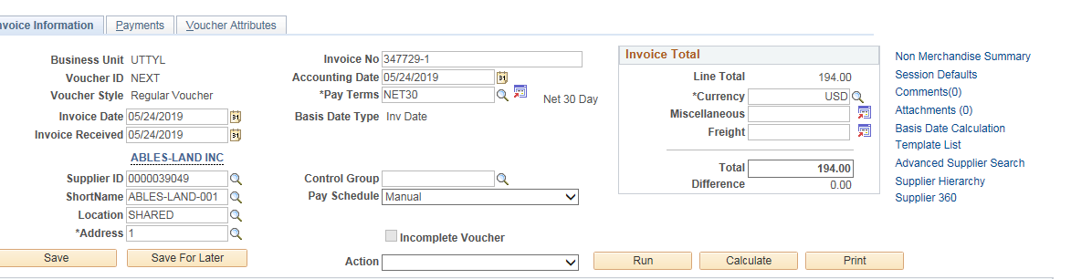

The 9.2 UT Share/PeopleSoft software upgrade includes an option to upload as many as five (5) documents at one time.

Click the Add Attachment button, click Browse to select your document (up to five times) then click the Upload button.

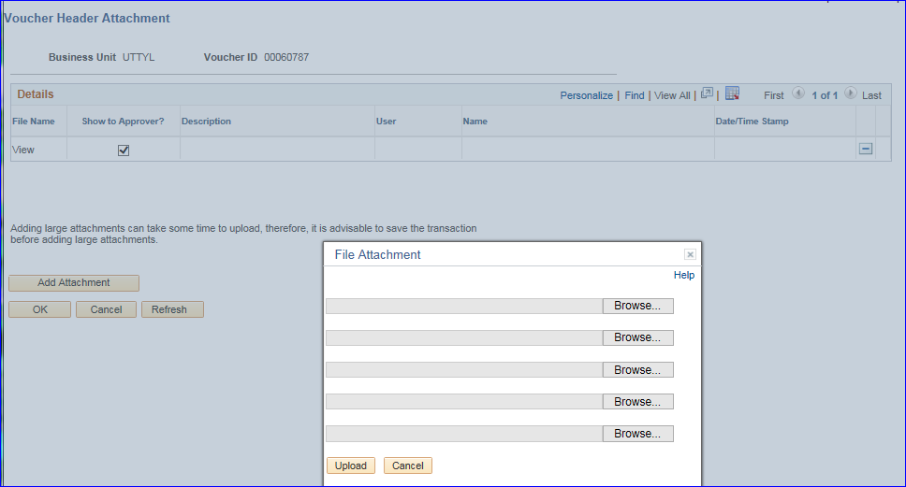

When you are finished attaching the necessary documents, click the OK button to return to the Invoice Information screen. Please note: Accounts Payable will not approve the Voucher without the necessary supporting documentation attached.

On the Invoice Information screen, click the Save or Save For Later button again after the attachment has been added.

As needed, Comments may be added to the voucher, by clicking the Comments hyperlink found on the Invoice Information tab. Adding Comments is optional.

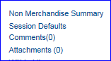

On the Invoice Information tab, click the Calculate button in the top section of the screen found below the Invoice Total box.

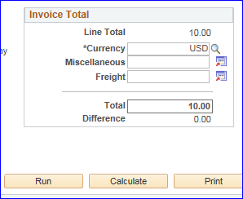

If a Difference error populates, then the dollar amount of difference between the Invoice Total section of the screen and the Invoice Lines section of the screen must be corrected. After making changes in either section, click the Calculate buttons again until there is no Difference error.

Click the Save or Save For Later button again

On the Invoice Information tab, click the Action drop down box arrow, then click the Budget Checking option and finally click the Run button.

The message “Do you want to wait for the process to be completed?” If you click Yes, the Voucher will be displayed once the process ends. If you click No, the voucher will be exited.

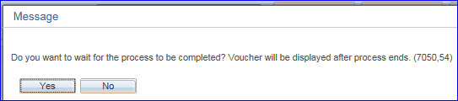

If you selected Yes, then once Budget Check has run, if budget errors exist, you will receive a Message pop up box.

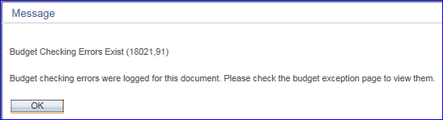

Click the OK button to continue.

Click on the Summary tab then click on the Budget Status Exceptions hyperlink to view the budget errors.

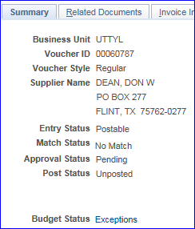

Please note: When you click on the Exceptions hyperlink you will be redirected to the Commitment Control module.
You will see one of two error messages in the Budget with Exceptions field:

- Error Message – “Exceeds Budget Tolerance”

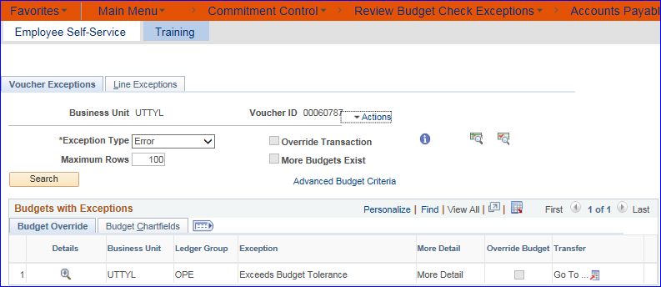

- If there just aren’t enough funds to cover the expense line, you may need to change the Chartfield string in the voucher on the Invoice Information tab. Go into the Invoice Lines or Distribution Lines to change to a chartfield with sufficient funds. Then click Save and redo the, Budget Check step, or

- Create a Budget Transfer and send to the Budget Office or work with the Budget Office to override the error if a Budget Transfer is pending. Then return to the voucher, click the Save button and redo the Budget Check step.

- Error Message – “No Budget Exists”

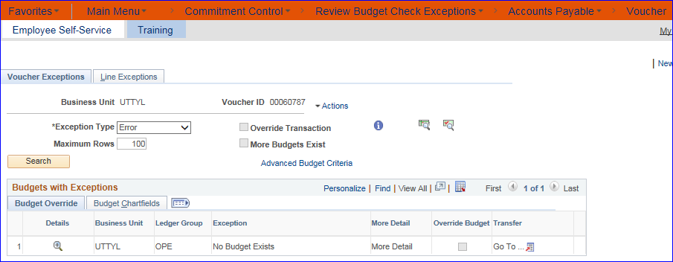

- Click on the Budget Chartfields tab and review the parts of the chartfield string.

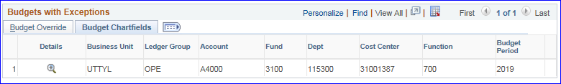

- Check all components of your chartfield string (Fund, Department, Cost Center, Function, Project ID, etc.), if there are errors return to the voucher to make corrections, then click Save, redo the Budget Check step.

- If after careful review, you believe all chartfield components are correct, but the document still shows a budget error contact the Budget Office at budget@uttyler.edu for cost center assistance and the Central Grants Office for project assistance. After the Budget or Grant Office makes their adjustments, then Budget Check again. The voucher cannot be processed further while it has budget errors.

Note: To go back to the Voucher to make changes you must navigate to:
Main Menu>Accounts Payable>Vouchers>Add/Update>Regular Entry, then click on Find an Existing Value, enter search criteria such as the Voucher ID to locate the voucher with budget errors.

Once Budget Errors have been corrected, you will need to run Budget Check again (as instructed above) to validate. After Budget Check has been run, click on the Summary tab to return to the Summary screen. Verify that the Budget Status is Valid before proceeding.

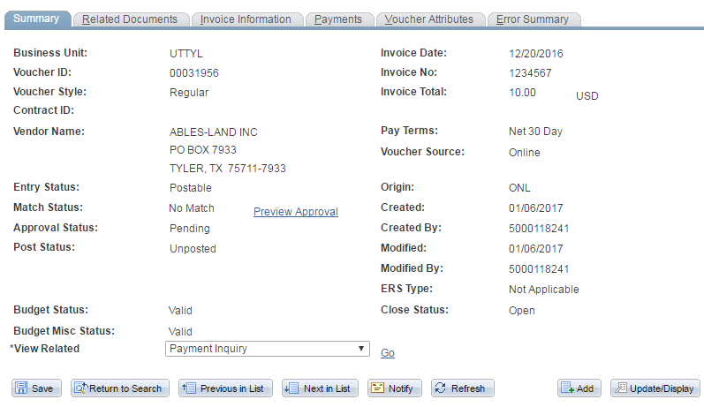

Click on the Payments tab.

- Standard State of Texas payment terms are Net 30 and are calculated based on the dates when goods or services are received and when the vendor Invoice is received.

- Leave the Pay Terms at the State standard of Net 30 unless the vendor offers a discount for early payment or unless other payment terms have been negotiated and are in writing in an executed contract.

The Pay Term should be assigned when the Requisition is created, however, if it was missed, or if the vendor is now offering a discount for paying early, then click on the search icon, and select the appropriate term from the search list.

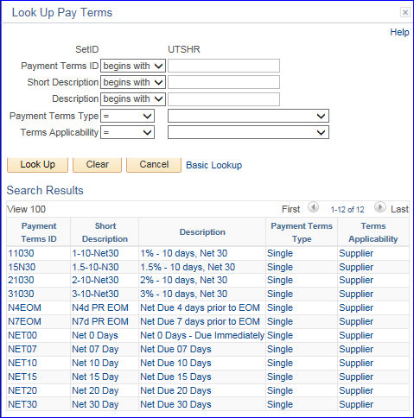

Based on the vendor’s stated discount for early payment or on the negotiated contract payment terms, review the Scheduled Due field in the Payment Information section. Click on the calendar icon to change the date to the appropriate date.

You do NOT need to change the date when the payment terms are Net 30. UT Share/PeopleSoft is programmed to meet State of Texas compliance rules for the correct State of Texas calculation.

The Net Due field shows the Net 30 payment date as calculated to comply with the State Comptroller’s rule.

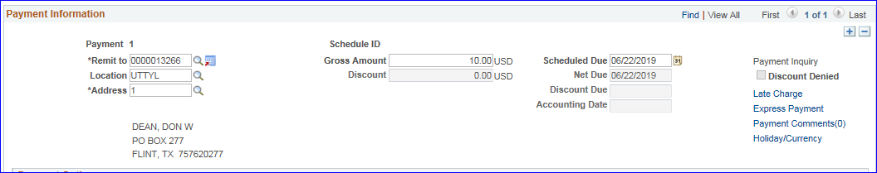

Verify that the Remit To address found on the vendor Invoice matches the Remit To address that defaulted in from the vendor record. If it does not match, click on the Address search icon and select the vendor address that matches the Remit To address on the vendor Invoice.

In the Payment Options section,

The Method of payment should default to ACH if the vendor provided bank account information or

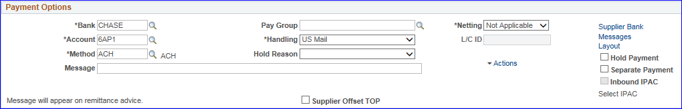

To CHK for a paper Check if there is no bank account information for the vendor.
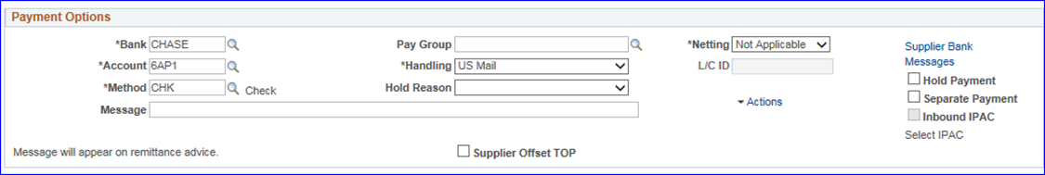

In the Payment Options section select the Handling code for the paper Check. Click the down arrow, then

use PU for check pickup or US for US Mail. Please note that there is a long list of options – most of which are used by other campuses. For UT Tyler, use the PU and US options. If you think you need to select a different option – Contact Accounts Payable first in order to avoid your check being lost.

If you are selecting the PU option it is recommended that you enter the check pickup instructions into the Message box.

Please note, instructions entered into the Message field within the Payment Options section will appear on the printed check stub or “remittance advice”. The Message field may also be used for other notes intended for the vendor (for example: an account number, case number, contract number, or contact name).

If the vendor’s payment Method is ACH, then do not change the Handling code.

Accounts Payable strongly recommends always checking the Separate Payment option box found on the right side of the Payments Options section. To avoid misapplied payments by the vendors, it is a good rule of thumb to check Separate Payment, to avoid your payment being combined with other department’s payments, preventing your payment from posting correctly with the vendor.

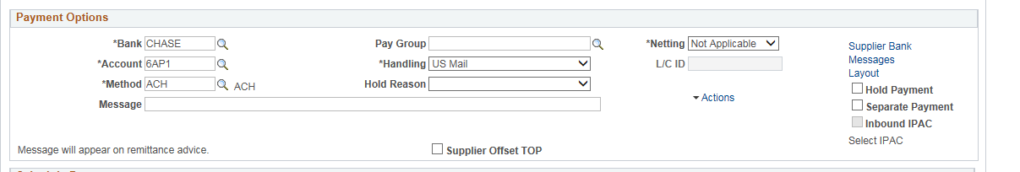
Please do not change any of the other fields found on the Payments tab the voucher. If you believe that a field not described in these procedures might apply to your payment, please email Accounts_Payable@uttyler.edu for assistance.

The last section of the Payments tab is the Schedule Payment section. The Schedule Payment section remains blank until the voucher processes for payment. After processing for payment, the actual ACH or Check date is shown in the Payment Date field and the ACH or Check number or “Reference” is populated.
You may always return to your voucher to check on the status of the payment or to identify the assigned Reference number.
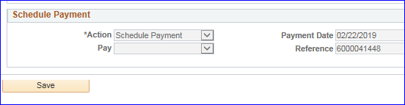

After making changes to any of the Payment Information or Payment Options fields, make sure to click the Save button found at the bottom of the screen.

Prior to Submitting a voucher into approval workflow, the Approval message on the Summary tab will show Preview Approval.

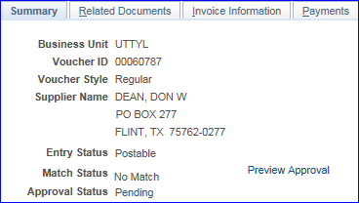

Clicking on the Preview Approval hyperlink at this stage, shows that the non-PO voucher has not yet been routed to the Department budget authority.

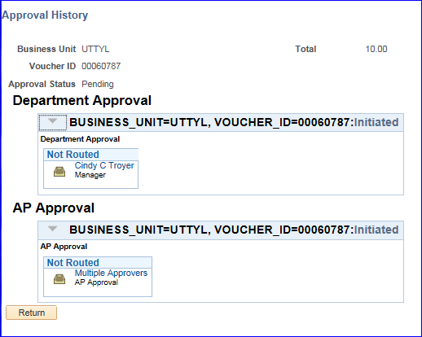

Return to the Invoice Information tab to submit the voucher into the approval workflow. Click on the Submit Approval button.

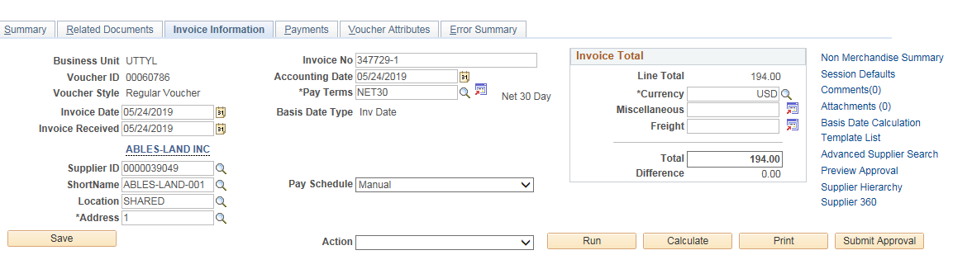

An Approval Comments box will pop up where additional details and/or comments can be added for the Approver. Click the OK button to submit the voucher into approval workflow or click the Cancel button if you need to make changes to the voucher.

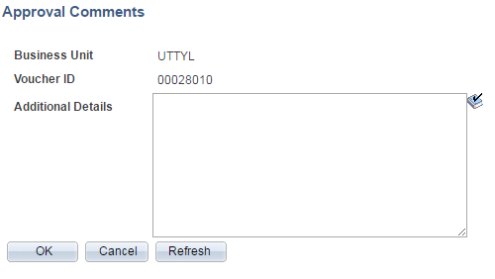

The Refresh button can be clicked but doesn’t appear to make the process / wait any shorter.

When the Submit process is complete, you will be returned to the Invoice Information screen. The Submit button is no long available.

Click on the Summary tab and the Approval Status should now show Approval History. Click the Approval History hyperlink to view the next approver(s) in the workflow process.

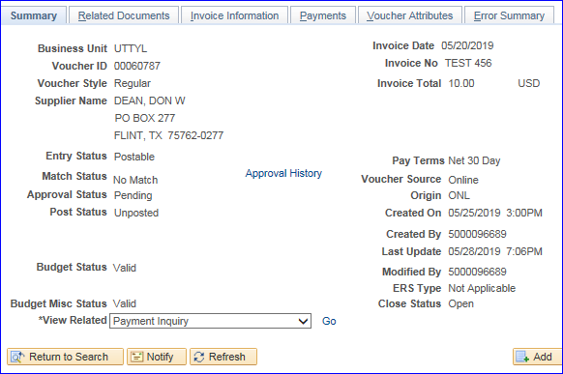

Vouchers route first to Department budget authority approvers, then project managers (if applicable), then the Central Grants Office and finally Accounts Payable.

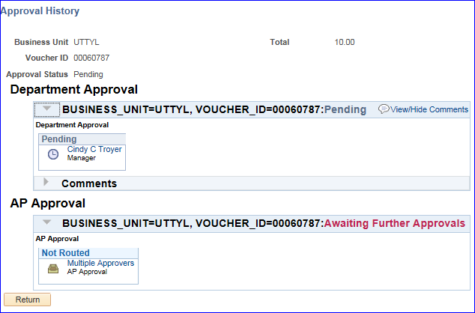

The example Approval History shows the Voucher is pending Department budget authority approval. When the option Multiple Approvers is shown then you may click the hyperlink to view the list of possible Approvers. Click the “X” to close the pop up, then click Return to navigate back to the Summary screen.

NOTE: Approvers have 3 choices when reviewing a voucher: Approve, Send Back or Hold.

If the Approver chooses to Send Back or Hold, a notification email will be sent to the document creator. The Send Back button returns the document to the creator where it will remain until either resubmitted or deleted. The Hold button will hold the document until it is denied or approved by the Department budget authority, Grants Office approvers, or Accounts Payable approvers.

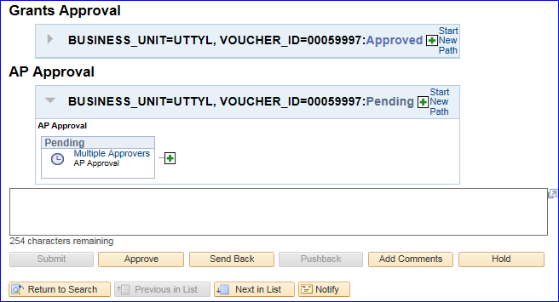

In addition to the Find an Existing Value search option, the UT Share/PeopleSoft 9.2 Upgrade includes a new search option called Keyword Search.

To view an incomplete voucher or an existing complete voucher, you may use either search option.

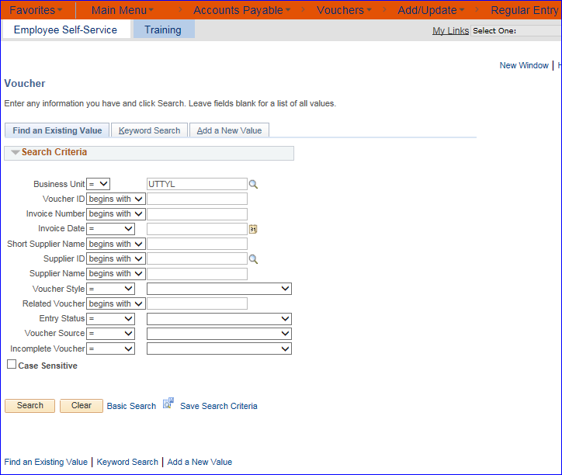

The Find an Existing Value can be used for a quick search when you have your Voucher ID number or Supplier ID at hand and can quickly type it in.
Please note the new search criteria labeled Incomplete Voucher. If you have Saved your voucher in an Incomplete status as described in the preceding procedures, when you select this search criteria, a list of Incomplete Vouchers populates and then you can select yours from the list.

The 9.2 version of UT Share/PeopleSoft, offers the option to search by any Keywords and the program will pull all vouchers that contain that keyword or other specific search criteria.
To begin, click on the Keyword Search button.
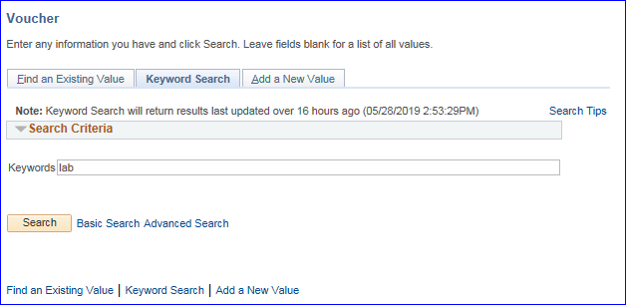
Type in a word that you would like to search on and then click on the Search button.

The screen will populate with various vouchers that have something to do with that search word.

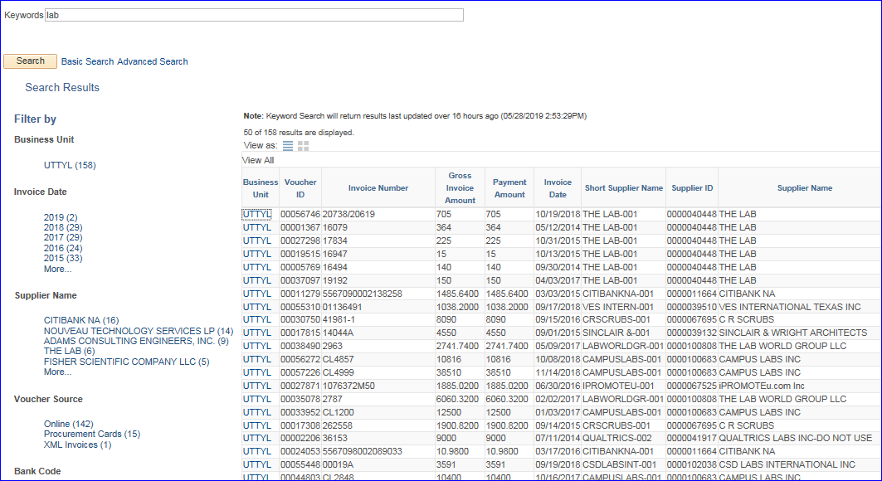

Or after clicking on the Keyword Search button, then click on the Advanced Search hyperlink.

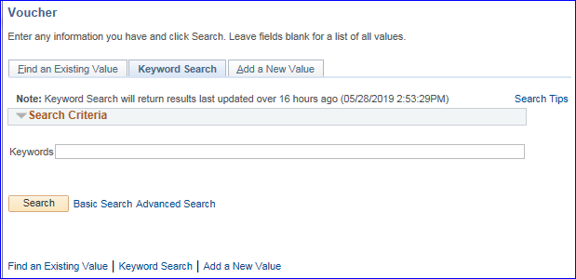

The resulting screen will be a list of various criteria you may use to search for your vouchers.

At the bottom of the search criteria list, there is an option for “Entered By.” Please note that the Entered By search criteria works with an employee’s EMPL ID number and not his/her name.

After entering your desired search criteria, click the Search button at the bottom of the screen.
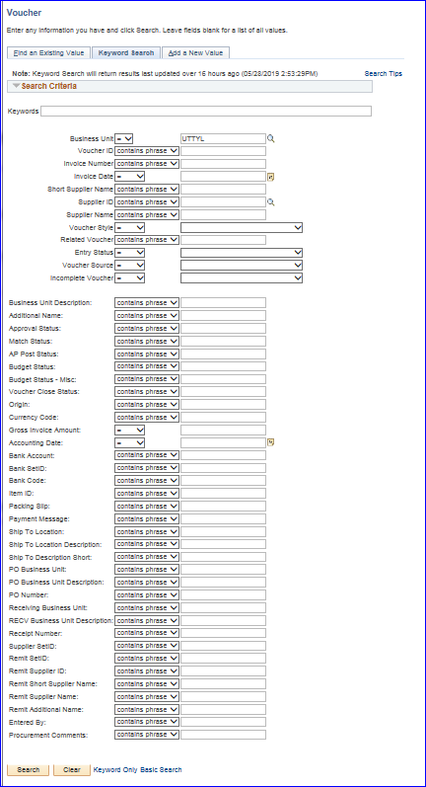
Search results may either be viewed in a GRID format:

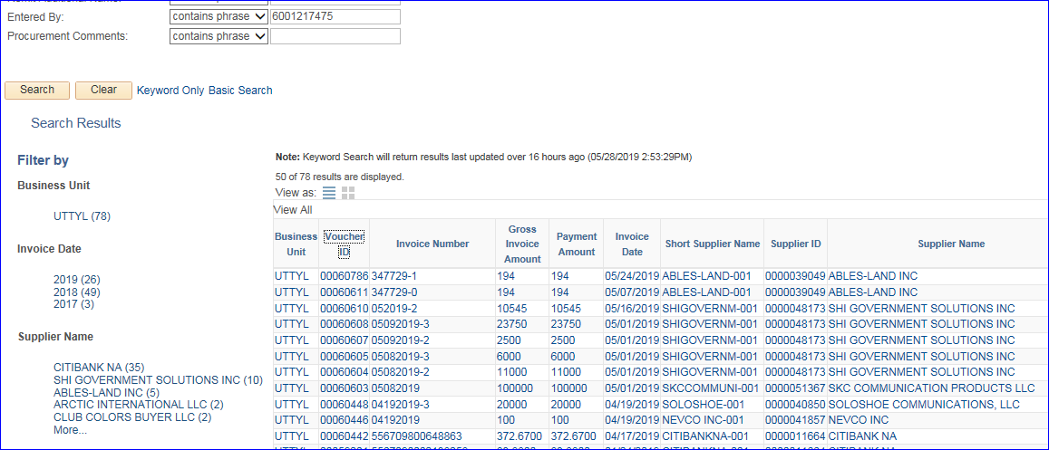

Or in a LIST format:

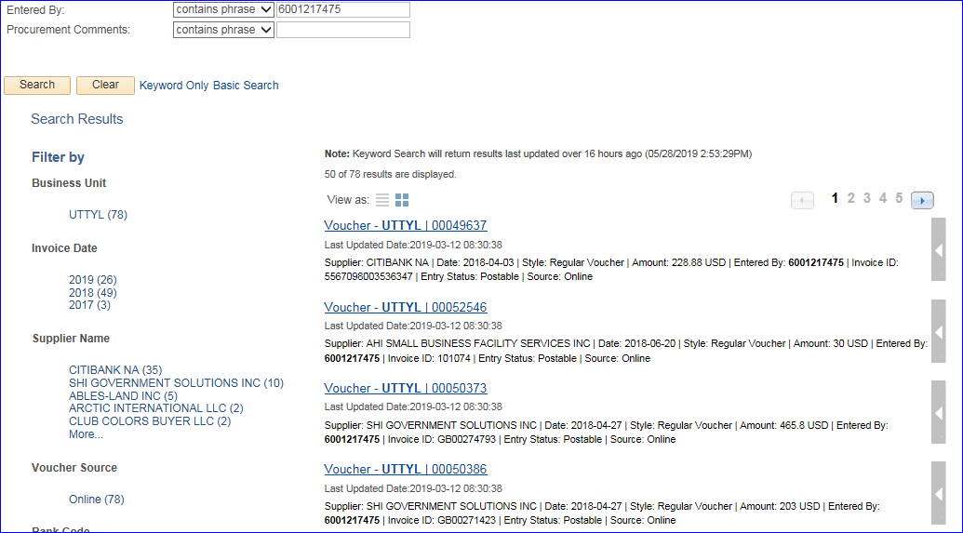

In the LIST format, you may click on the arrow to the right of the voucher result to see more actions available for that voucher (i.e. Review Voucher Status).

The sample below shows that the voucher has been paid and shows the check number. Click the Cancel or Return to Search buttons to leave the popup screen.

