eSHOP New User Training Manual

Table of Contents
Overview 1
Introduction 1
About eSHOP 1
Process Flowchart 2
General Steps ………………………………………………………………………………………………………………………………………2
Assumptions 2
Roles and Responsibilities 3
Shopper 3
Requester 3
Buyers 3
Business Unit Administrator 3
System Administrator 3
Accessing eSHOP 4
Logging in as a Shopper 4
Logging in as a Requester 5
Navigation 6
Interface 6
Main Workspace 7
Side Navigation Menu 8
Top Banner 9
Managing a Profile 10
View My Profile 10
User Profile and Preferences 11
Update Security Settings 12
Default User Settings 12
User Roles and Access 14
Ordering and Approval Settings 14
Permission Settings 14
Notification Preferences 14
User History 16
Dashboards 16
Set My Home Page 17

Shopping in eSHOP 18
Shop by Catalog 18
Hosted Catalogs 18
Punch-Out Catalogs 18
Shop at the Top– Shopping Dashboard 19
Document Search 21
Search Documents 21
Contract Search 23
Advanced Search 23
Shopping Advanced Search 23
Contract Advanced Search 24
Documents Advanced Search 25
Saved Searches 26
To Create a New Search Folder 26
To Save a Search 27
Shortcuts 28
Favorites 28
Adding Items to Favorites 28
Quick Order 30
Shopping Carts 31
eInvoicing 32

Overview

Introduction
The Purchasing function within Financial Services Department is the area responsible for overall management of the University’s procurement programs for the solicitation of goods and services. Promoting preferred suppliers, ensuring contract compliance, and searching for savings opportunities are just the beginning of what the Purchasing team does on a daily basis. In May 2017, UT System and the UT Tyler Purchasing staff introduced an eProcurement system to make this process more efficient.
eSHOP is the e-procurement system which allows UT institutions to:
- Secure better pricing of commonly used products
- Provide one-stop shopping
- Reduce time and effort in the purchasing process
- Select goods from online suppliers
- Produce cost savings through the use of eSHOP contract suppliers
- Simplify business practices with the introduction new roles
- Increase efficiency with the use of central invoicing
- Increase the flow of requisitions to UT Share/PeopleSoft

This system will be integrated with the current UT Share/PeopleSoft system to complete the procure-to-pay process. The purchasing rules and UT Share/PeopleSoft processes that run in the background are unchanged. Essentially, eSHOP is a shopping tool. The workflow, requisitions, purchase orders, receiving and payments will still go through UT Share/PeopleSoft. eSHOP is an additional feature added to make creating requisitions and acquiring products more efficient.

About eSHOP
eSHOP is exclusively for Hosted and Punch-Out catalog items and suppliers. Anything that does not meet these criteria will go through a traditional UT Share/PeopleSoft purchase order. Not all campus vendors are available through eSHOP.

Process Flowchart
Below is a flowchart that describes the flow of a requisition initiated through eSHOP.
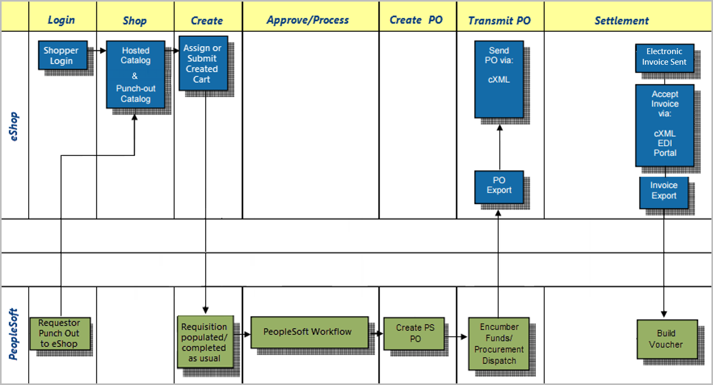
General Processing Steps
- Shopper or Requester Logs in
- Search/Shop and add Items to Shopping Cart
- Assign or Submit created cart
- Requester returns cart to UT Share/PeopleSoft
- A requisition is created in UT Share/PeopleSoft
- Requester adds accounting information and submits requisition in UT Share/PeopleSoft as usual
- UT Share/PeopleSoft workflow is initiated
- A Purchase Order is created in UT Share/PeopleSoft
- Purchase Order is dispatched
- Purchase Order is automatically exported to eSHOP and sent to Vendor
- An Electronic Invoice is sent to eSHOP from the vendor
- eSHOP import the invoice to UT Share/PeopleSoft
- UT Share/PeopleSoft builds a voucher

Assumptions
- User is familiar with procurement policy and procedure for their Business Unit.
- Requesters are familiar with UT Share/PeopleSoft and know how to create a requisition in UT Share/PeopleSoft.

Roles and Responsibilities
Roles in eSHOP are assigned to a particular user based on levels of responsibilities within individual departments and are controlled within the eSHOP application. Roles can be changed if there is a business need. If a role needs to be changed, please contact the campus Business Unit Administrator.

Shopper
The Shopper is responsible for creating shopping carts by performing basic or advanced search for catalog items. Shoppers will log into eSHOP and search for items using Hosted catalogs, Punch-Out catalogs, or consortium and contract suppliers. Shoppers must assign the cart to the Requester for approval and submission. Shoppers can quickly select the appropriate Requesters from a short list that has been added to their profile.

Requester
Requesters are responsible for reviewing and submitting carts to become formal requisitions for approval in UT Share/PeopleSoft. This role is responsible for reviewing the carts, creating UT Share/PeopleSoft requisition line items, finalizing accounting and shipping information, placing attachments to requisitions, and ensuring the proper accounting information is correct on a requisition. Furthermore, Requesters can utilize eSHOP to make changes to carts, cancel carts, or finalize carts. Requesters are typically administrative assistants or other support staff of university departments. Requesters can also shop and submit carts they themselves have created.

Buyers
Buyers are responsible for the transactional activities of a purchase order. Buyers create purchase orders in UT Share/PeopleSoft and communicate any changes to purchase orders to Requesters or individuals with approval authority. The primary responsibility of Buyers is to process the requisition by following state laws and regulations in order to create and dispatch purchase orders to suppliers. Buyers are also responsible for final approval of requisitions into purchase orders.

Business Unit Administrator
Business Unit Administrators are responsible for ensuring that the workflow and systems both support the needs of their respective campuses. They are responsible for assigning and managing roles, managing user privileges within eSHOP, and making changes to the systems and processes as it relates to the unique challenges of each institution. The Business Unit Administrators do not have the ability to create customizations to their eSHOP instances, add or remove suppliers, access documentation or contracts from other UT entities, or perform technical administration. They will have additional roles including addressing order failure, PO dispatch failure, and release management.

System Administrator
The System Administrator is part of UT System Shared Information Services and will facilitate and manage any universal changes that will affect all Business Units. The System Administrator responsibilities include: updating and maintaining the solution under the direction of the project manager, documenting processes and configuration changes, troubleshooting issues with users, managing order failures, and communicating issues and issue resolution recommendations to project leadership in a timely manner.

Accessing eSHOP
Depending on the user’s role, there are 2 ways to access the eSHOP.
If the user has a Shopper role, the user will access the eSHOP from a direct web address. The user will sign on with his or her UT Tyler network ID and password, which is the same ID and password used to access their campus computer. Any person that logs into the direct link is considered a Shopper, Requesters that enter eSHOP through the direct link will not have the Requesters permissions and can only function as a Shopper.

Logging in as a Shopper
- Navigate to your eSHOP sign-on screen.
- Enter Network ID and Password
- Click Login
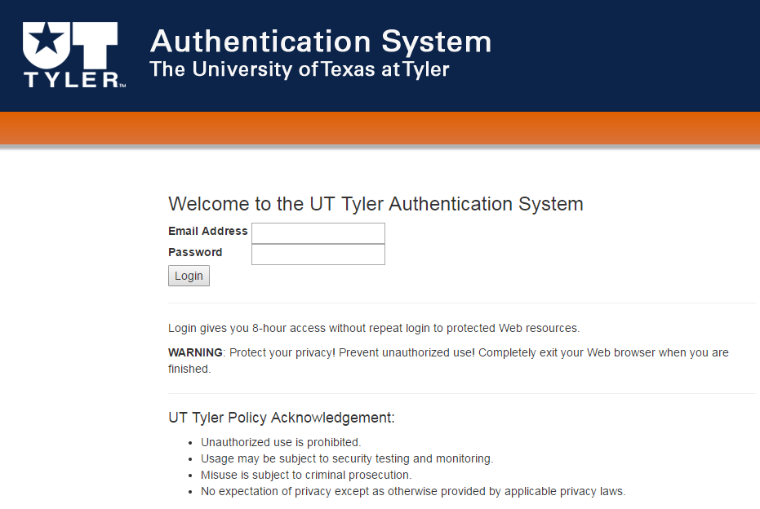
- Begin Shopping
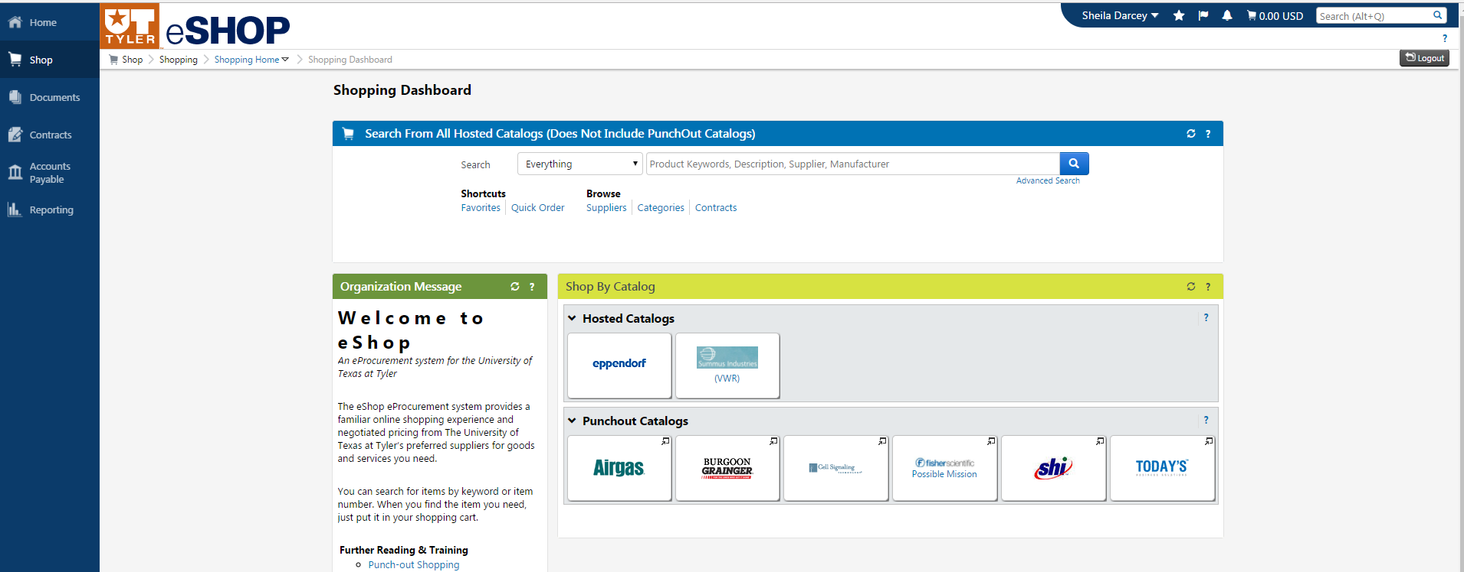

Logging in as a Requester
If a user has a Requester role, they will access eSHOP from a link within UT Share/PeopleSoft. Requesters will login to UT Share/PeopleSoft and navigate to Requisition, where there will be a link to eSHOP under the web tab. Employees with only an eSHOP Shopper role will NOT have access to this UT Share/PeopleSoft link and must use the direct web address to shop.
- Login to UT Share/PeopleSoft
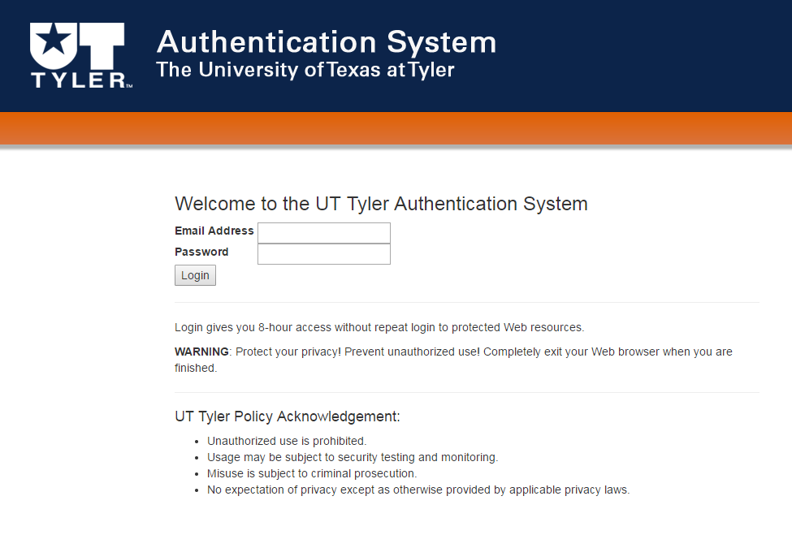
- Navigate to requisition (Navigation: Main Menu > eProcurement > Requisition)
- Enter Business Unit or Accept Default
- Enter Requester
- Click OK
- Click on Request Options drop down box
- Click Web link
- Punch-Out to eSHOP by clicking eSHOP link
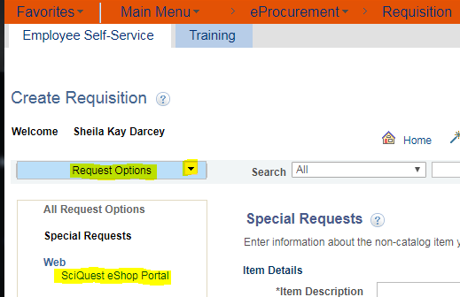

Navigation

Interface
There are three main areas of eSHOP:
- The Main Workspace
- The Side Navigation Menu
- The Top Banner
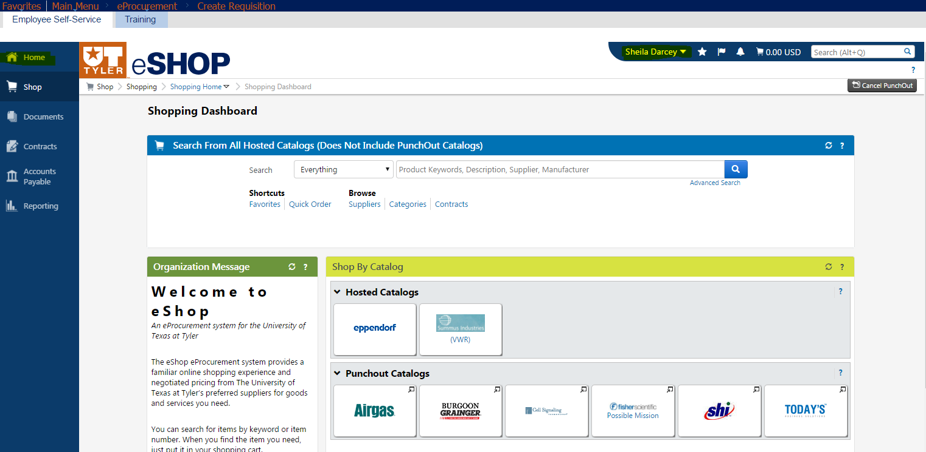

Main Workspace
In the main workspace, one can view and manage the active eSHOP features. For example, if a user is working in the Shopping Dashboard the page will display in the main workspace as shown in the example below. As a user accesses other areas of eSHOP only the main workspace changes and the side navigation menu and top banner remain in place. At all times, the main workspace will display breadcrumbs that tell what page a user is on and the navigation path to the page. A drop‐down icon beside a page name indicates that users can select it to access another page.
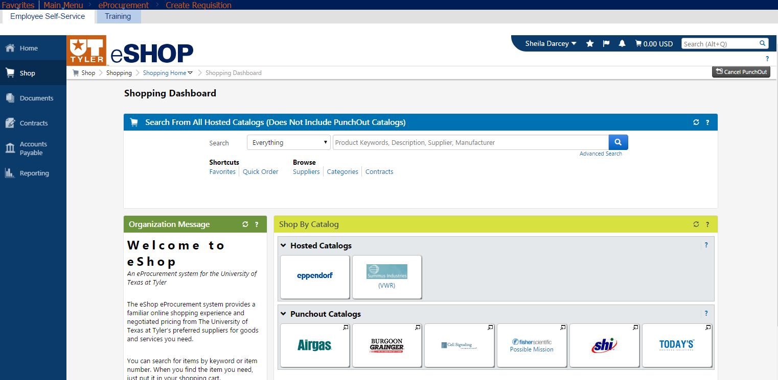
The image below shows the Advanced Document Search active in the main workspace.
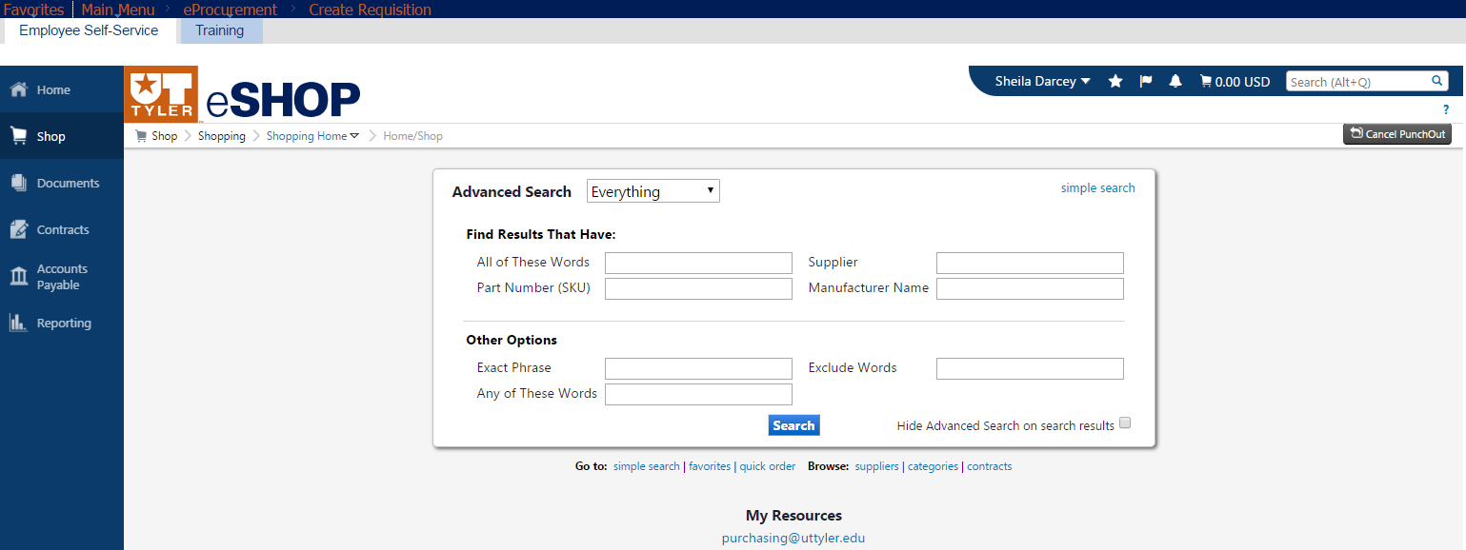

Side Navigation Menu
Most areas of eSHOP can be accessed from the side navigation menu. The side navigation menu contains top‐level menu items. When a user rolls over the main menu icons, slide‐out sub‐menus display. In general, menus are grouped by related tasks. For example, shopping tasks are grouped in the Shop menu, document search tasks are grouped in the Orders & Documents menu, etc. Clicking on the Home Icon returns to the homepage from anywhere in eSHOP. Depending on the roles assigned to a user, all of the following menus may not be available to each employee.
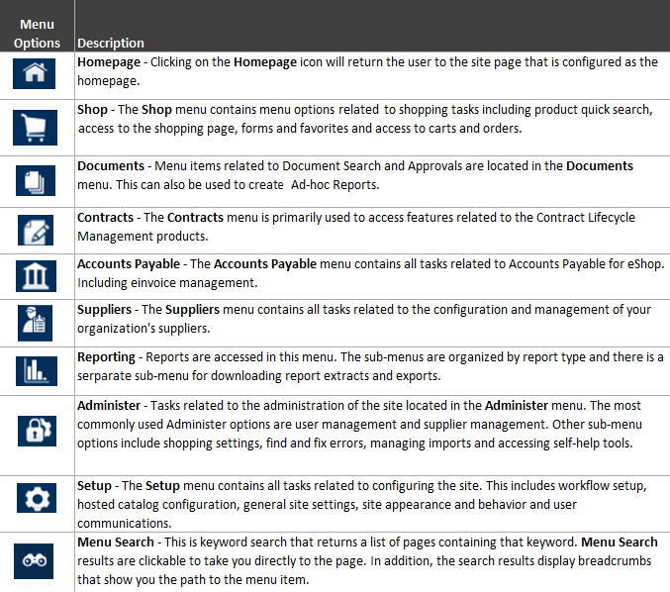

Top Banner
The top banner contains access points to the user profile, bookmarks, assigned actions items and available notifications. In addition, users can access a quick view of their active shopping cart and perform a quick search of the site.
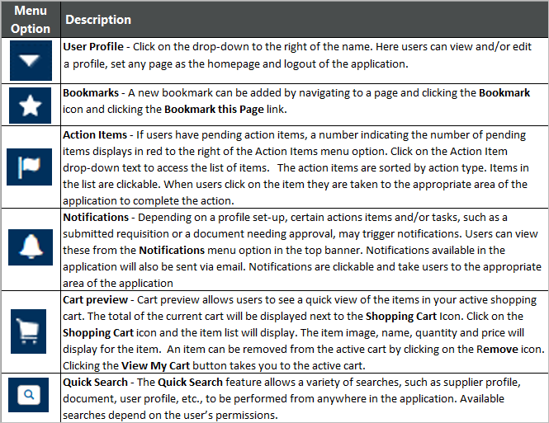

Managing a Profile
Each user has a profile which is created when access is granted. Some user profile information will need to be personalized to the user preferences, these preferences will need to be set at first login. At first login, users will be directed to their profile to customize.
Users can view and/or edit their profile and set any page as their home page. They can also logout of eSHOP. In order to access profile options, click on the drop‐down to the right of the name in the Top Banner.
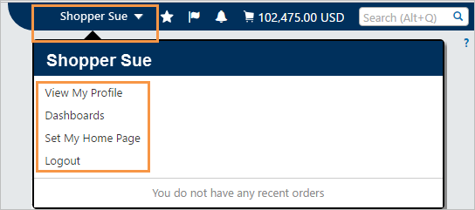

View My Profile
When View my Profile is selected from the dropdown menu, users will get a summary of their basic information and list of their user profile, settings, preferences and permissions. This basic information includes basic contact and login information. Review the populated information and make changes if necessary.
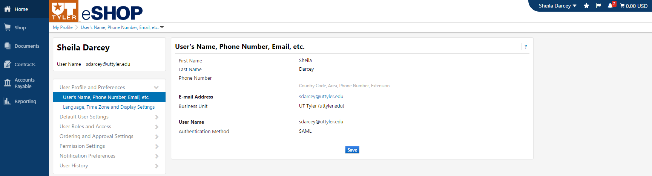
There is a list of setting, permissions and preference sections to the right of the screen. The sections listed are dependent on a user’s permissions. Users may have more or less sections than displayed or they may see sections that they cannot edit. There are sub-sections for each section listed as well. Once users click on the section they wish to edit, sub-sections will display. If a sub-section is editable there will either be a dropdown menu or blank field. Some sections have an Edit Section link instead.

User Profile and Preferences
The User Profile and Preference section has basic contact and login information, plus language and other preferences that will personalize the user experience. This section as two subsections:
- User's Name, Phone Number, Email, etc.
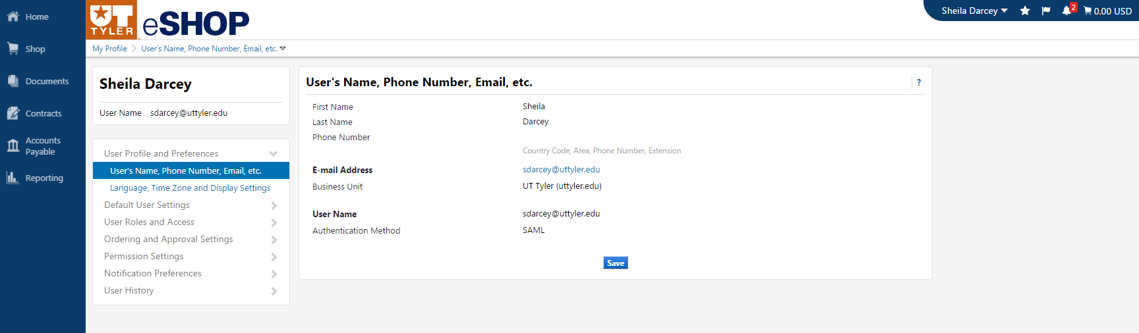
- Language, Time Zone and Display Setting
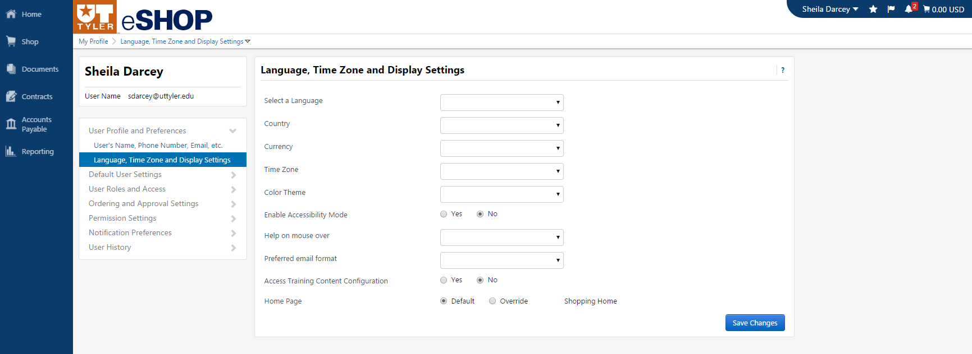

Use the dropdown menu to choose a preferences or type the appropriate information next to the text field to update this information. Once finished Click Save or Save Changes.

Update Security Settings
This is where a user may change his/her password and security questions. Since UT Tyler uses a single-sign on password, this section will not be editable. To change your password, please change your network password from the UT institution login.

Default User Settings
The Default User Setting section is largely defaulted according to the user’s profile from UT Share/PeopleSoft. Some of these sections cannot be revised. However, there are some sub-sections under Default User Settings that should be reviewed to make sure they are set correctly and completely.
- Custom Field and Accounting Code Defaults – are not used for this module and will be blank or pre-populated from UT Share/PeopleSoft and should not be modified
- Default Addresses – Are populated from UT Share/PeopleSoft. These addresses here will not be accepted on the UT Share/PeopleSoft requisition and will revert to the default addresses stored in UT Share/PeopleSoft if they happen to differ. If a user needs to change the address for a requisition it needs to be done in UT Share/PeopleSoft.
- Cart Assignee – Anytime a user is creating or reviewing a cart but will not be the person who “Returns it to PeopleSoft”, they will need to assign the cart to a cart assignee. Cart assignees are Requesters that have the authority to submit a cart to UT Share/PeopleSoft. The person or persons who are responsible for creating and submitting requisitions for the department will most likely be the cart assignees for that particular department.

Adding an Assignee to User Profile
- Access the User Profile.
- Click on the Default User Setting menu option on the left.
- Click Cart Assignees.
- Click the Add Assignee button.
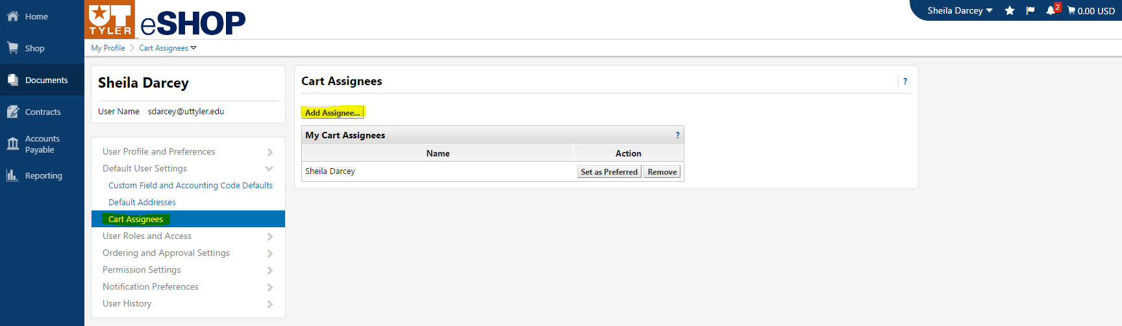
- A User Search box will display, enter all the known fields. 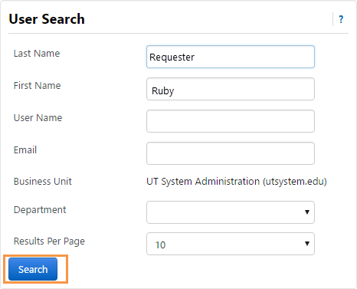
- Click the Search button.
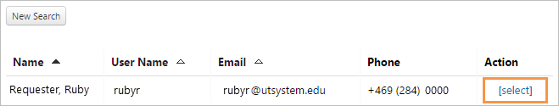
- From the Search Results, click Select link to select the correct person.
- The assignee displays in the Cart Assignees page. From this screen you should be able to Set as Preferred or Remove. Clicking Set as Preferred will make this person your default assignee. Click Remove if you need to remove an assignee. 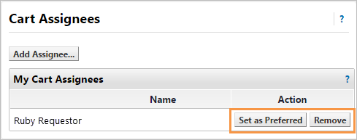

User Roles and Access
The User Roles and Access gives a snapshot of the roles that are assigned to a user and the access a user has when accessing a document search from the side navigation menu.

Ordering and Approval Settings
This section is defaulted, view only and cannot be changed.
- User Purchasing and Approval Limit Values – this section to set the financial limits for the user or role.
- Punch-Out Access - This section displays the permissions for viewing and accessing Punch-Out suppliers. A check mark indicates that the user has access to the Punch-Out and an X indicates that the user does not have access.
- Product Views – this section manages the types of products that specific users or user roles are able to view in search results. These views are based on supplier and product category classes as well as specific product flags.
- View Assigned Approval Folders – this section is a folder Summary tab that lists all of the folders for which a user is assigned as an approver. It will be a view-only look at the approver's workflow folders.

Permission Settings
Permissions determine what functions are available to a particular user, including what navigation tabs and screens are viewable and editable by the user. When a role is assigned to a user, default permissions are automatically given to the user, but can be overridden by an administrator if necessary. This will be a view-only section unless the user has an administrator role.
Permission are included for Shopping, Carts & Requisitions, Orders, Approvals, Contracts, Administration, Accounts Payable, Custom Fields, and Mobile. A check mark indicates that the user has access to the permission and an X indicates that the user does not have access. To get more clarification on a permission click the question mark at the end of the permission name to show help text.

Notification Preferences
eSHOP can be configured to notify users when specific events happen in the system or an issue is pending that requires the user's attention. All notifications are available by email and a sub-set are also available in eSHOP in the Notifications menu in the top banner.
Notifications for specific users are managed through the Notification Preferences menu in the user profile. This includes configuring which notifications the user will receive and the method of delivery (in application, email or both). Often, this information is inherited from a role but it can be overridden at the user level. If a notification preference is not inherited, it will default to None.

Setting Notification Preferences
- Access the user profile.
- Click on the Notification Preferences menu option on the left.
- Select a sub-menu to choose a specific notification preference.
- Click the Edit Selection link for the corresponding section.
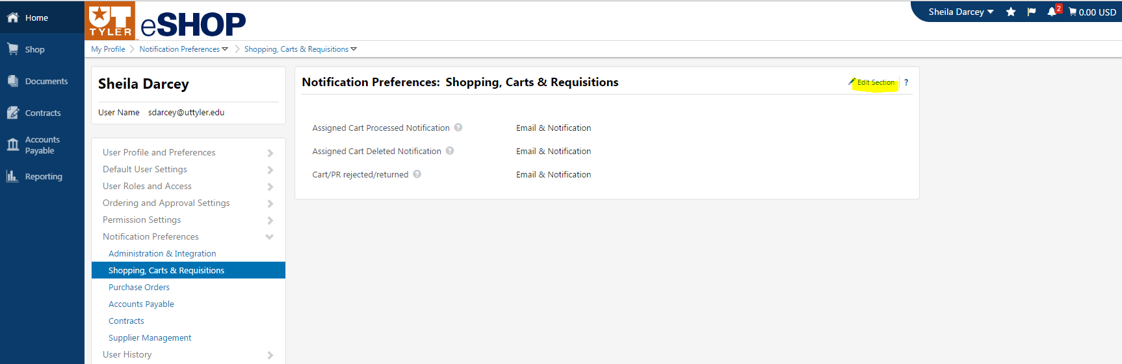

- Radio button options will display to the right of the notification. To override the default status for the notification, click the Override radio button. Adversely, if a status has been overridden and you would like to restore the default, click the Default radio button.
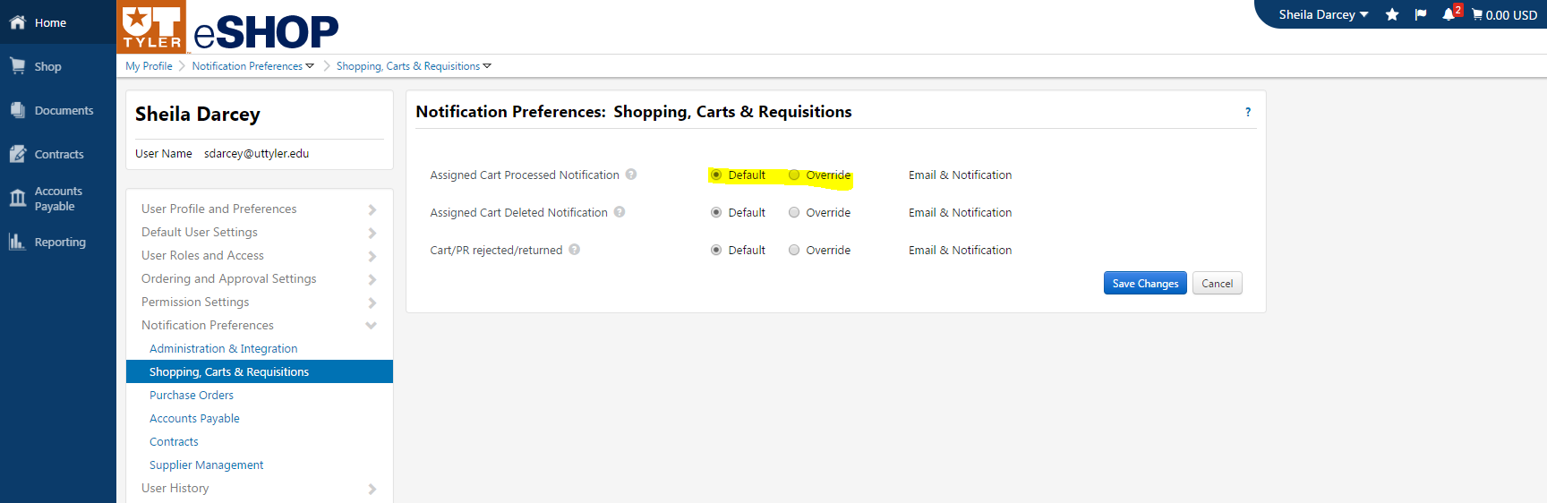
    - When selecting the Override radio button, a dropdown will display and the user will select from the following options.
      - Email indicates that the user receives the notification by email.
      - Notification indicates that the user receives the notification in eSHOP. Important Note: In-application notifications are not available for all notification options. For those items, the Notification status option will not be available.
      - Email & Notification indicates that the user receives the notification in both ways.
      - None indicates that the user does not receive this notification.
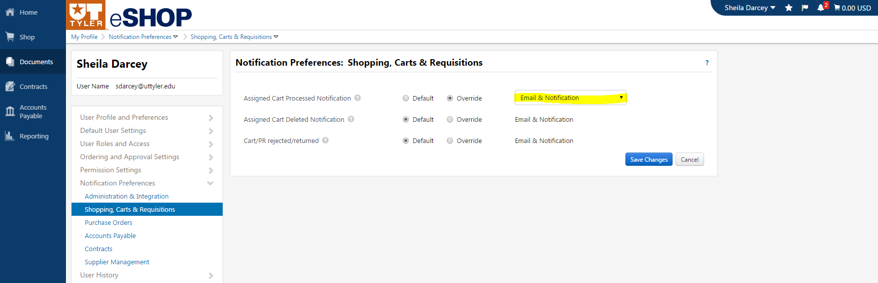
- When you have completed the changes, click the Save button.

User History
The User History provides an audit trail that tracks changes made to a user’s profile. This is an information-only screen that provides detailed information about potentially important changes such as changes to roles and permissions, addresses, and more. The History screens are used to track changes, additions, and deletions.

Dashboards
Dashboards reduce the need to search for frequently used features by placing them all in a single location. Dashboard "widgets" or sections provide access to general functionality and information, such as product search or the organization message, or to functionality and information specific to a product.
The Shopping Dashboard will be the default homepage for users. The Shopping Dashboard offers quick access to tasks and information that you use on a regular basis. There are four widgets available for the Shopping Dashboard.
A Shopping Dashboard example is shown below:
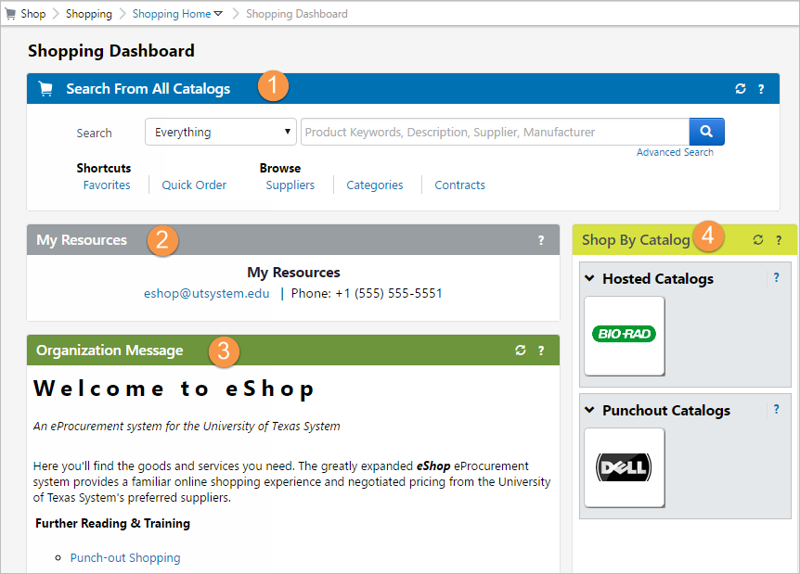
- Product Search - allows the user to locate shopping items from the dashboard. Users can perform a simple product search, access advanced search, shop from several types of shortcuts or through browsing items.
  - To perform a simple search from the widget, select a category in the drop-down field, enter a value in the text field and click the search icon.
  - To perform an advanced search, click the Advanced Search link.
  - Shortcuts are available to take you to your favorites or suppliers, and to create a quick order. To access a shortcut, simply click on the link. Item browse options are available. To access any options, simply click on the link.
- My Resources - displays the system support contact information for UT Tyler.
- Organizational Message - displays a message, which has information for UT Tyler.
- Catalogs - displays the suppliers and services a user may have access to that are featured by any particular Business Unit.

Set My Home Page
Set My Home Page allows users to set their personal homepage to fit their needs. The Shopping Dashboard is the default homepage for users.

To set the homepage:
- Navigate to the desired page in eSHOP.
- Find your name in the Top Banner and click.
- Click Set My Home Page in the menu.

This pop-up will display:
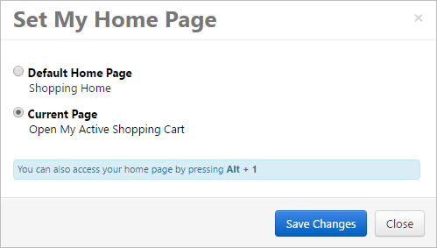
- Select the Current Page radio button to set the current page as the homepage. Select the Default Home Page radio button to return your homepage to the default homepage.
- Click Save Changes once you have made your selection.

Shopping in eSHOP
There are two basic methods for locating products in eSHOP based upon supplier type: Hosted and Punch-Out Catalog. The type of supplier you select will influence the manner in which you search for products and process your order in eSHOP.

Shop by Catalog
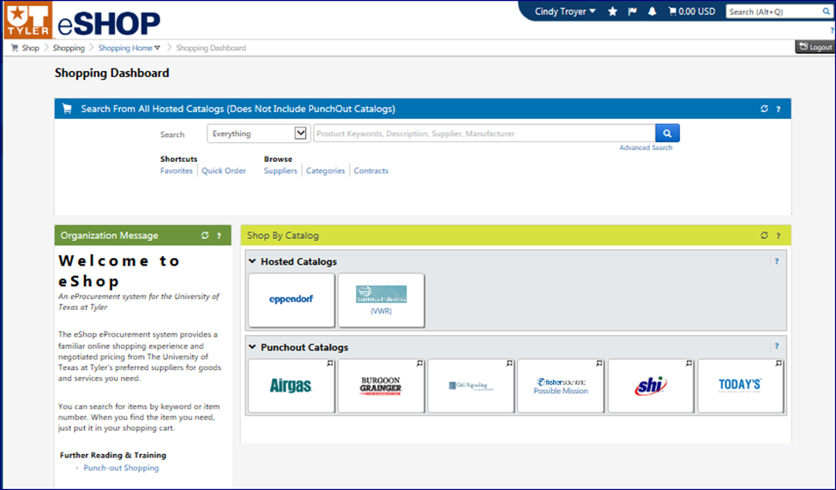

Hosted Catalogs
Hosted catalogs contain product data and details, along with UT System negotiated prices and terms for each item. When a product search is performed, the products in all of the Hosted catalogs are searched. Hosted catalog search results contain product information from all suppliers depending on the search criteria entered by the users. Hosted catalogs allow the user to perform side-by-side comparison shopping.

Punch-Out Catalogs
Punch-Out catalogs are integrated external links to a supplier’s web-based catalog. The user automatically exits eSHOP to search and select products from a supplier’s web catalog, and then is returned to the eSHOP shopping cart at checkout. The selected items are then submitted through the standard requisition/order process. Since a Punch-Out catalog only allows the user to be in that one vendor catalog – no side-by-side comparison can be performed except for products comparisons within that one Punch-Out catalog.

Shop at the Top– Shopping Dashboard
From the eSHOP Shopping Dashboard, enter the name of the item you are searching for in the product search bar. Users can also search by a part number or style number. Click the Search icon.
On the right side of the product list, the price displays along with packaging information. The quantity defaults to “1” and can be changed here before adding to the cart. If this is an item that is ordered frequently, one can click the add favorite link. If a user has several items to compare between suppliers, he or she can click the compare link. A checkmark will appear to indicate it is selected to be compared. The Compare Selected button will activate and show how may items you have selected to compare. To remove a product that you have selected, click the remove link.

Once users have selected all their items to compare and a page will display for a side by side comparison of your product.
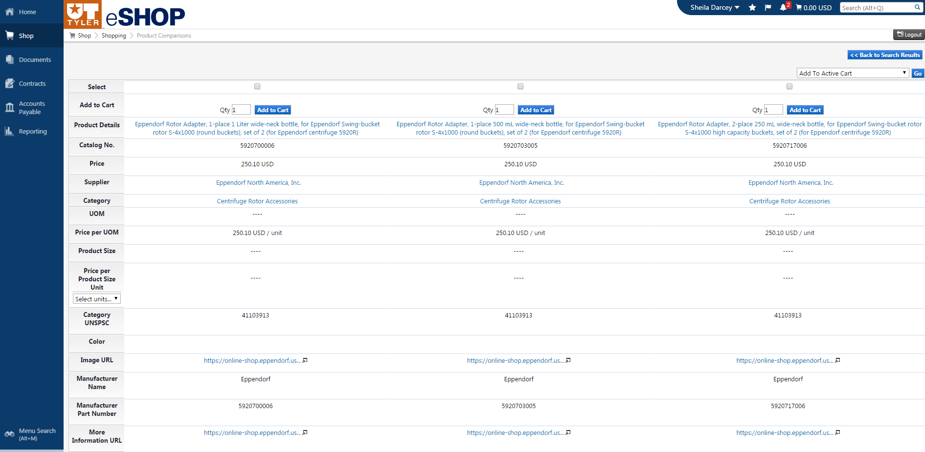
Once you determine the product you want to purchase, simply click the Add to Cart button.
NOTE: If the search results in no items returned on contract or in a catalog, this would indicate you would use a standard special item requisition through UT Share/PeopleSoft to order the product(s).

Document Search
The Document Search provides the ability to search across carts, purchase orders and eInvoices to view the document histories all at the same time. When doing this, users will be presented with search options that span across multiple document types. The default document type is “All Documents”. My Carts and My Purchase Orders can also be accessed from this tab. Document searches are used to not only tell about “past” orders, but to access carts in process to find out the status.
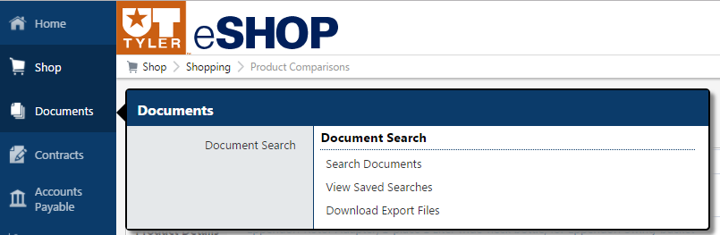

Search Documents
Click the Orders and Documents Icon from the Side Navigation Menu. Then choose Document Search and Search Documents from the sub-menus. These fields are searchable in search documents:
- Cart Number
- Purchase Order Number
- Contact Number
- Catalog Number
- Requisition Name
- Requisition Number
- Supplier Name
- Key Word (from the cart name, item description, etc.)
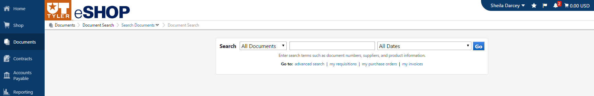
Document search offers a variety of date ranges to search by. To change the date ranges, use the drop down box – All Dates in the search box and choose from the following options:
- Days
- Calendar
- Fiscal
- Other
Prior to running the search, the date range or the document type may be selected.

Filter Options
Once a query has been initiated there are many options for filtering the results to get to the information the user is seeking. In this example the user searches for all documents for the fiscal year to date:
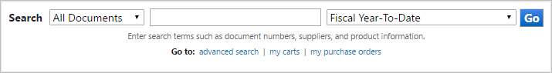
The results will give all documents that meet this date range. See the left hand side of the screen for the current search filters that apply to this search. Use Refine Search Filters to further filter the results.
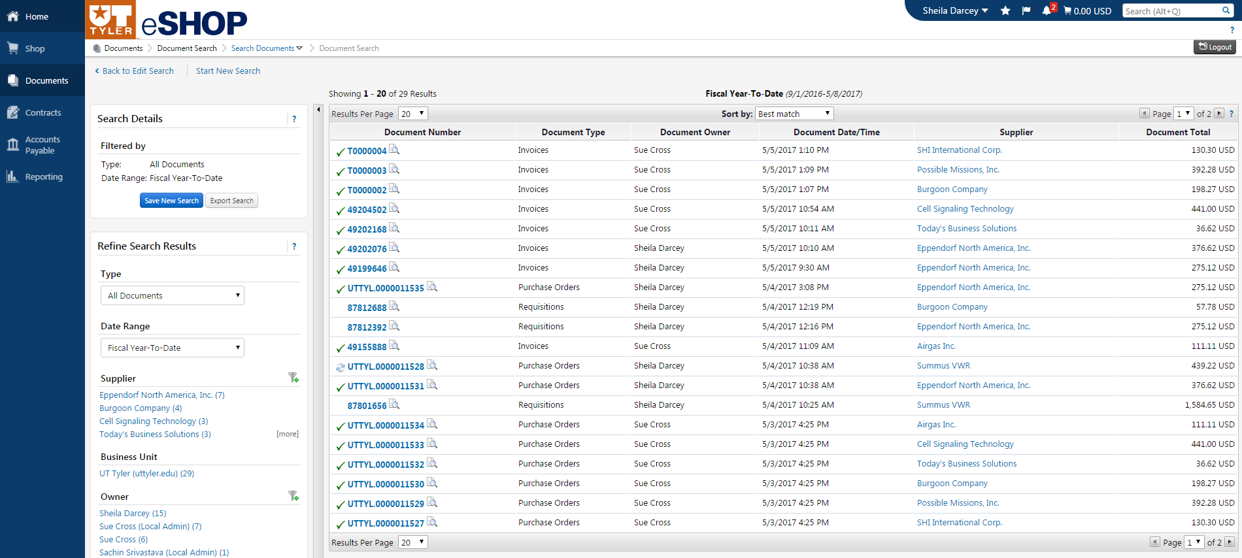

Contract Search
The Contract Search provides the ability to search contracts loaded into the eSHOP system. Users are able to search contracts in the same manner as documents. Contracts are an easy way to procure goods as the procurement process is already complete and the goods and pricing has previously been approved by procurement before purchase. 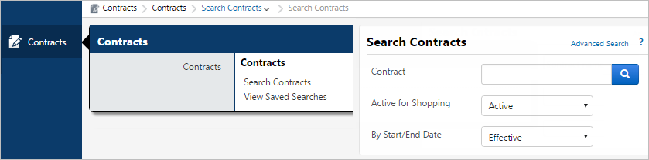

Advanced Search
Advanced Search offers users the option to enter very specific, detailed search criteria. Advanced Search gives users the ability to pre-define search criteria. Users should use advanced search when they know of specific criteria on which to search for their documents.
The following are examples of where to find the advanced search and what options are available.

Shopping Advanced Search
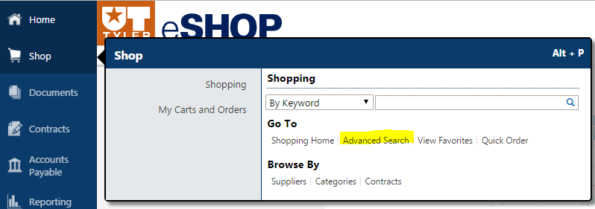
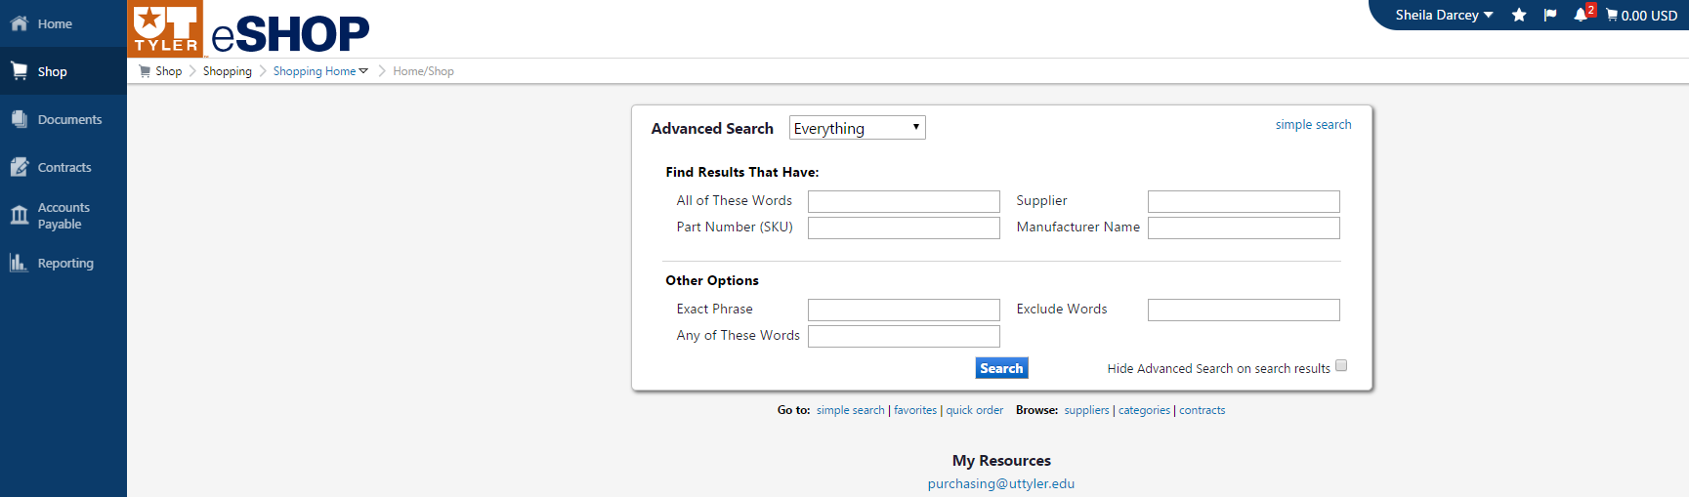

Contract Advanced Search
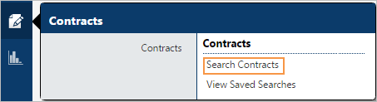
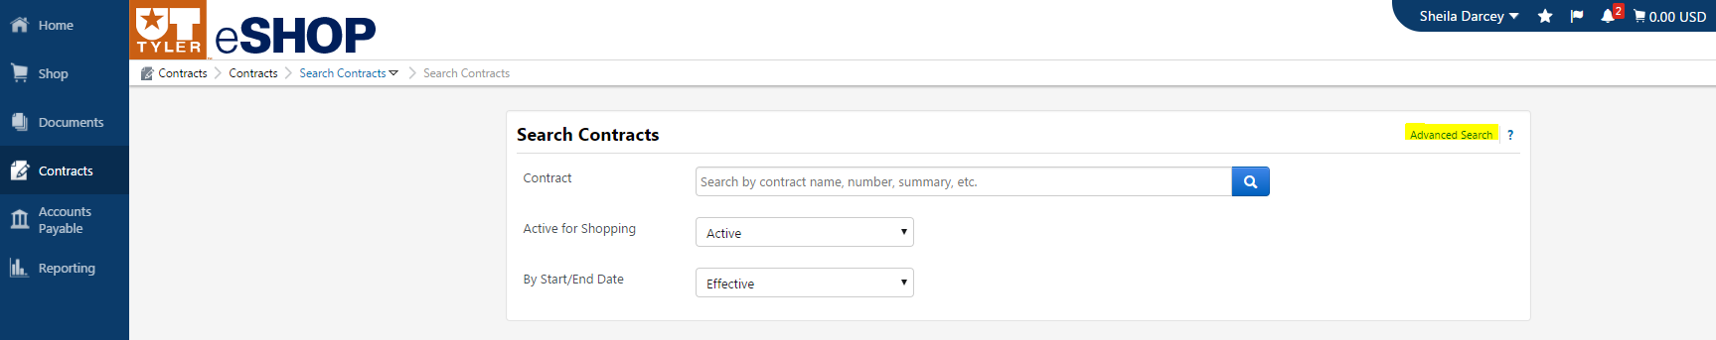
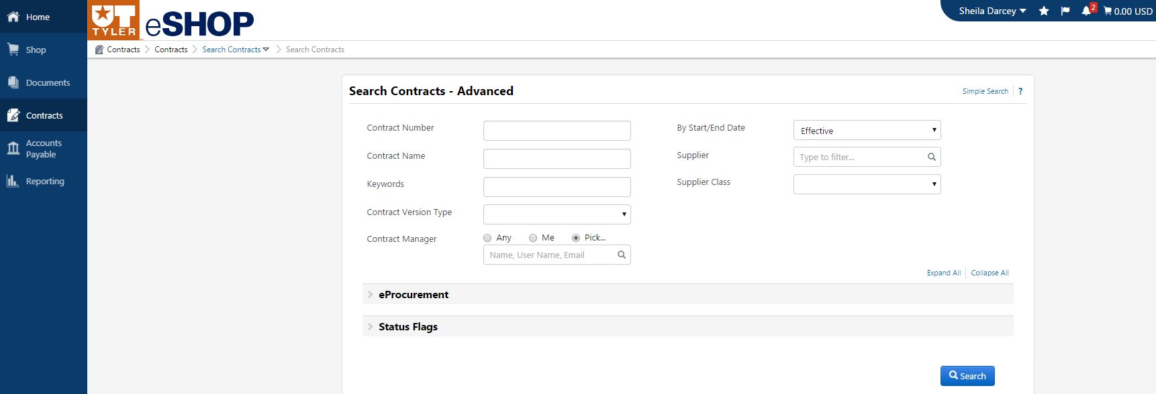

Documents Advanced Search
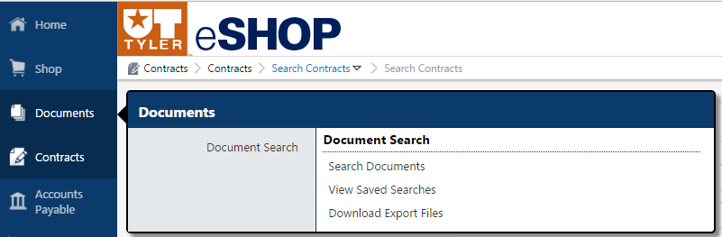
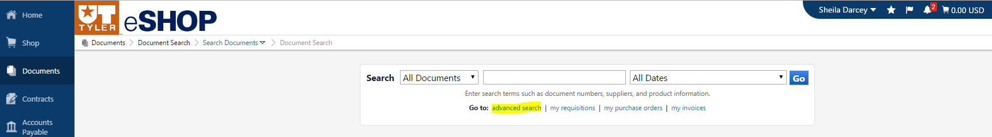
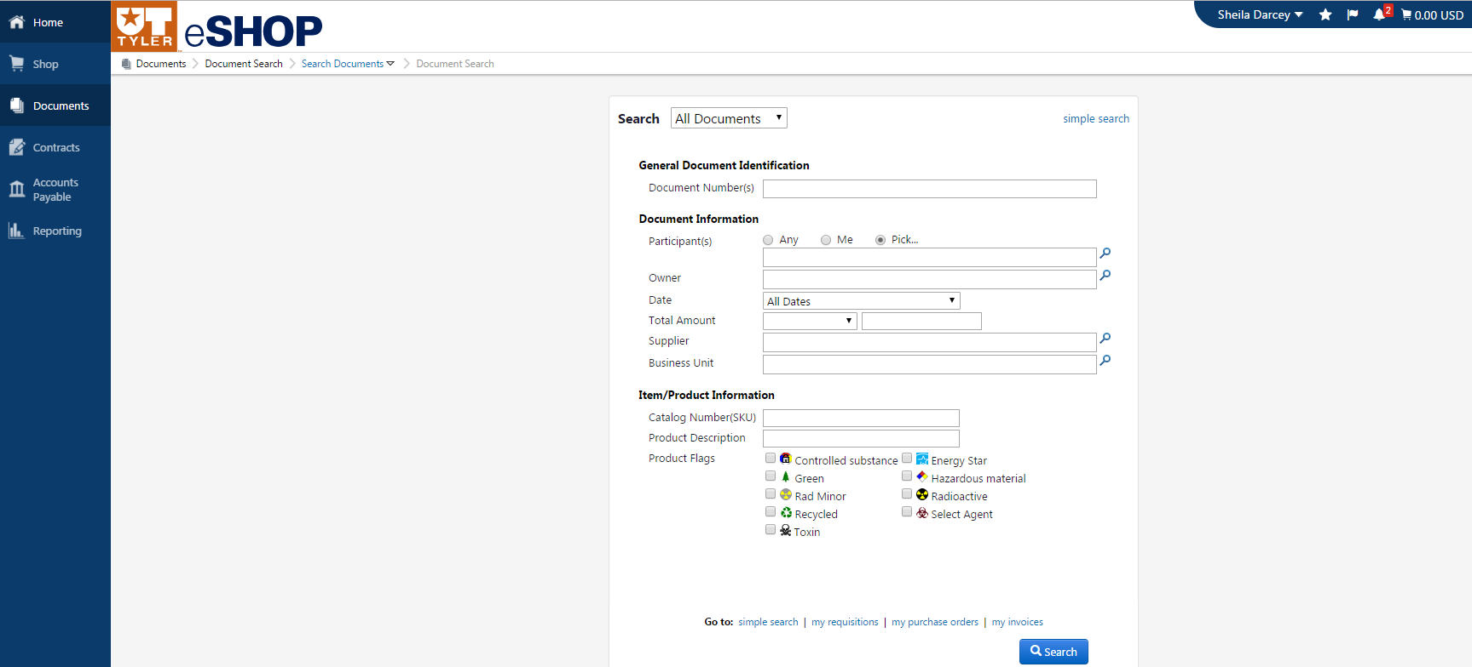

Saved Searches
Many users will find that there are searches that they will perform over and over.
eSHOP through the Search feature will allow certain searches to be saved so that a useful search is quick and easy to recreate without having to perform all the filters manually each time.
Saved searches are created from the search results page. When you opt to save a search you are essentially saving the search you executed to get to that results page. For example, you run a search on Carts from the last 30. If you opt to save this search, then the criteria saved in the search will be the same. It is important to note that when you execute a saved search the dates will be relative, meaning the last 30 days would be from the date of report execution vs. the date that the report was saved to a folder.
Saved searches are organized using folders, helping to easily locate and manage them. Folders can be created in the saved searches tab or on the fly when saving a search.
Saved searches can also be managed. Searches can be deleted and moved/copied to another folder. Search names and descriptions can be edited. From the view saved searches link you can also add a saved search as a shortcut on your main search.

To Create a New Search Folder
- In document or contract search, select the view saved searches sub menu from the Side Navigation Menu.
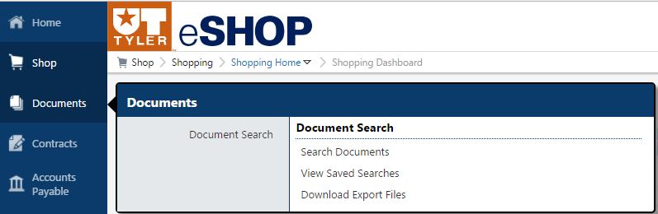

- Select the Add New button in the top left.
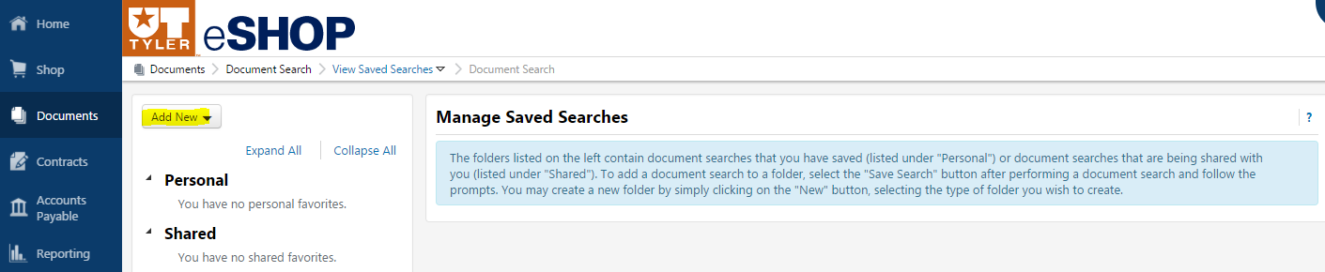
- Select Top Level Personal Folder Link for New Top Level Folder or Subfolder to add to an existing folder
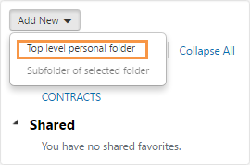
- A new window will appear prompting a name for the search and a description (optional). 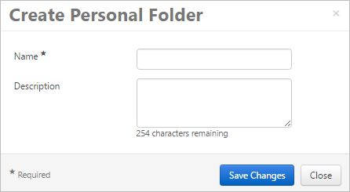
- Once Information is entered, click Save Changes.

To save a search
- Click the Save Search button after filtering all the criteria.
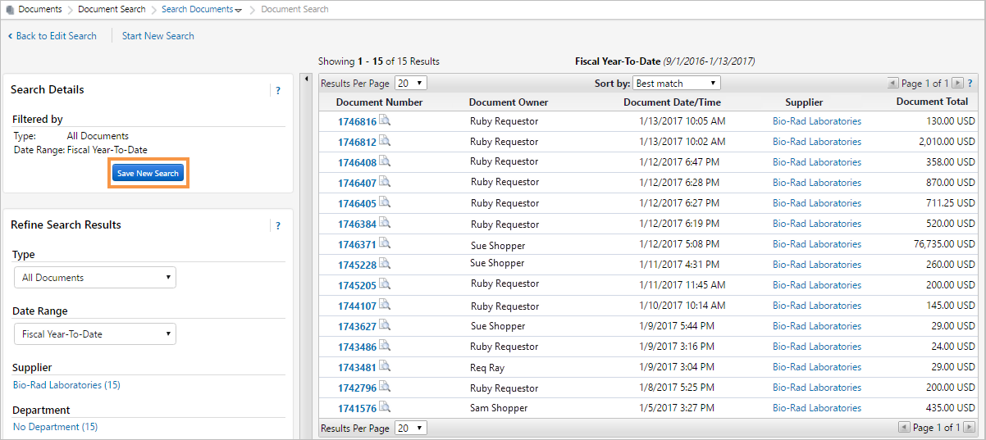

- A new window will appear prompting a name for the search and a description (optional).
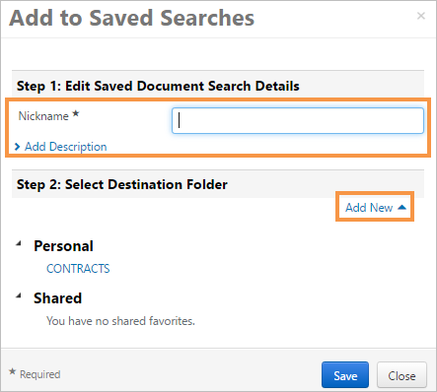
- Once named, add this search to a personal folder by clicking on the folder the search will be saved in. NOTE: If a user has never created a folder for searches he/she will have to click the Add New link to create the folder.
- Click Save.

Shortcuts
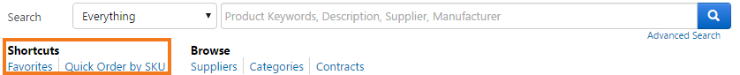

Favorites
Favorites can be used to identify items that are referenced or ordered frequently. By setting up Favorites less time is spent searching for items that will be ordered again in the future.
Within eSHOP, there are two types of Favorites – Personal and Shared. Personal Favorites are those that a user identifies for future purchasing. With personal Favorites, folders and sub-folders can be created. Users have full control over items in their personal folders. Shared Favorites and folders are set up by the administrator and can be set up for use for the entire campus. Shared Favorites typically represent frequently ordered products or suggested products for purchase.

Adding Items to Favorites
Favorite items can be added from the product search results or from the cart. Although the “starting point” may be different, the way in which Favorites are added is the same.
- Search for an item. From the search results, locate the item to add as a favorite.
- To the right of the item, just below the Add to Cart button, click the add favorite link. The Add to Favorites dialog box displays. 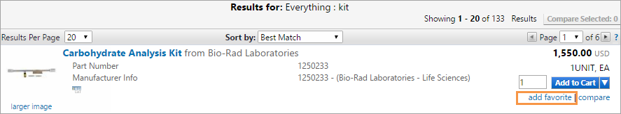
- In the Item Nickname box, you may name the reference rather than using the supplier’s product description. You might want to name the item something that you can recognize. 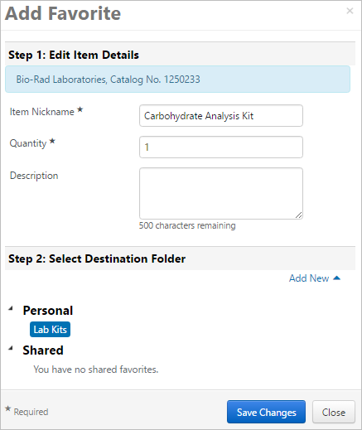
- Enter the standard quantity that will be ordered. The quantity can always be updated when adding to the cart.
- Select the destination folder. You can add the item to an existing folder or create a new folder. NOTE: If you need to create a new folder, click the Add New Link. Enter the folder name and description, then click Save. The new folder displays in the list and it automatically selected for the favorites item. Click Submit to save the item.
- Click Save Changes. After the item is added, a confirmation box displays.
Once saved as a personal Favorite, you can reorder by clicking on the Favorites tab or they can still be found by conducting a search. When searched the items are displayed with a star and display first in the search results. If you renamed your product with a nickname, you can also search on that nickname. 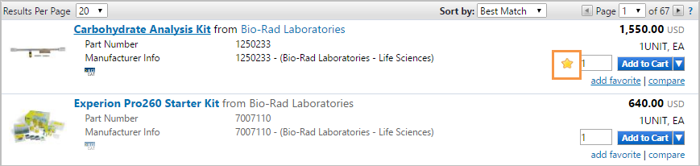

Quick Order
Quick Order is used when the exact product catalog number (SKU) is known. Both the supplier and manufacturer part numbers are searched when using Quick Order. If the catalog number entered is an exact match to a product in the hosted catalogs, and there is only one match, the product is automatically added to the shopping cart. If an exact match is not found or more than one product is found, Search Results are presented to allow for the selection of the appropriate product. Quick Order allows you to order one or more products simultaneously.
- Access Quick Order in one of the following ways:
  - Navigate to Shop > Shopping. The Shopping slide-out menu displays. In the Go To section click Quick Order.
  - From the default Shopping Home page click the quick order link located at the top of the page. Often the Shopping Home page is your default home page.
- To quick order for a specific product vertical, select an option in the Category field (optional). 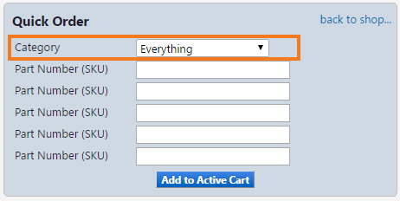
- Enter the catalog number(s) in one or more of the Part Number (SKU) fields. If you would like to add the SKU automatically, it is important to enter the SKU exactly as the supplier has it listed.
- Click the Add to Active Cart button.

Shopping Carts
Shopping Carts contain line items that represent items, goods, or services being requested through eSHOP. Users with Shopper permissions add items to a cart then assigns the cart to a requester for submission into UT Share/PeopleSoft. A Shopper has a UT Share/PeopleSoft ID but does not have the permissions to create requisitions in UT Share/PeopleSoft. A Requester actually submits the cart on behalf of a Shopper or creates one themselves, the cart is then imported into UT Share/PeopleSoft as a Requisition.
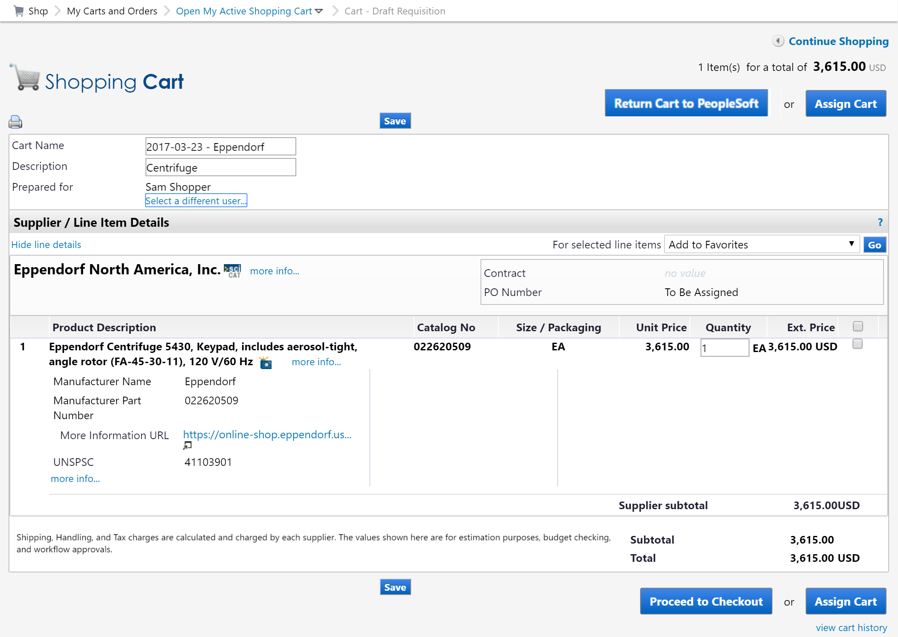
When accessing a cart. You are able to see the cart name and description, who the cart is prepared for, the supplier name, the item and its details, the cart totals and view the cart history.
There are also several actions users can take from the screen. Users can add to the cart from the same supplier by clicking the Continue Shopping link. They can change the cart name or description. Depending on their role, they can click buttons to Return to PeopleSoft or Assign Cart. Users can change the quantity of a hosted item. Also, users can select the item or items to perform the following action from the for selected line items dropdown.
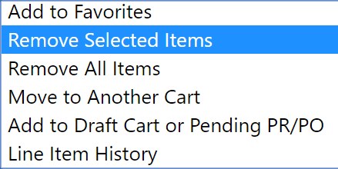

eInvoicing
Invoicing is an automated process for eSHOP purchase orders. Once a supplier has sent an invoice, it will be received by eSHOP. That invoice information will then be sent to UT Share/PeopleSoft, where a voucher is built, matched and budget checked. Once budget checked, it will go through any approval workflows required by the campus. Once approved, it will be sent to pay cycle for release of payment. An example of the workflow is illustrated below.
