eSHOP Suppliers

Table of Contents
Supplier Types 2
Hosted Catalog 2
Punch-Out 2
Browse/Search Suppliers 2

Supplier Types
Hosted Catalog – These suppliers have searchable catalogs in eSHOP. Most catalogs are for Contract Suppliers who offer special pricing and customer service. Their pricing is audited to confirm the pricing posted includes the centrally negotiated discount. These catalogs are offered as a convenience and resource for product searching.

Punch-Out or External Catalog – These suppliers are contract suppliers and provide a direct link in eSHOP to their website where products can be chosen and brought back into your eSHOP shopping cart. These products are NOT included in product search.

Browse/Search Suppliers
- Navigate to the Shopping Dashboard (Default Homepage) – Shop > Shopping > Shopping Dashboard
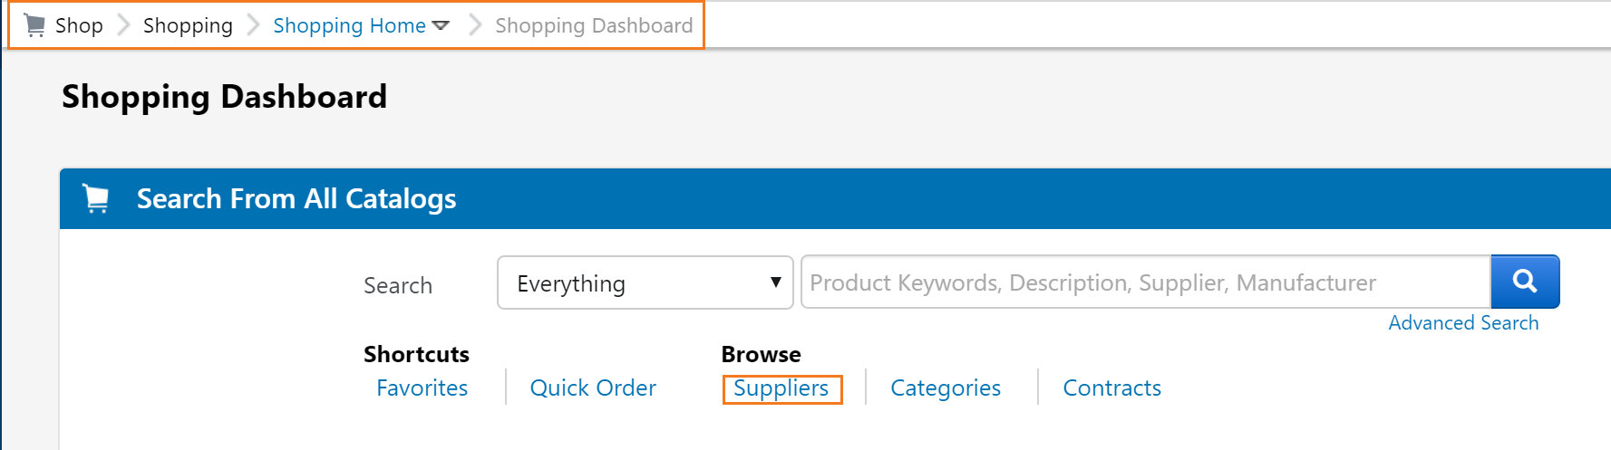
- Click the Supplier Link.
- Click to Expand Search for Supplier Filter.
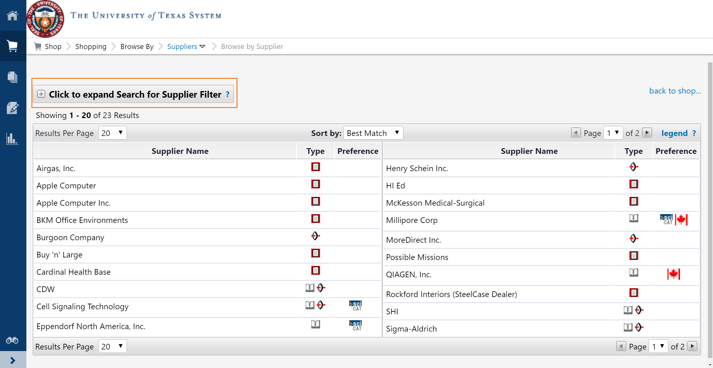
- Enter your search criteria Supplier Name, choose the Supplier Type.
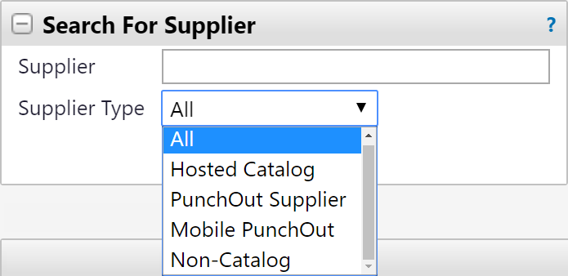
- Click Search.
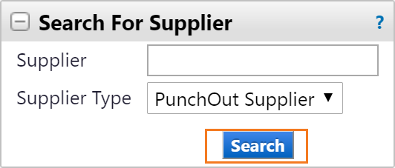
- Results will Display.
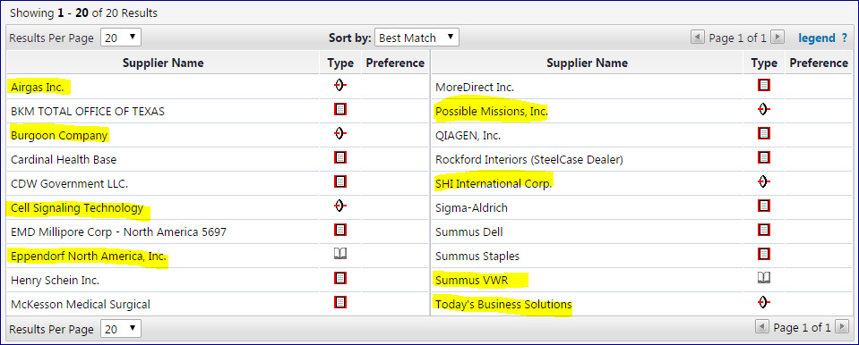
Please Note: Approved UT System contractors for UT Tyler as of 05/2017 use are:
- Airgas USA
- Burgoon Company (HUB for Grainger)
- Cell Signaling Technology
- Eppendorf North America
- Possible Missions (HUB for Fisher Scientific)
- SHI International (HP and Dell computer equipment)
- Summus (HUB for VWR)
- Today’s Business Solutions (UT System HUB office supplies contractor)

