Budget Authority
Review and approval of Procurement Card transactions

- Review Statements
  - Budget Authority or his/her Reports To supervisor, reviews Procard transactions and Approves for further processing
    - Navigation: Menu>Financials>Purchasing> Procurement Cards> Reconcile> Reconcile PCard Statement
    - Function: The Budget Authority / Supervisor approver accesses Procard Transactions and reviews items showing a Status of “Verified”
    - Role: ProCard Reviewer
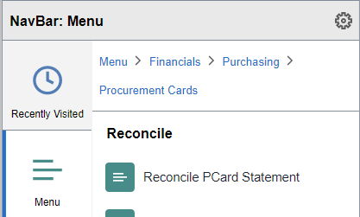
Or go to the Procurement Operations Drop Down and click on the Reconcile PCards tile
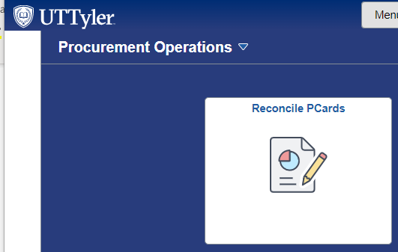

On the resulting screen, select appropriate Role Name, Employee ID and/or name of one of your cardholders. Select Statement Status of “Verified” then clear the 50 Rows Per Page limitation and click the “Search” button.

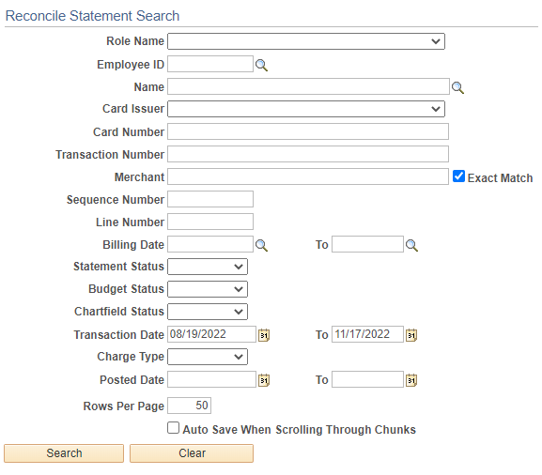

Once cardholder transactions populate the screen, verify that all transactions agree to receipts and the required Procard Log. Note, as with other UT Share/PeopleSoft screens, you may click the “View All” link to view more transactions than show on the screen initially. (See screen shot below).
Review the attached receipts, Procard Log, and other supporting documentation by clicking on the text “bubble”. Only one attachment may be made per screen, so you may need to click the View All option to see all attachments.
Review the accounting information by clicking on the “More Detail” icon. The More Detail icon (looks like a page with 3 arrows in bottom right corner) will access the Account Distribution screen.
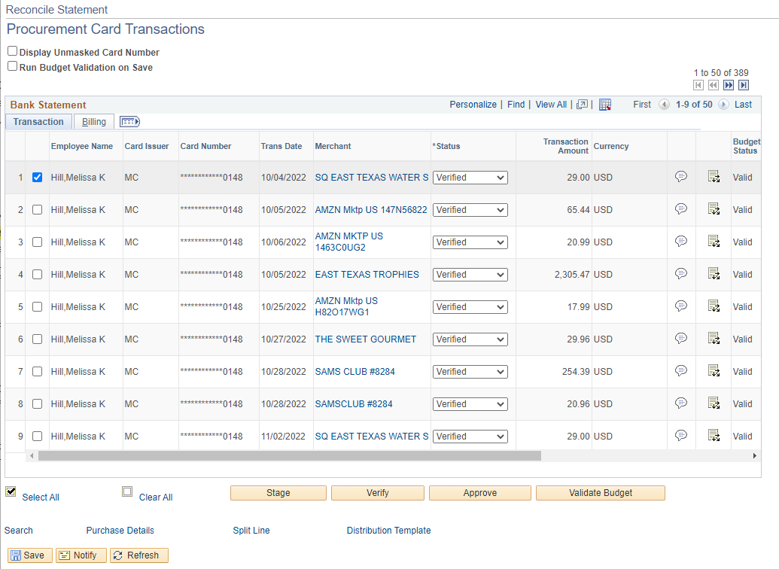

On the Account Distribution screen, pull the scroll bar left or right as needed to review budget chart field information then click OK to review to the Procurement Card Transactions screen.

If charges should be posted to a different set of budget chart fields or split between two or more sets of chart fields notify your Procard Reconciler/Administrative Assistant to login to PeopleSoft and make the necessary changes or corrections BEFORE you Approve that transaction.
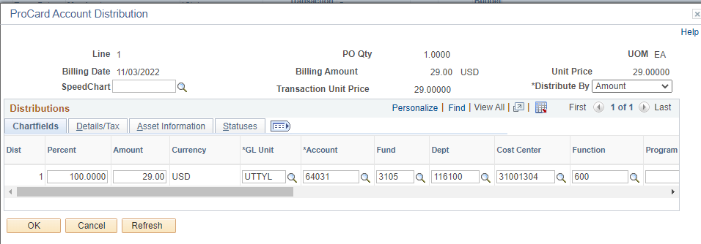
Note any discrepancies to discuss with cardholder. NOTE: ALL CHARGES MUST BE RECONCILED AND APPROVED FOR PAYMENT PRIOR TO THE DEADLINE. If there is a discrepancy, the cardholder must either work with the vendor to obtain a credit (applied to a future month’s statement) or if a charge is unauthorized, the cardholder must work with Citibank. Citibank will credit fraudulent charges on a future month’s statement.
Review or add Comments as needed for each transaction by clicking on the Comments “balloon” icon found on the Procurement Card Transactions screen. Click the “OK” button if Comments were added or click the “Cancel” button when done to return to the Procurement Card Transactions screen.
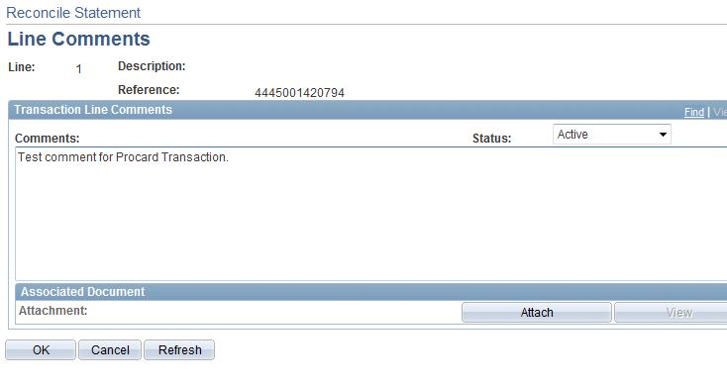
When a transaction is determined to be acceptable, click the Drop-down box in the “*Status” column and change the status from “Verified” to “Approved. Optionally, after you have reviewed and reconciled ALL transactions, you may click the “Select All” link and then click the “Approve” button to change the status from “Verified” to “Approved” for all transactions at once.
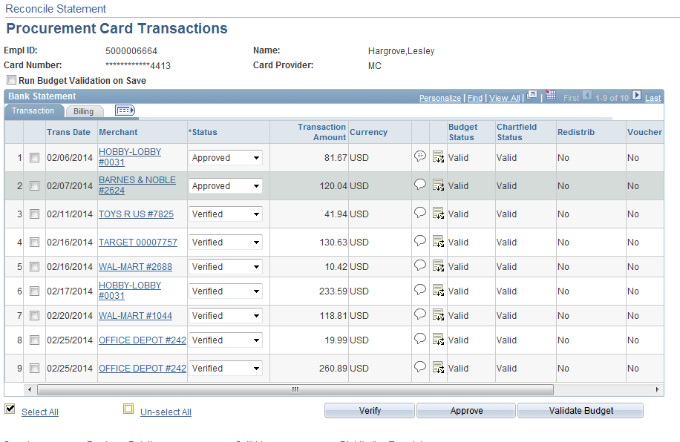
When all transactions have been Reconciled for this cardholder and “*Status” changed from “Verified” to “Approved”, click the “Save” button at the bottom left corner of the screen. Note, if necessary, you can “Save” your work before all transactions have been marked for Approval and log in later to complete the Review and Approval process.
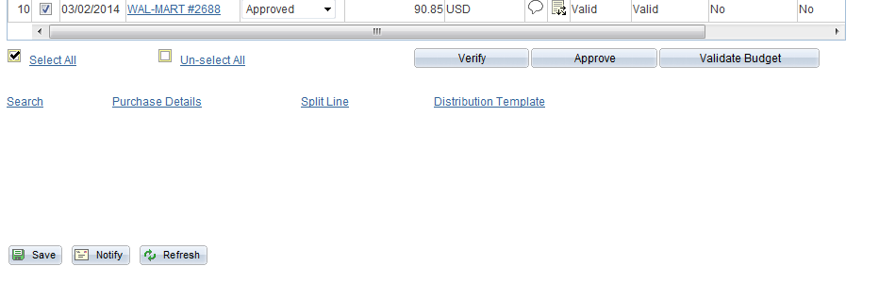

Please note that often the “Save” button is below the bottom horizon of the screen. You must scroll down to click the Save button!

