Account Reconciliation Process – Reconciliation Report

  - Major Steps
- Run Statement of Accounts (Reconciliation Report)
- Review support for transactions and perform reconciliation (Page 5)

Run Statement of accounts
Security Requirements: Campus ISA should assign the UTZ_FI_KK_REVIEW_BUDGETS to end users who will perform account reconciliations
  - Menu Navigation:

Click Add a New Value:
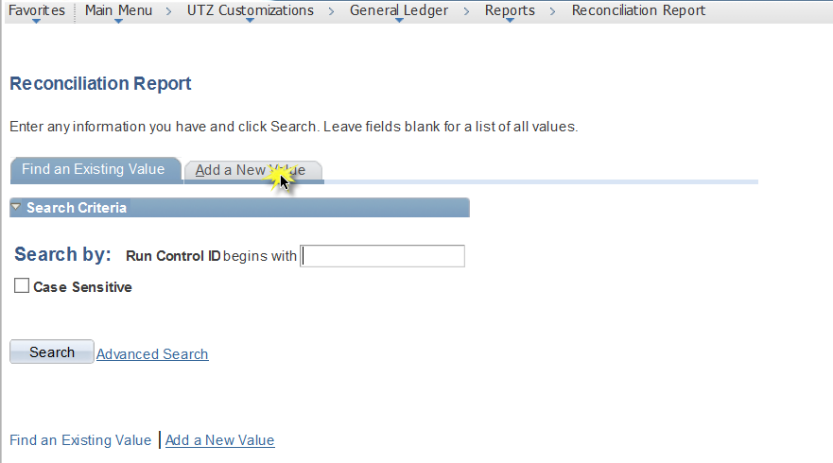
Add a New Value:
Enter Run Control Parameters
Enter required fields denoted by asterisk. Report is able to span multiple periods Ex. Sep - Nov 2015
Enter Department, Project ID or Cost Center

- Create new run control with ID
- Select business unit, Fiscal Years, Accounting Periods. Expanded run control allows for report to be run for multiple periods.
- Report may be run by department, cost center or project ID. Only one parameter is required
- Click run
Detail and Summary report could be viewed in Report manager:

Select the Format and Click Ok. Reports are available in PDF and Excel (XLS)
Detail and Summary report could be viewed in Report manager:
Detail and Summary report could be viewed in Report manager:
File name includes department ID, project ID or cost center and process instances for run control. Detail report is identified by DTL in file name.
Ex: Summary: UTARL 315201 551086.xls (Business Unit, Department, Process Instance) Detail: UTARL 315201 551086 DTL.xls
Click on hyperlink to access report(s).
Report will provide a summary and transactional information for department, cost center and/or grant/project. Summary report includes high level overview of expenditures.
Detail report will include transactional data with identifying information such as Departmet ID, Cost Center, Document Type, Document ID, Vendor Description, etc for amounts included in summary: . Note: when downloading to excel, data by account will display in multiple tabs.

Summary
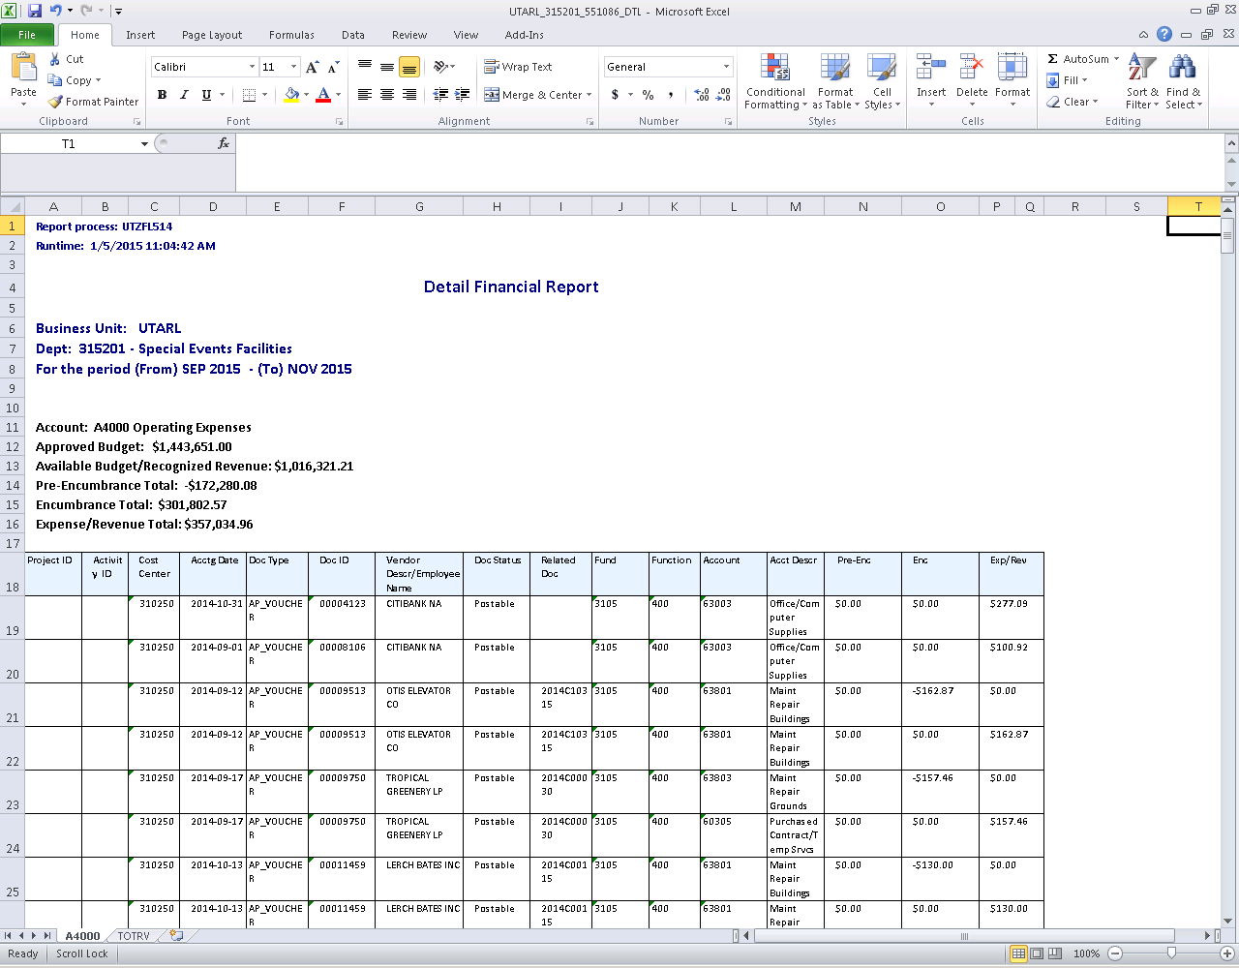
Detail

Review Support for Transactions and Perform Reconciliation

- Review source documentation for all transactions on file (invoices, receipts, and etc.).
- Verify that all expenses were authorized for payment against cost center, department, grant, or capital project.
- Forward to Reviewer and Approver to sign and date.

General Information

- Months typically close on the 5th working day of the following the month.
- Reconciliations are to be performed within two months of the close of the month.
- Records Retention Schedule notes that reconciliation should be kept for current fiscal year + three years.
For assistance regarding transactional data included, contact Budget and Financial Reporting Office at budget@uttyler.edu.

