This report is designed to allow faculty to run a report of their University Course Evaluation results for a selected semester. The report may be run at any time during the year, and for any semester from Fall 2010 forward, except during the evaluation period each term.
1. Be sure pop-up blockers are either turned off in your browser or set your browser to always allow pop-ups from sis-cs-prod.uttyler.edu.

NOTE: Follow these set-up steps a. through c. only for the first time you retrieve your course evaluation report. From then on, go directly to the Course Evaluation Report link.
a. Click on the “Faculty/Staff Home Page” tab:
b. On the right side panel, click “Set User Defaults”, type in the “SetID” box “UTTYL” as shown:
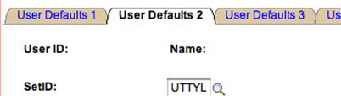
c. Click Save.

2. In myUTTyler, navigate to the System Access and click on Course Evaluation Report.
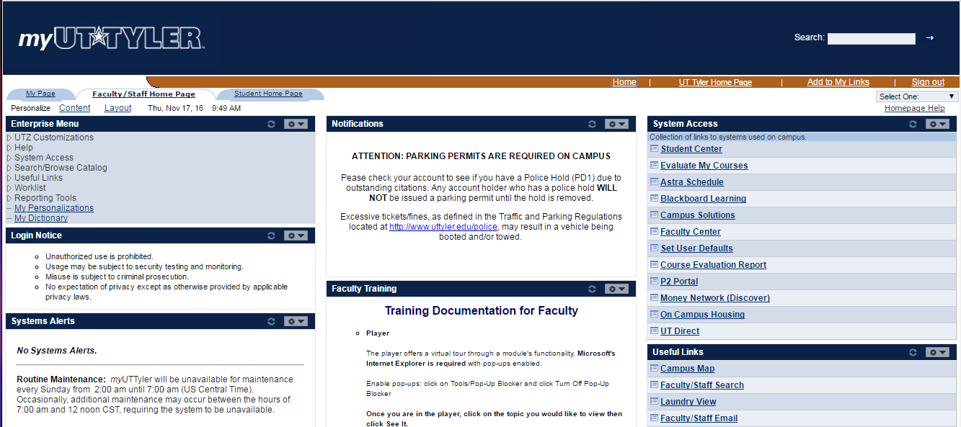

3. Course Evaluation Summary Rpt
(If you have previously set up a report name, go to Step 3b.)

3a. For first-time report setup: Click “Add a New Value”. In the Run Control ID box, type a generic display name that will help you to identify your report for now and for future semesters; ex: “Course_Eval_Rpt”. Name should have no embedded spaces. This initial setup is done only once.
Click Add.
Go to Step 4.
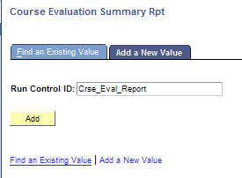
3b. Once setup (Step 3a) has been created, simply click “Find an Existing Value” and click Search to find the report name you set up in Step 3a. Click on the name of the report in Run Control ID column.
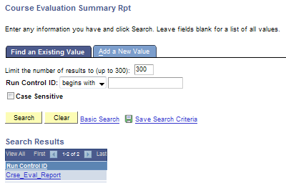

4. Course Evaluation Summary Report
Term: Type in the term code of your choice. Use the magnifying glass for help with Term codes. Type in the calendar year in the Description Begins With field to see codes for Fall, Spring, Summer of that year.
Session: Select “Regular” for the normal long session or select another session code, as appropriate for your class(es).
Include Student Comments on Report?: Check the box to have the comments included in the report.
Click Run
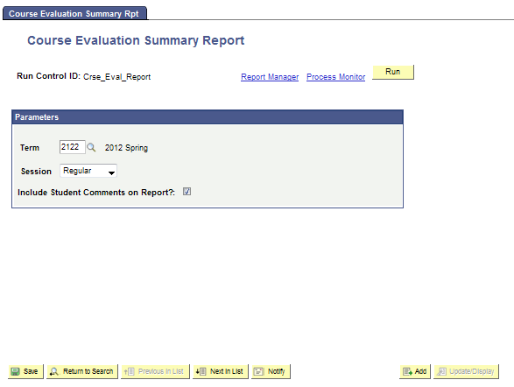
5. Process Scheduler Request page will display.
Type: Email
Format: PDF
Click Distribution
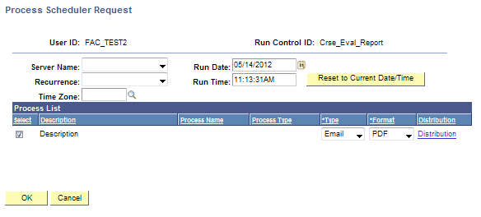

10. Distribution Detail
Folder Name: Leave blank.
Retention Days: Leave at 7.
Email Subject: Add any text that will be meaningful for you when it hits your Outlook Inbox.
Message Text: Add any text desired.
Email Address List: You may enter an email address here if you wish to send a copy to someone other than yourself.
ID Type: Select “User”
*Distribution ID: Your User ID should default here in all caps, such as “JRFACULTY”. (This is the User ID you use to log in to myUTTyler.) This information is used to find your email address, which is stored elsewhere in the system.
Click OK

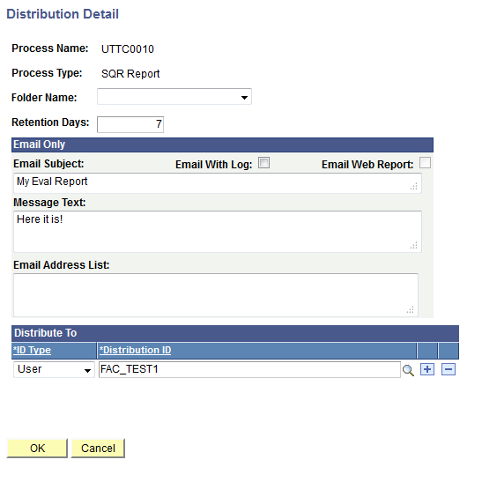

11. You will be returned to the Process Scheduler Request page.
Click OK
Your report should only take a few minutes to run.

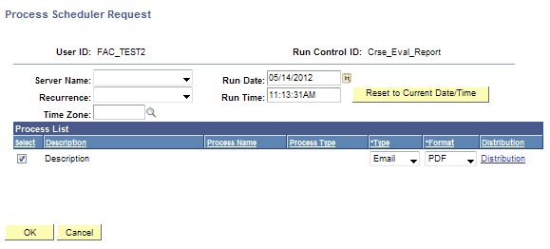

12. You are returned to the Course Evaluation Summary Report page. Notice near the upper right corner there is a Process Instance number displayed. This indicates that your report is running.
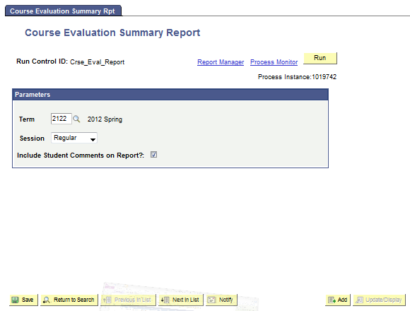

13. Check your email. The sender address will be tcsprd@uttyler.edu. Your report will be an attachment.

14. Save the PFD report to your files for future reference.
15. For assistance with this report, email instructorevals@uttyler.edu.

