**Create a Travel Authorization**

**Navigate  to Navigator > Financials> Travel & Expense > Travel & Epxense Center > Travel Authorization > Create/Modify**

**OR**

**Click on the center drop down and scroll to Travel & Expense then click on the Create Travel Authorization tile.**

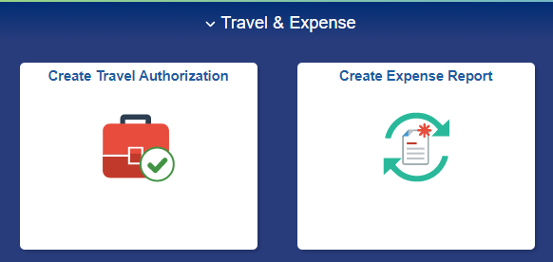

Enter the **Empl ID –** Click **Add OR** Click on the Search icon and type in the last name and click on  **Look UP –** Choose the correct Employee **-** Click **Add**

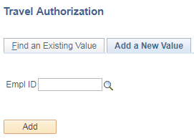 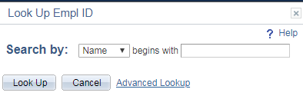

On the Create Travel Authorization screen:

* Select the **Business Purpose** (drop down)
* Enter the **Description** of travel (for example: Attend Conference, or Student Recruiting)
* Select the **Default Location** (click on look up icon)
* **Comment** about the travel (you may enter a trip estimate or attach an estimate spreadsheet)
* **Reference –** (not used for Travel Authorizations)
* Select the **Date From** and **Date To** (actual dates of the trip)
* Select the **Benefit** (drop down)
* Select the **Disposition of Duties** (drop down)
* If the traveler is going to Washington DC
  + Click on the **No** drop down and select Yes
  + Click on the **Purpose** drop down and select the appropriate purpose.

Please note that UT Tyler does not use Quick Fill for a TA since we only create one Expense Type line as an encumbrance placeholder.

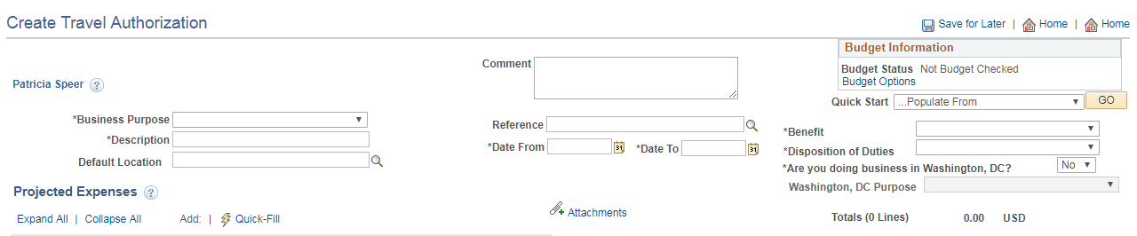

Under the Projected Expenses section of the screen:

* Enter the **Date**
* Select the **Expense Type** (scroll down to TA-Travel Auth-Encumbrance)

*This generates the **Accounting Details** and **Speed Chart** fields.

* Enter a **Description** (or copy **Description** from above)
* Select a **Payment Type** (drop down)
* Enter the **Amount** as .01 (unless encumbering funds for end of fiscal year travel)
* Click on the **+** plus sign to add more lines
* **Billing Type** auto fills and does not need to be changed.
* Enter the **Speed Chart** cost center or project number

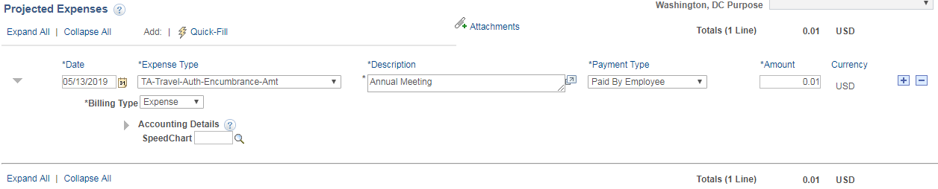

To see the full Chartfield string click on the arrow in front of the Accounting Details.

If the Accounting Details have been set for the traveler to the correct cost center etc., then the speed chart may not be needed.

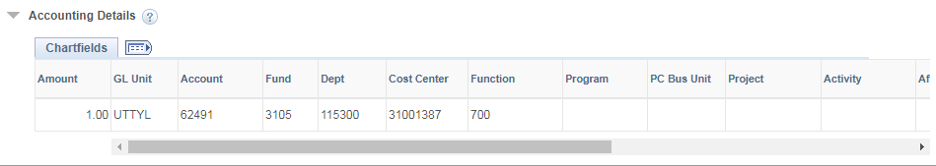

Leave the Accounting Details as is or change the funding information as directed by the Budget authority.

* Click on the **Attachments** hyperlink to add attachments (for example: cost estimate spreadsheet or conference registration information).

After all lines have been entered, click on **Save for Later** and an Authorization ID will be assigned and the document status will show “Pending”.

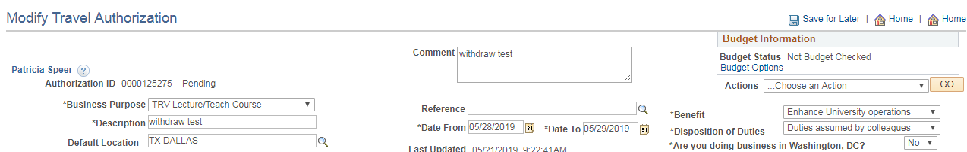

Click on the **Budget Options** hyperlink. A Commitment Control Screen will open.

Click on the **Budget Check** button to run the process.

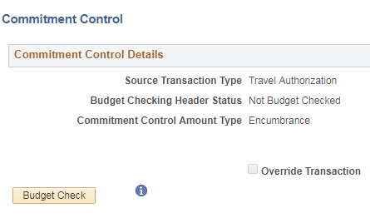

The screen will show a status of **“Valid**” or **“Exception”.**

If the budget check process results in a Valid status, click the **OK** button at the bottom of the page.

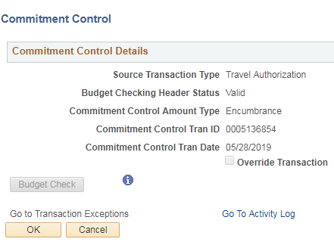

If Budget Check process results in an Exception message

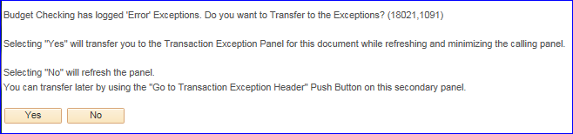

Determine whether the chart fields are all correct and fix, or contact the Budget team ([budget@uttyler.edu](mailto:budget@uttyler.edu)) for assistance.

After Budget Error has been resolved, rerun the Budget Checking process and when Budget Check is complete and valid, click on the **OK** button.

Click on the **Summary and Submit** hyperlink to review and submit the travel authorization.

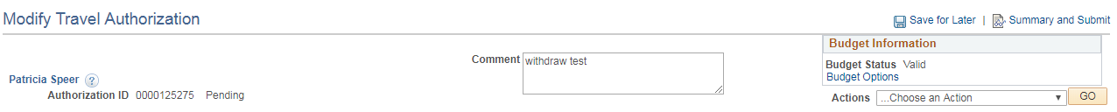

If changes need to be made, click on the **Travel Authorization Details** hyperlink and the previous page is shown. Make the necessary changes, Save for Later, re-Budget Check, re-Submit.

When complete, click on **Submit Travel Authorization** button to finalize the report. Note there are two **Save** for Later buttons.

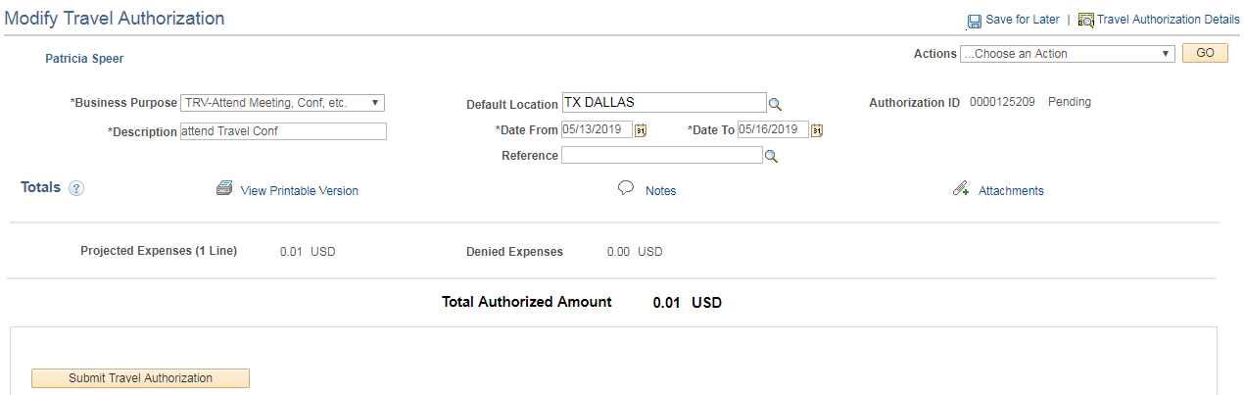

Click the **OK** button to complete or click the **Cancel** button to return to the Travel Authorization to make any needed changes.

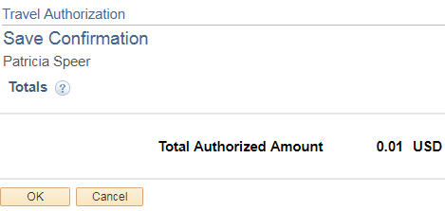

If the **OK** button was clicked then the travel authorization is submitted for approval.

Click on the **Refresh Approval Status** button to see the Approval History.

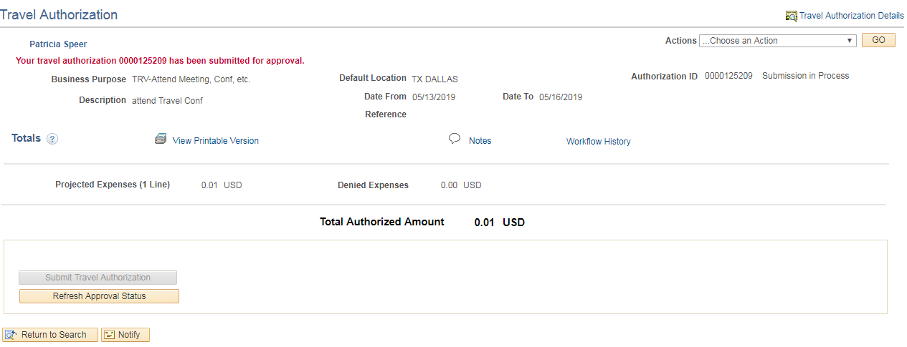

The Approval History shows whose workflow the report is waiting on.

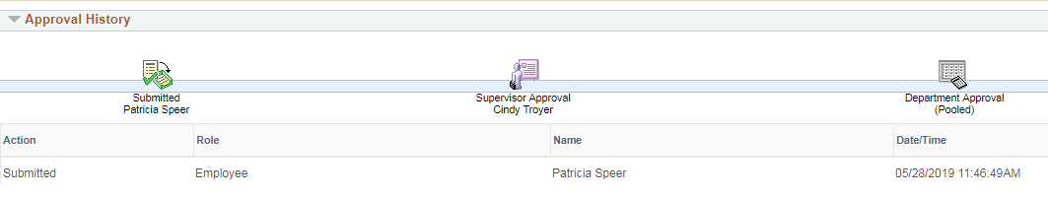

The **Supervisor Approval** is determined by the traveler employee’s HR assigned “Reports To “supervisor.

The **Department Approval** is the Budget Authority for the Department code (or codes) used in the Accounting Details.

The Reports To Supervisor may or may not be the same person as the Department Budget Authority.

Clicking the **Withdraw Travel Authorization** button will open the report back up to make any needed changes or add attachments.

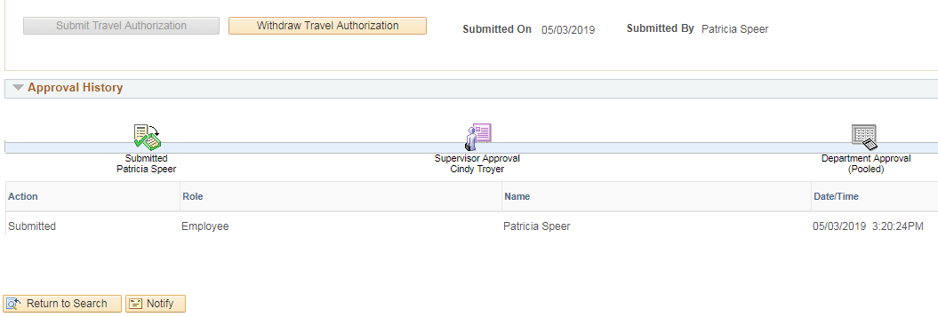

Click the **Refresh Approval Status** button until you see the red “Your travel authorization ### has been withdrawn from approval queue”.

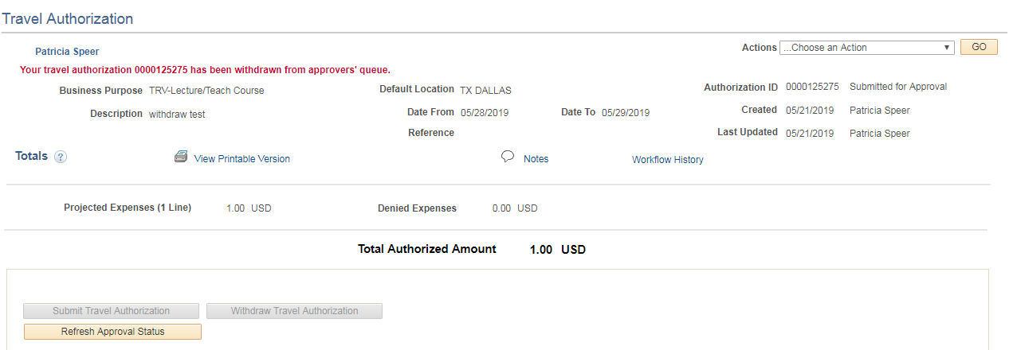

Navigate back to Travel Authorization > Create/Modify > Find an Existing Value and key in the Report ID. The report is now open for changes to be made.

Once all changes are complete, follow the same steps as were used when creating the Travel Authorization: Save for Later – Budget Options - Budget Check – OK – Summary and Submit – Submit Expense Report – OK and the Travel Authorization is once again submitted for approval.