eSHOP Managing Assignees

Table of Contents
Overview 2
Add Assignee to Profile 2
Assigning a Substitute 3

Overview
A Cart Assignee is a Requester who is authorized to submit carts into UT Share PeopleSoft. When you select a Requester and specify him/her as your preferred Cart Assignee, the cart for all of your subsequent orders will automatically be assigned to that Requester. When submitting the cart, you can reassign any of these carts to a different Requester, if needed.
As an assignee, you can reassign carts that have been assigned to you or allocate a substitute assignee for any purpose.

Add Assignee to Profile

- From the eSHOP homepage, access your profile by clicking your name and selecting the View My Profile link.
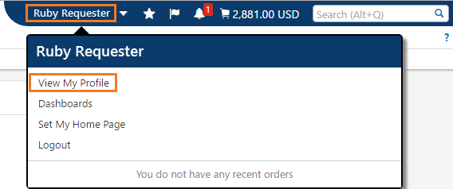

- Within your profile, click on Default User Setting > Cart Assignees.
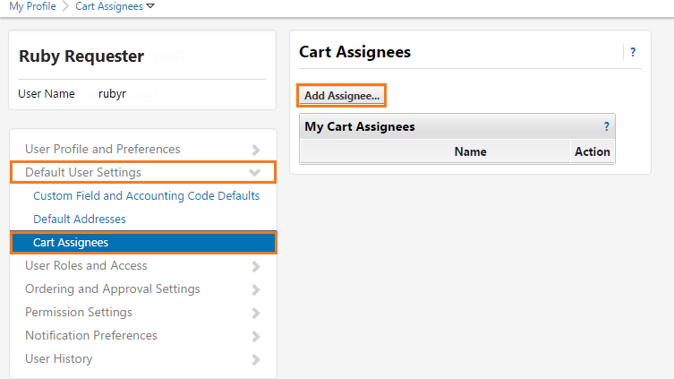

- Click the Add Assignee button.

- In the resulting pop-up window, enter the search criteria and press the Search button.
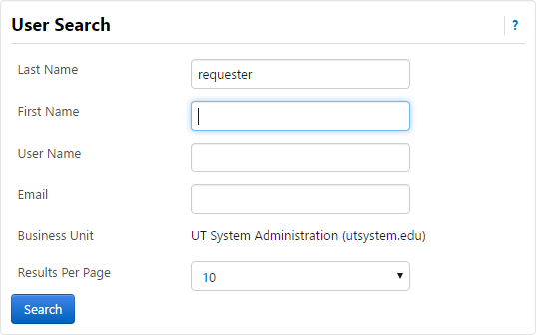

- In the resulting window, click the [select] link next to the desired Requester.
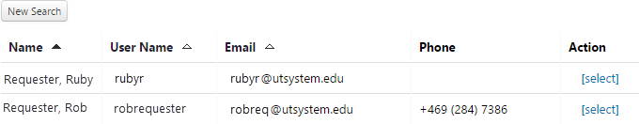

Assigning a Substitute

Users can set up a substitute assignee in any event they cannot process any carts. Cart submitter will receive an email notification informing that the cart has been delegated to your substitute. Users can also remove the substitute as necessary.

- Login to eSHOP
- Navigate to Draft Shopping Carts
  - Side Navigation Shop > My Carts and Orders > View Draft Shopping Carts
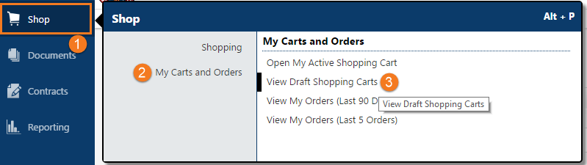
- Click the Assign Substitute – Located between Create Cart button and My Drafts lists.

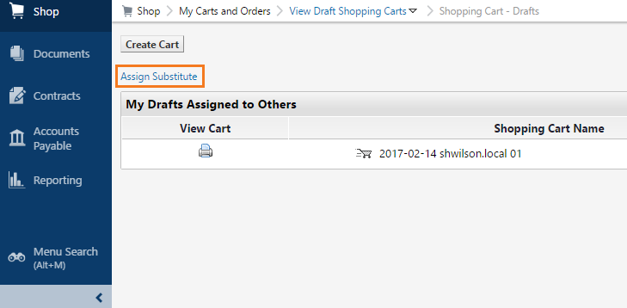

- A Search pop up will display. Enter the appropriate search criteria to find your Substitute Assignee.
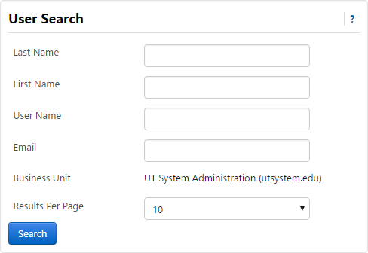

- Click Search.
- Search Results will display, choose the correct substitute by clicking the Select action link.
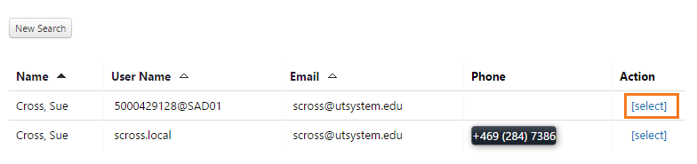

- Notice your current substitute will show

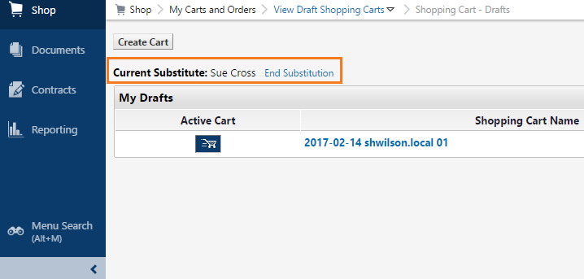

- Click the End Substitution Link to cancel the substitution and return yourself as the assignee.

