eSHOP Profile Management

Table of Contents
User Profile and Preferences 2
Update your name, phone number or email addresses. 2
Cart Assignees 3
Add Assignee to Profile 3
Notification/Email Preferences 5
To access your notification/email preferences: 5

User Profile and Preferences

Update your name, phone number or email addresses.

- Click your name in the Top Banner 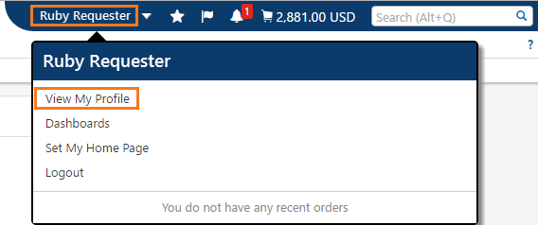
- Click View My Profile
- Make necessary change(s) to User Name, Phone Number, Email etc. page 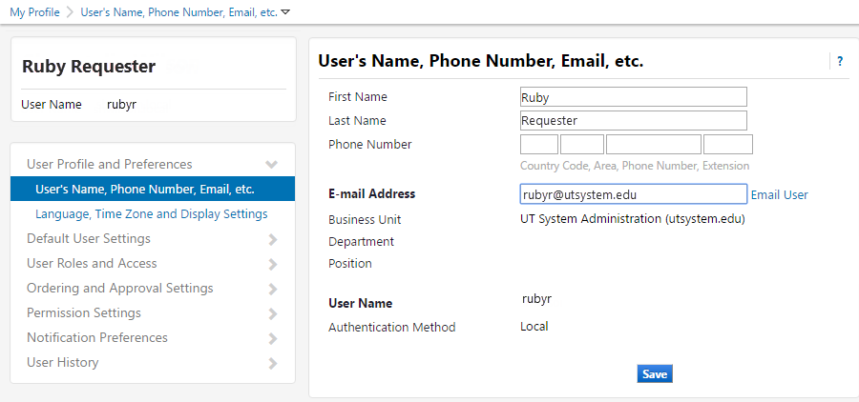
- Click Save
- Click Language, Time Zone and Display Settings, make necessary changes to that page. 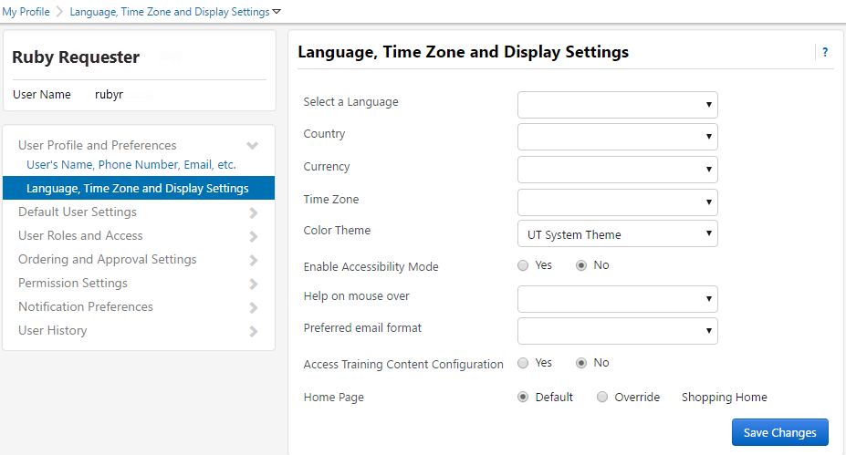
- Click Save Changes

Cart Assignees
A Cart Assignee is a Requester who can submit carts into UT Share/PeopleSoft. When you select a Requester and specify him/her as your preferred Cart Assignee, the cart for all of your subsequent orders will automatically be assigned to that Requester. When submitting the cart, you can reassign any of these carts to a different Requester, if needed.

Add Assignee to Profile
- From the eSHOP homepage, access your profile by clicking your name and selecting the View My Profile link.
- Within your profile, click on Default User Setting > Cart Assignees.
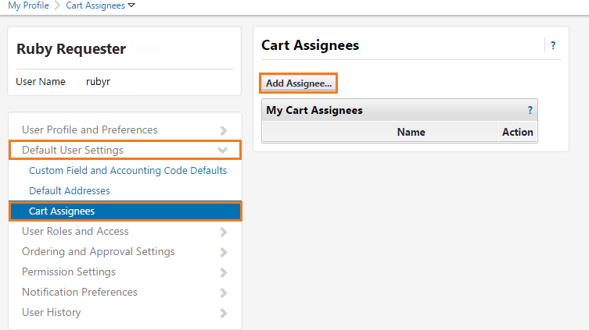
- Click the Add Assignee button.
- In the resulting pop-up window, enter the search criteria and press the Search button. 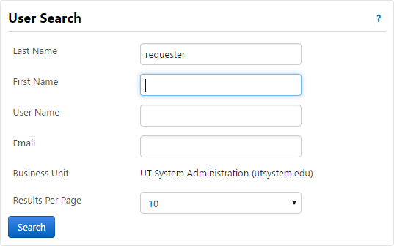
- In the resulting window, click the [select] link next to the desired Requester.
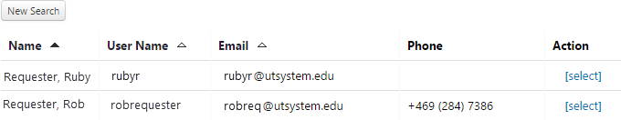

Notification/Email Preferences
For each system generated notification/email message, you have the ability to choose the way you want to receive the information. The options are:
- None – no message is sent
- Email – a message is sent to the email address stored in your eSHOP profile
- Notification – a message is available under Notifications in the eSHOP Top Banner
- Email & Notification: a message is sent via email AND displayed under Notifications in the eSHOP Top Banner

To access your notification/email preferences:
- Click your name in the banner
- Click View My Profile
- Click Notification Preferences in the side menu, a sub menu of links will display.
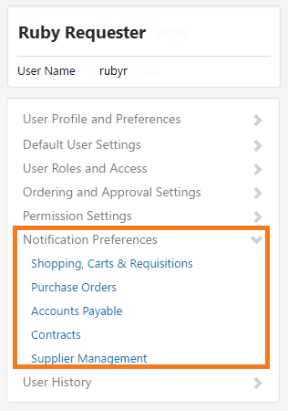
- Click the area in which you wish to set a notification, i.e. Shopping, Carts & Requisitions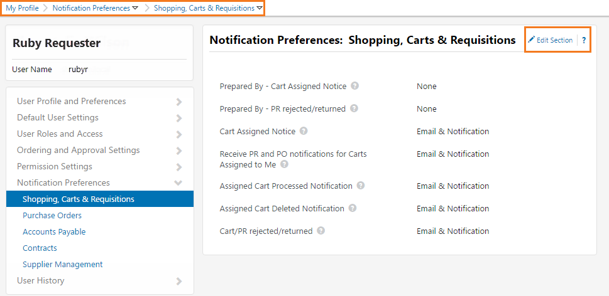
- Click Edit Section to make changes
In Edit Mode, you can choose the system default, or override the default with your choice from the drop down list. 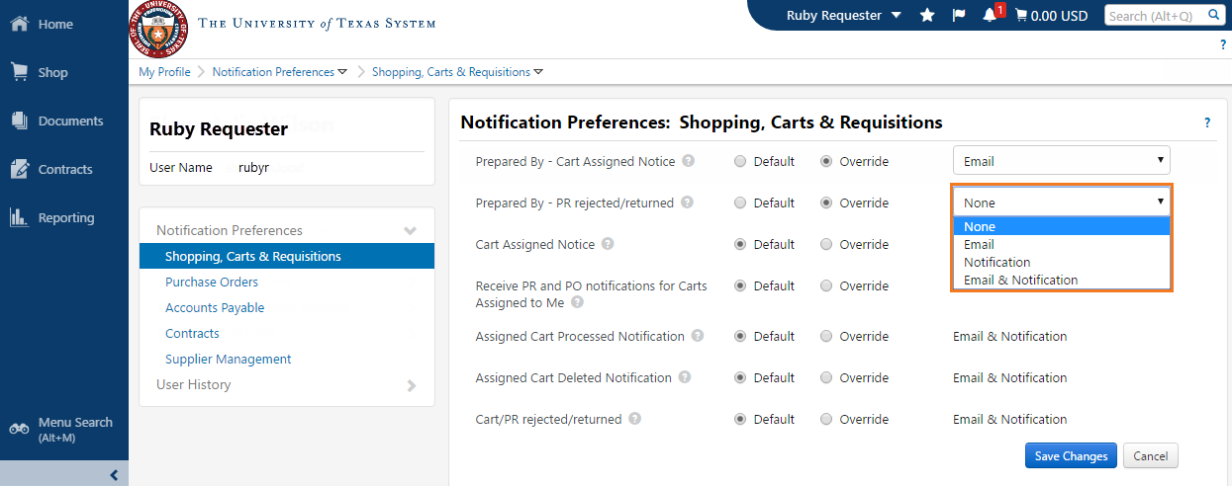
- Click Save Changes when finished

