The University of Texas at Tyler
UT SHARE / PEOPLESOFT
Expense Reimbursement Procedures for
Employee / Payee Certification
Financial Services highly recommends that you choose Chrome as your browser for entry, certification and approval in UT Share/PeopleSoft.

Employee Certification through notification by email:

Employees will be notified by email that a reimbursement is in process for them which requires their review and certification of the charges.

Note: The email address that is on file with Human Resources is used to generate the email notification.

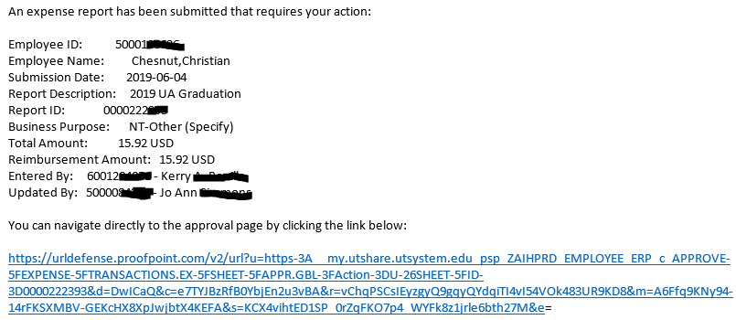

Click on the blue hyperlink to navigate to the expense report.

Enter your entire email address and university single sign-on password if you are not already logged in.

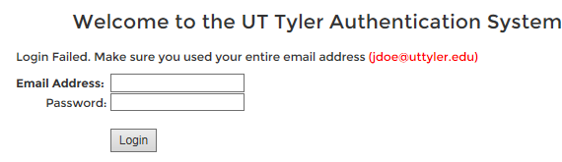
If you deleted the email notification, you can also login directly to UT Share/PeopleSoft.

Employee Certification through your “Worklist”:

After you have logged in, click on the “Worklist” hyperlink.

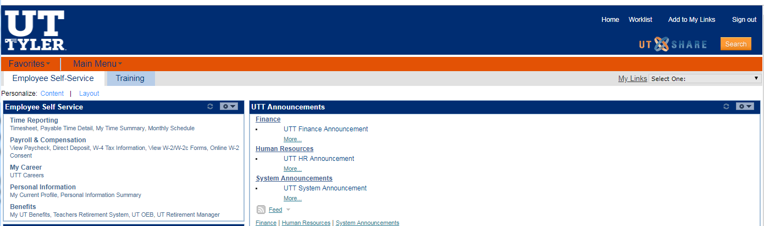

The following screen populates.

Click on the link showing your name.

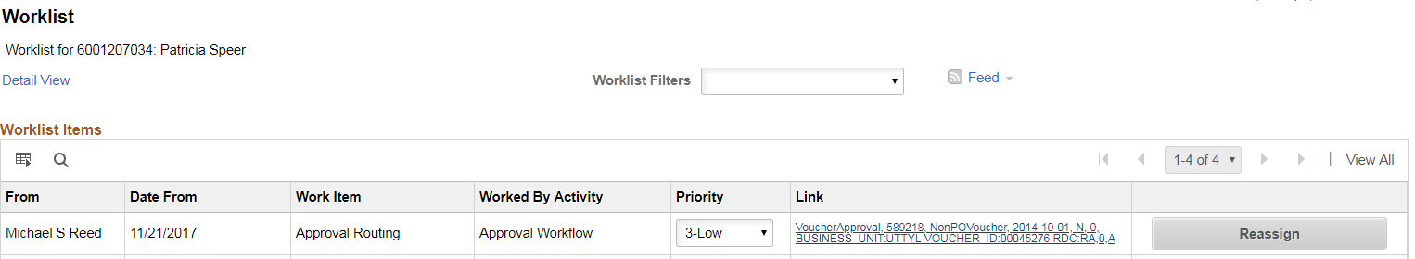

After choosing one of the two options to locate the Expense Report, you are ready to review and certify your reimbursement.

Verify that all information is correct and complete, then click on one of the two options available.

- Click the “Reviewed” button if all information is correct.

- Click the “Send Back” button for revision, if the information is incorrect.

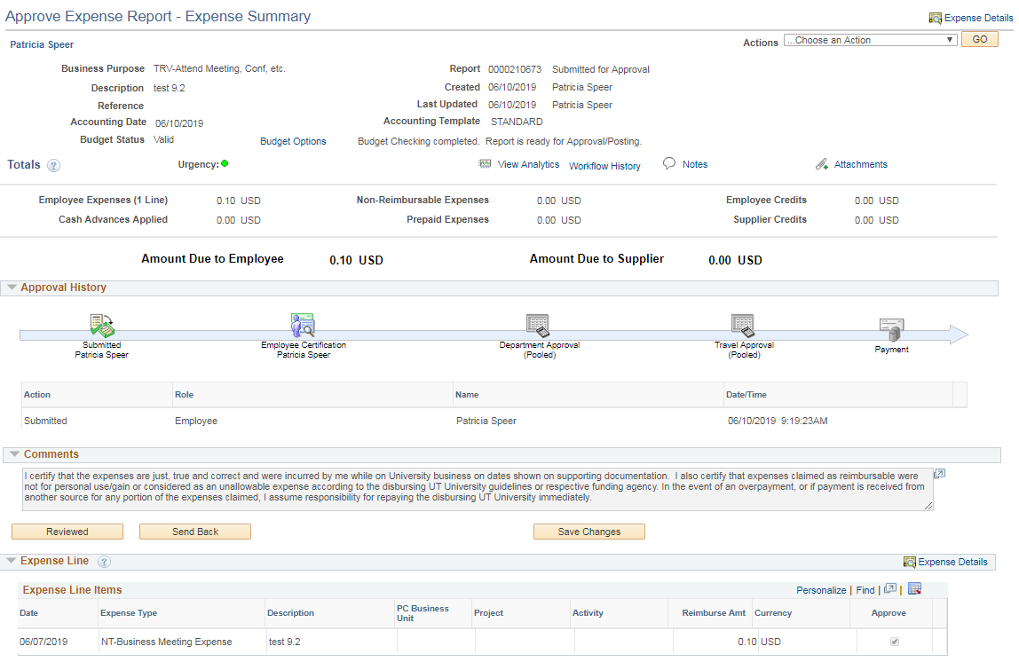

After clicking the “Reviewed” or “Send Back” button, you should get a pop-up box with an “OK” or “Cancel” button.

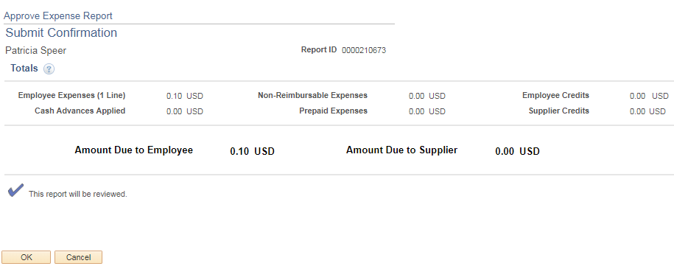

- By clicking the “OK” button, you are completing the Employee Certification. Next the document routes to the Budget Authority.

- By clicking the “Cancel” button the Expense Report page will populate and allow further review or allow you to “Send Back” the document to the creator for corrections.

Note: By clicking on the “Reviewed” button, you are agreeing with the certification statement found in the “Comments” section which reads in full:

“I certify that the expenses are just, true and correct and were incurred by me while on University business on dates shown on supporting documentation. I also certify that expenses claimed as reimbursable were not for personal use/gain or considered as an unallowable expense according to the disbursing UT University guidelines or respective funding agency. In the event of an overpayment, or if payment is received from another source for any portion of the expenses claimed, I assume responsibility for repaying the disbursing UT University immediately.”

June 2019

