UT Tyler - UT Share / PeopleSoft
Department Reconciliation and Processing for Procard Transactions

To reconcile Procurement credit card transactions:

After logging in to the UT Share/PeopleSoft accounting system, the assigned Reconciler will navigate to

Purchasing> Procurement Cards> Reconcile> Reconcile Statement

Reconciliation requires a review of individual transactions by merchant, date, amount, and chart field distribution for validity and appropriate accounting.

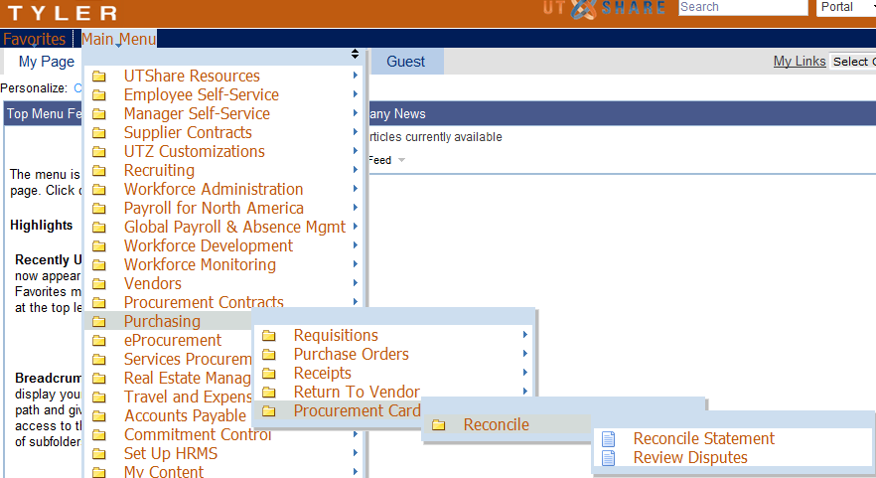
On the resulting screen, select appropriate Role Name, Employee ID and/or name of one of your cardholders. Select Statement Status of “Staged” then click the “Search” button. NOTE: If you only reconcile ONE Procard account, PeopleSoft will direct you to that set of transactions without having to Search.
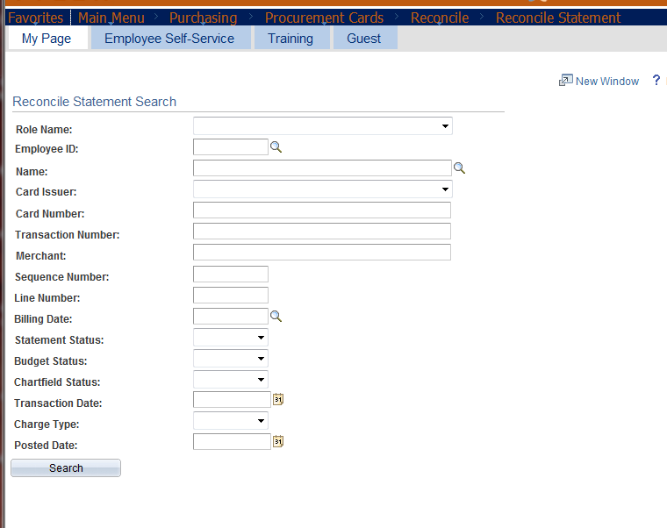
Once cardholder transactions populate the screen, verify that all transactions agree to receipts and required Procard Log. Note, as with other UT Share/PeopleSoft screens, you may click the “View All” link to view more transactions than show on the screen initially.
Note any discrepancies to discuss with cardholder. NOTE: ALL CHARGES MUST BE RECONCILED, SHOW A BUDGET STATUS OF VALID, BE APPROVED AND PAID. If there is a discrepancy, the cardholder must either work with the vendor to obtain a credit (applied to a future month’s statement) or if a charge is unauthorized, the cardholder must work with Citibank. Citibank will credit fraudulent charges on a future month’s statement.
Click on the more detail for “Distribution” icon (looks like a page with 3 arrows in bottom right corner).

The default Account Code on all Procard transactions is 63003 for “Office/Computer Supplies”. If this is not correct for the transaction you are reconciling, click on the magnify glass search icon and search for an Account Code which appropriately represents the transaction. Please note: Expenditure Transactions begin with a “6…” If you believe that an Account Code starting with some other number is the one you should use, please contact Accounts Payable to discuss BEFORE selecting it.

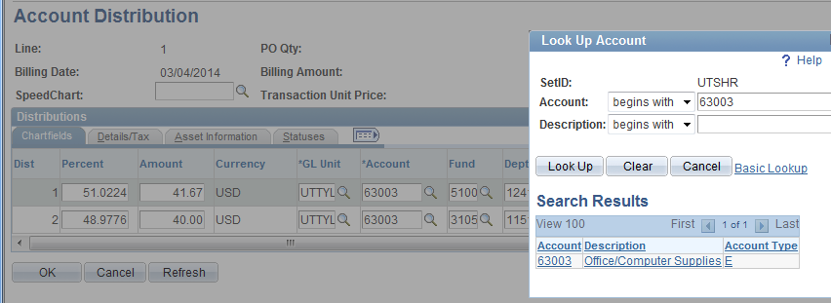

Review budget chart fields. If charges should be posted to a different set of Budget chart fields or split between two or more sets of chart fields, pull the scroll bar all the way to the right side and click the “+” or “-“ button depending on what your intention is and what is needed. DO NOT use the “Speed Chart” field; it has not been programmed for the UT Shared project use.
Click the “OK” button once changes to the Account Code and funding chart fields are complete.
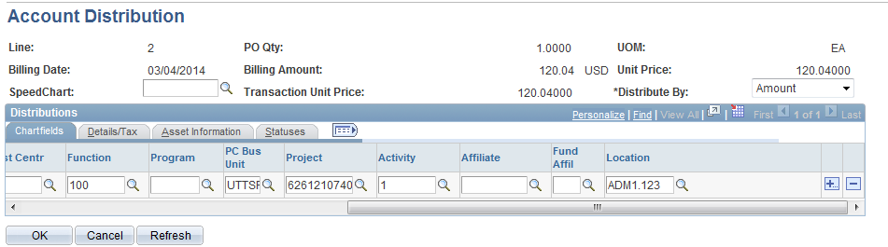
NOTE: The Account Distribution screen is also the screen to review an ERROR “Budget Status.”
If you have made changes to ANY of the chart fields, including the Account code, the Budget Status of your Reconcile Statement screen will have changed from “VALID” to “NOT CHK’D.”
Click the CHECK BOX on the left side next to the transaction number of EACH row showing “NOT CHK’D” then click the “VALIDATE BUDGET” button. It will take a few seconds to process. When it has finished processing the Budget Status SHOULD have changed to VALID. If so, you may then mark this transaction to Verified. If the Budget Status shows “ERROR”, STOP, do NOT mark the transaction to Verified. Send an email to Budget@uttyler.edu and include screen shots of the Error details shown on the Account Distribution screen. Once the Budget Office has run their process OR once you have changed the funding chart field string to a set that has good funding, you can click the “VALIDATE BUDGET” button again to see if the transactions process to a VALID status.
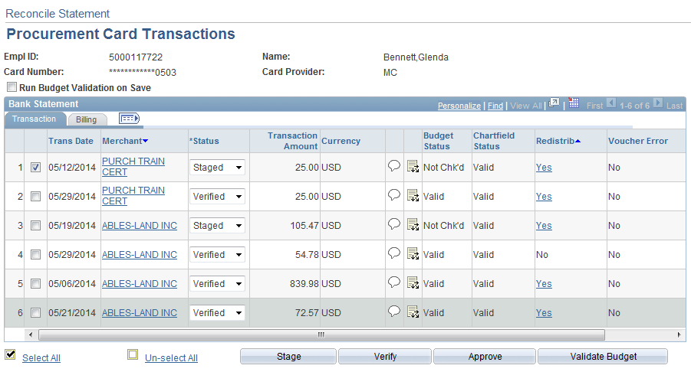

Enter Comments as needed for each transaction by clicking on the Comments “balloon” icon.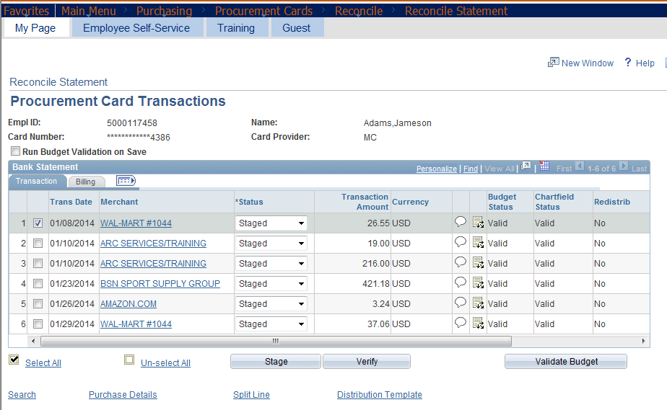
Attach receipts or other purchase supporting documentation and the signed Procard Log for each* transaction by clicking on the “Attach” button then clicking on the “Choose File” button. After your file has been selected, click the “Upload” button to complete the action.
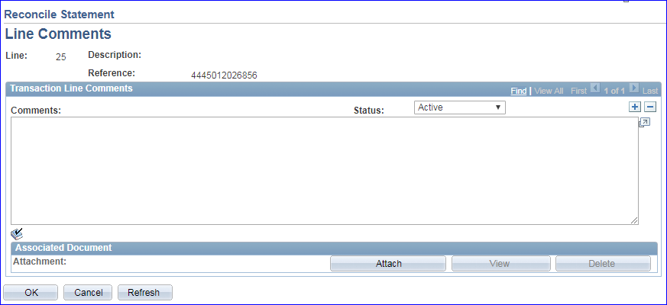
After Comments have been entered and supporting documents attached, click the “OK” button when done to return to the Reconcile Statement screen. If nothing is entered or attached, you may click the “Cancel” button to return to the Reconcile Statement screen.
Please do NOT enter a “Description” on the Billing tab. Entering information in this field overwrites the merchant information that should populate the payment voucher. The merchant information is required on payment vouchers for state required Historically Underutilized Business (HUB) reporting.
Instead, please use the Comments “balloon” icon as described above.
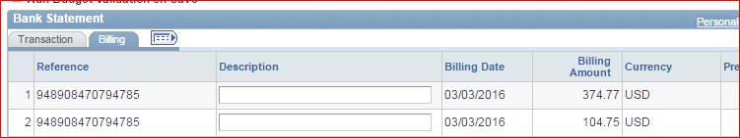

As each transaction is reconciled, budget chart field information verified, and Budget Status shows VALID, you may click the Status Drop down box and change the status from “Staged” to “Verified” OR after you have reconciled ALL transactions and ALL transactions show a Budget Status of VALID you may click the “Select All” link and then click the “Verify” button to change the status from “Staged” to “Verified” for all transactions at once.
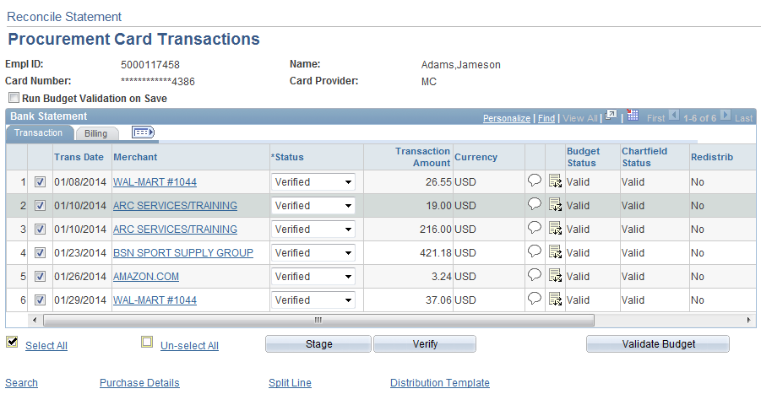

When all transactions have been Reconciled and show a Budget Status of “VALID” for this cardholder and “*Status” changed from “Staged” to “Verified” for all transactions, click the “SAVE” button at the bottom left corner of the screen. Note, if necessary, you can “SAVE” your work before all transactions have been marked as “Verified” and log in later on to complete the Reconcile and Verify process.
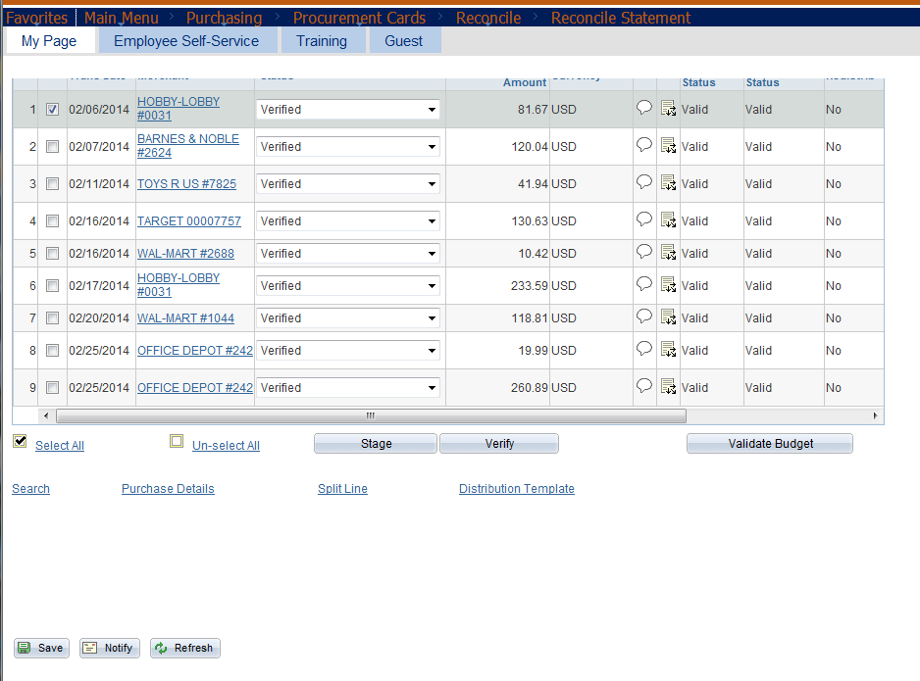
Note: There are NO automated notifications generated from PeopleSoft to let the assigned Reviewer/Approver know it is his/her turn to access the Procard transaction data to Review and mark the transactions to Approved status.
It is the Admin Assistant/Support Specialist Procard Reconciler’s responsibility to notify the assigned Reviewer/Approver when transactions show a Budget Status of “VALID” and have been marked “VERIFIED” so the assigned Reviewer/Approver may Review and Approve the transactions to facilitate payment processing prior to the Procard Payment Deadline.
Note: There is NO electronic Workflow for Procard transaction processing. The assigned Reviewer/Approver must login to PeopleSoft using the same navigation you do to get to the transactions and look at the same transaction data on the same screens you do.
*Attachments - Once transactions are marked to a “Closed” status, they are no longer grouped together the same way as when they were in “Staged” or “Verified” status. It is strongly recommended that if you normally scan all receipts together with the signed Procard Log and monthly cycle statement that you attach this multi-page file to EACH Procard transaction. For audit or reconciliation purposes, it will be much easier if each transaction has the file and you don’t have to click through many transactions to find one attachment for the month.
Version 03/2018

