DISSERTATION TITLE
(DOUBLE-SPACED, CENTERED, AND ALL IN CAPS WITH NO BOLD OR ITALICS)

by

YOUR NAME (CAPITALIZED)

A dissertation submitted in partial fulfillment
of the requirements for the degree of
Doctor of Philosophy in Nursing
School of Nursing

Name of Committee Chair
College of Nursing and Health Sciences

The University of Texas at Tyler
Month, Year

The University of Texas at Tyler
Tyler, Texas

This is to certify that the Doctoral Dissertation of

YOUR NAME (CAPITALIZED)

has been approved for the thesis/dissertation requirement on
(your defense date)
for the (your degree) degree

Approvals:

__________________________________
Thesis/Dissertation Chair: Name
(triple space between text and lines)

__________________________________
Member: Name

__________________________________
Member: Name

__________________________________
Member: Name

__________________________________
Executive Director, School of Nursing

___________________________________
Dean, College of Nursing and Health Sciences

Copyright (year) by Your Name
All rights reserved.

Dedication

Acknowledgments

Table of Contents
List of Tables ........................................................................................................................... v
List of Figures.......................................................................................................................... vi
Abstract.................................................................................................................................... vii
Chapter 1: Title…………………………………………. ....................................................... 1
Heading 2……………………...................................................................................... 3
Chapter 2: Title…..................................................................................................................... 5
Abstract......................................................................................................................... 5
Heading 2.......................................................................................................................7
Heading 2……………….............................................................................................. 8
Heading 3…….................................................................................................. 8
Heading 3.......................................................................................................... 11
Heading 3.......................................................................................................... 13
Heading 3.......................................................................................................... 14
Heading 4.............................................................................................. 15
Heading 4.............................................................................................. 16
Discussion..................................................................................................................... 17
Co-Creating Value............................................................................................ 17
Implications...................................................................................................... 19
Conclusion ................................................................................................................... 20
References..................................................................................................................... 21
Chapter 3: Title………………………………………………………………………………. 25
Abstract......................................................................................................................... 25
Heading 2……………….............................................................................................. 27
Heading 2...................................................................................................................... 27
Heading 2...................................................................................................................... 28
Heading 3.......................................................................................................... 28
Heading 3.......................................................................................................... 29
Heading 3.......................................................................................................... 30
Heading 3.......................................................................................................... 31
Heading 2...................................................................................................................... 33

Heading 3.......................................................................................................... 33
Heading 2...................................................................................................................... 33
Heading 3.......................................................................................................... 33
Heading 3.......................................................................................................... 34
Conclusion ................................................................................................................... 54
References.................................................................................................................... 55
Chapter 4: Title…………......................................................................................................... 60
Abstract................................................................................................................................ 60
Heading 2...................................................................................................................... 62
Heading 2...................................................................................................................... 63
Heading 3.......................................................................................................... 63
Heading 3.......................................................................................................... 63
Heading 3.......................................................................................................... 63
Heading 2...................................................................................................................... 65
Heading 2...................................................................................................................... 68

Summary..................................................................................................................... 87
References................................................................................................................... 88
Chapter 5: Summary and Conclusions.................................................................................... 93
Heading 2………….................................................................................................... 94
Heading 2………........................................................................................................ 95
References................................................................................................................... 97
Appendix A. Title................................................................................................................... 99
Appendix B. Title................................................................................................................... 100
Appendix C. Title................................................................................................................... 109
Appendix D. Title................................................................................................................... 120
Appendix E. Title.....................................................................................................................121
Appendix F. Title.................................................................................................................... 121
Biographical Sketch................................................................................................................ 180

List of Tables
Appendix A. Chapter x Tables............................................................................................. 99
Table 1. Title of Table.............................................................................................. 99
Appendix B. Chapter x Tables............................................................................................. 100
Table 1. Title of Table.............................................................................................. 100
Table 2A. Title of Table........................................................................................... 101
Table 2B. Title of Table........................................................................................... 101
Table 3. Title of Table…………………………………………………….............. 102
Table 4. Title of Table.............................................................................................. 103
Table 5. Title of Table…………………………………………………………….. 104
Table 6A. Title of Table........................................................................................... 106
Table 6B. Title of Table........................................................................................... 106
Table 6C. Title of Table........................................................................................... 107
Table 6D. Title of Table........................................................................................... 107
Table 7A. Title of Table........................................................................................... 108
Table 7B. Title of Table........................................................................................... 108
Appendix C. Chapter x Tables............................................................................................. 109
Table 1. Title of Table.............................................................................................. 109
Table 2. Title of Table.............................................................................................. 110
Table 3A. Title of Table........................................................................................... 111
Table 3B. Title of Table........................................................................................... 112
Table 4. Title of Table.............................................................................................. 113
Table 5. Title of Table.............................................................................................. 114
Table 6. Title of Table.............................................................................................. 115
Table 7. Title of Table.............................................................................................. 116
Table 8. Title of Table.............................................................................................. 117
Table 9. Title of Table.............................................................................................. 118
Table 10. Title of Table............................................................................................ 119
Table 11. Title of Table............................................................................................ 119

List of Figures
Appendix D. Chapter x Figures..................................................................................... 120
Figure 1. Title of Figure.…………………………………………………….... 120
Appendix E. Chapter x Figures...................................................................................... 121
Figure 1. Title of Figure...................................................................................... 121
Figure 2. Title of Figure...................................................................................... 122
Appendix F. Chapter x Figures....................................................................................... 123
Figure 1. Title of Figure...................................................................................... 123
Figure 2. Title of Figure....................................................................................... 124

Abstract

FULL TITLE OF DISSERTATION (CAPITALIZED, Single spaced)
Your Name
Dissertation Chair: Name
The University of Texas at Tyler
Month, year
Start your abstract here…

Chapter 1: Title

Heading 2
Flush left, no caps, bolded, written in title case.
Heading 3
Flush left, bolded, written in title case, italicized.
Heading 4. Indented, bolded, written in title case, written in line with paragraph.

Chapter 2: Title
Abstract
Start your abstract here…

Chapter Title

Heading 2
Flush left, no caps, bolded, written in title case.
Heading 3
Flush left, bolded, written in title case, italicized.
Heading 4. Indented, bolded, written in title case, written in line with paragraph.

References
- Double space between entries; single space within each entry.

Chapter 3: Title
Abstract
Start your abstract here…

Chapter Title

Heading 2
Flush left, no caps, bolded, written in title case.
Heading 3
Flush left, bolded, written in title case, italicized.
Heading 4. Indented, bolded, written in title case, written in line with paragraph.

References
- Double space between entries; single space within each entry.

Chapter 4: Title
Abstract
Start your abstract here…

Chapter Title

Heading 2
Flush left, no caps, bolded, written in title case.
Heading 3
Flush left, bolded, written in title case, italicized.
Heading 4. Indented, bolded, written in title case, written in line with paragraph.

Summary

References
- Double space between entries; single space within each entry.

Chapter 5: Summary and Conclusion

Heading 2
Flush left, no caps, bolded, written in title case.
Heading 3
Flush left, bolded, written in title case, italicized.
Heading 4. Indented, bolded, written in title case, written in line with paragraph.

References
- Double space between entries; single space within each entry.

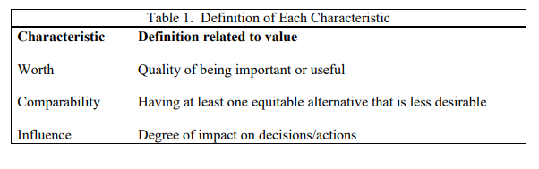
Appendix A. Chapter x Tables
- The title for each table (Table1. Title) should always appear on the top of the table
- Each table should be placed on its own separate page

Appendix B. Chapter x Tables
- The title for each table (Table1. Title) should always appear on the top of the table
- Each table should be placed on its own separate page

Appendix C. Chapter x Tables
- The title for each table (Table1. Title) should always appear on the top of the table
- Each table should be placed on its own separate page

Appendix D. Chapter x Figures
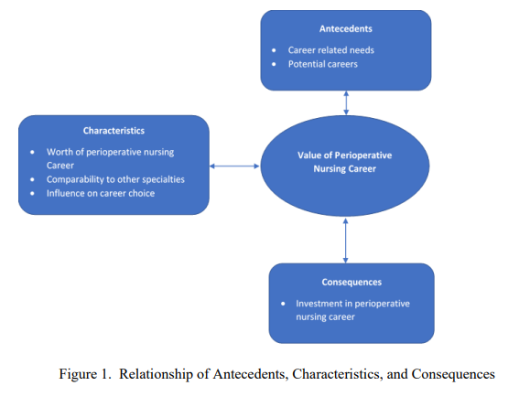
- The title of each figure (Figure 1. Title) should always appear at the bottom of the figure
- Each figure should be placed on its own separate page

Appendix E. Chapter x Figures
- The title of each figure (Figure 1. Title) should always appear at the bottom of the figure
- Each figure should be placed on its own separate page

Appendix F. Chapter x Figures
- The title of each figure (Figure 1. Title) should always appear at the bottom of the figure
- Each figure should be placed on its own separate page

Biographical Sketch

