University of Texas at Tyler
HIST 4397 Sites of History: WWII in Europe (Travel Abroad)
Maymester 2019, M-F: 9:00-10:40

Instructors: Dr. Mandy Link (Tyler) mlink@uttyler.edu & Dr. Matt Stith (Tyler and Europe) mstith@uttyler.edu
Group Leaders: Dr. Stith; Mrs. Misty Holmes mistyholmes@uttyler.edu; Dr. Emily Scheinfeld escheinfeld@uttyler.edu
Office: CAS 127 & 128
Office Hours: By appointment.

Course Description:
This course explores the Second World War in Western Europe through readings, discussion, lectures, and a trip to England, and France. We will tour major and minor historic sites and monuments on a range of topics regarding the war on in Western Europe. Travel and tours will be contextualized with readings and discussions in order that we gain a strong understanding and appreciation the course and consequences of World War II on the home front and battlefield.

Content Objectives:
Upon completion of this course, students should be able to:
- Demonstrate a strong understanding of the causes, course, and consequences of the Second World War in Europe.
- Think critically and objectively about the European Theater during World War II and its role in the broader course of the global conflict.
- Develop analytical skills through thinking, speaking, touring, and writing about history generally and the the Second World War specifically.

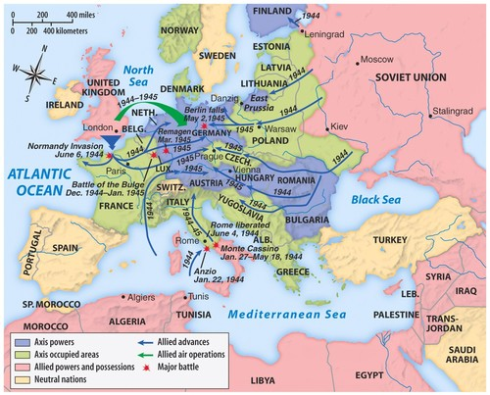

Required Reading:
- Selected Readings to be Posted on Canvas (Stay Tuned)

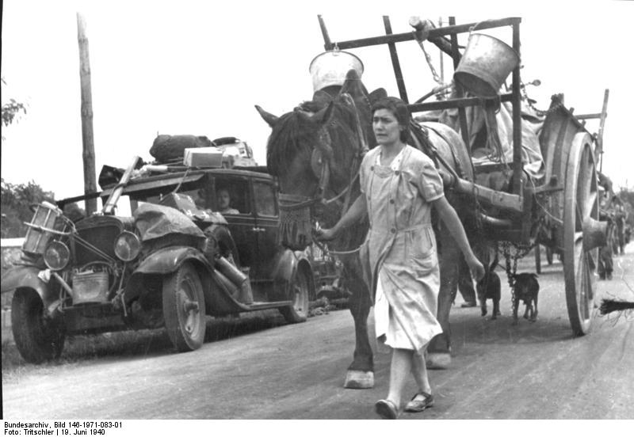
French Refugees (1940)

Assignments:
- Tour (100 pts)
  - Conduct a brief 15 minute on-site tour for the class in Europe. Locations TBA.
- Presentation (100 pts)
  - Deliver a brief 15 minute presentation for the campus community when we return.
- Paper (100 pts)
  - Write a brief (8-page, double-space) paper on the same site.
- Attendance and Active Participation (200 pts)
  - Attend and actively participate in all course related events in Texas and in Europe. Failure to do so (without instructor consent) will result in a zero on the attendance/participation.

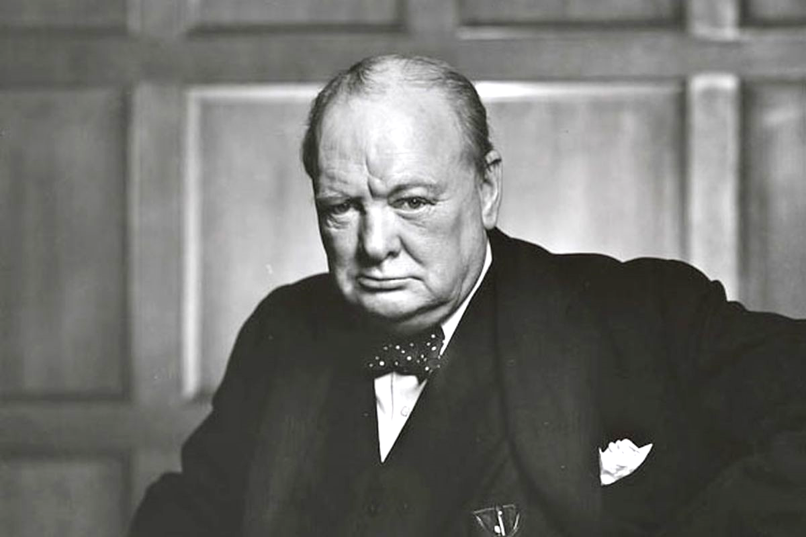
Winston Churchill

Attendance, Participation, and Decorum:
This is an upper-level university course. Attendance and participation are mandatory. In light of the nature of this travel course, it is imperative that you show up on time for all meetings, tours, and any other class-wide event. All students must attend all class events. Failure to do so without instructor consent will result in a zero on the participation grade.

Point Breakdown:
Tour: 100 pts
Presentation: 100 pts
Essay: 100 pts
Attendance/Participation 200 pts
Total: 500 pts

Make-up Policy:
We will work with you on an individual basis regarding any missed exams or deadlines.

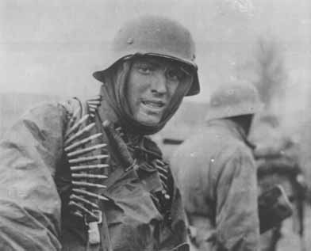
German Soldier American Soldier, Omaha Beach, D-Day

Academic Honesty:
Cheating of any kind, including plagiarism, will result in immediate failure of the class and possibly further sanctions from the University of Texas at Tyler. Plagiarism, put simply, is using another’s work as your own without proper citation or usage. This includes everything from copying and pasting from the Internet to failing to cite an idea from another source that you put in your own words. We strongly recommend reviewing the university policy for cheating and academic dishonesty at the following website: http://www.uttyler.edu/judicialaffairs/scholasticdishonesty.php

Course Schedule:

Day 1: Fly out

Day 2: London
-Walking tour of London
-Imperial War Museum
-Group dinner

Day 3: London
-WWII themed guided tour of London
-Cabinet War Rooms

Day 4: London
-Bletchley Park
-Free time in London

Day 5: London-Dover-Calais
-Dover Castle and WWII tunnels
-Travel via ferry to Calais

Day 6: Calais-Dunkirk-Normandy
-Dunkirk Evacuation Museum
-Travel to Normandy

Day 7: Normandy
-Guided sightseeing in Normandy
-Caen Memorial: Museum of Peace
-La Pointe du Hoc
-American Cemetery
-Normandy beaches
-Arromanches

Day 8: Normandy-Paris
-Travel to Paris
-Walking tour of Paris (time permitting)

Day 9: Paris
-Guided WWII themed walking tour of Paris
-Shoah Memorial

Day 10: Paris
-Visit Les Invalides
-Napoleon’s tomb

Day 11: Fly out

Important Dates:
See attached

University of Texas at Tyler Policies

UT Tyler Honor Code
Every member of the UT Tyler community joins together to embrace: Honor and integrity that will not allow me to lie, cheat, or steal, nor to accept the actions of those who do.

Students Rights and Responsibilities
To know and understand the policies that affect your rights and responsibilities as a student at UT Tyler, please follow this link: http://www.uttyler.edu/wellness/rightsresponsibilities.php

Campus Carry
We respect the right and privacy of students 21 and over who are duly licensed to carry concealed weapons in this class. License holders are expected to behave responsibly and keep a handgun secure and concealed. More information is available at http://www.uttyler.edu/about/campus-carry/index.php

UT Tyler a Tobacco-Free University
All forms of tobacco will not be permitted on the UT Tyler main campus, branch campuses, and any property owned by UT Tyler. This applies to all members of the University community, including students, faculty, staff, University affiliates, contractors, and visitors.
Forms of tobacco not permitted include cigarettes, cigars, pipes, water pipes (hookah), bidis, kreteks, electronic cigarettes, smokeless tobacco, snuff, chewing tobacco, and all other tobacco products.
There are several cessation programs available to students looking to quit smoking, including counseling, quitlines, and group support. For more information on cessation programs please visit www.uttyler.edu/tobacco-free.

Grade Replacement/Forgiveness and Census Date Policies
Students repeating a course for grade forgiveness (grade replacement) must file a Grade Replacement Contract with the Enrollment Services Center (ADM 230) on or before the Census Date of the semester in which the course will be repeated. (For Spring, the Census Date is January 29) Grade Replacement Contracts are available in the Enrollment Services Center or at http://www.uttyler.edu/registrar. Each semester’s Census Date can be found on the Contract itself, on the Academic Calendar, or in the information pamphlets published each semester by the Office of the Registrar.
Failure to file a Grade Replacement Contract will result in both the original and repeated grade being used to calculate your overall grade point average. Undergraduates are eligible to exercise grade replacement for only three course repeats during their career at UT Tyler; graduates are eligible for two grade replacements. Full policy details are printed on each Grade Replacement Contract.
The Census Date (January 29) is the deadline for many forms and enrollment actions of which students need to be aware. These include:
- Submitting Grade Replacement Contracts, Transient Forms, requests to withhold directory information, approvals for taking courses as Audit, Pass/Fail or Credit/No Credit.
- Receiving 100% refunds for partial withdrawals. (There is no refund for these after the Census Date)
- Schedule adjustments (section changes, adding a new class, dropping without a “W” grade)
- Being reinstated or re-enrolled in classes after being dropped for non-payment
- Completing the process for tuition exemptions or waivers through Financial Aid

State-Mandated Course Drop Policy
Texas law prohibits a student who began college for the first time in Fall 2007 or thereafter from dropping more than six courses during their entire undergraduate career. This includes courses dropped at another 2-year or 4-year Texas public college or university. For purposes of this rule, a dropped course is any course that is dropped after the census date (See Academic Calendar for the specific date).
Exceptions to the 6-drop rule may be found in the catalog. Petitions for exemptions must be submitted to the Enrollment Services Center and must be accompanied by documentation of the extenuating circumstance. Please contact the Enrollment Services Center if you have any questions.

Student Accessibility and Resources
In accordance with Section 504 of the Rehabilitation Act, Americans with Disabilities Act (ADA) and the ADA Amendments Act (ADAAA) the University offers accommodations to students with learning, physical and/or psychiatric disabilities. If you have a disability, including non-visible disabilities such as chronic diseases, learning disabilities, head injury, PTSD or ADHD, or you have a history of modifications or accommodations in a previous educational environment you are encouraged to contact the Student Accessibility and Resources (SAR) office and schedule an interview with the Accessibility Case Manager/ADA Coordinator, Cynthia Lowery Staples. If you are unsure if the above criteria applies to you, but have questions or concerns please contact the SAR office. For more information or to set up an appointment please visit the SAR office located in the University Center, Room 3150 or call 903.566.7079. You may also send an email to cstaples@uttyler.edu

Student Absence due to Religious Observance
Students who anticipate being absent from class due to a religious observance are requested to inform the instructor of such absences by the second class meeting of the semester.

Student Absence for University-Sponsored Events and Activities
If you intend to be absent for a university-sponsored event or activity, you (or the event sponsor) must notify the instructor at least two weeks prior to the date of the planned absence. At that time the instructor will set a date and time when make-up assignments will be completed.

Social Security and FERPA Statement
It is the policy of The University of Texas at Tyler to protect the confidential nature of social security numbers. The University has changed its computer programming so that all students have an identification number. The electronic transmission of grades (e.g., via e-mail) risks violation of the Family Educational Rights and Privacy Act; grades will not be transmitted electronically.

Emergency Exits and Evacuation
Everyone is required to exit the building when a fire alarm goes off. Follow your instructor’s directions regarding the appropriate exit. If you require assistance during an evacuation, inform your instructor in the first week of class. Do not re-enter the building unless given permission by University Police, Fire department, or Fire Prevention Services.

Student Standards of Academic Conduct
Disciplinary proceedings may be initiated against any student who engages in scholastic dishonesty, including, but not limited to, cheating, plagiarism, collusion, the submission for credit of any work or materials that are attributable in whole or in part to another person, taking an examination for another person, any act designed to give unfair advantage to a student or the attempt to commit such acts.
- “Cheating” includes, but is not limited to:
- copying from another student’s test paper;
- using, during a test, materials not authorized by the person giving the test;
- failure to comply with instructions given by the person administering the test;
- possession during a test of materials which are not authorized by the person giving the test, such as class notes or specifically designed “crib notes”. The presence of textbooks constitutes a violation if they have been specifically prohibited by the person administering the test;
- using, buying, stealing, transporting, or soliciting in whole or part the contents of an unadministered test, test key, homework solution, or computer program;
- collaborating with or seeking aid from another student during a test or other assignment without authority;
- discussing the contents of an examination with another student who will take the examination;
- divulging the contents of an examination, for the purpose of preserving questions for use by another, when the instructors has designated that the examination is not to be removed from the examination room or not to be returned or to be kept by the student;
- substituting for another person, or permitting another person to substitute for oneself to take a course, a test, or any course-related assignment;
- paying or offering money or other valuable thing to, or coercing another person to obtain an unadministered test, test key, homework solution, or computer program or information about an unadministered test, test key, home solution or computer program;
- falsifying research data, laboratory reports, and/or other academic work offered for credit;
- taking, keeping, misplacing, or damaging the property of The University of Texas at Tyler, or of another, if the student knows or reasonably should know that an unfair academic advantage would be gained by such conduct; and
- misrepresenting facts, including providing false grades or resumes, for the purpose of obtaining an academic or financial benefit or injuring another student academically or financially.
- “Plagiarism” includes, but is not limited to, the appropriation, buying, receiving as a gift, or obtaining by any means another’s work and the submission of it as one’s own academic work offered for credit.
- “Collusion” includes, but is not limited to, the unauthorized collaboration with another person in preparing academic assignments offered for credit or collaboration with another person to commit a violation of any section of the rules on scholastic dishonesty.
- All written work that is submitted will be subject to review by Turn-It-In, available through Canvas.

UT Tyler Resources for Students
- UT Tyler Writing Center (903.565.5995), writingcenter@uttyler.edu
- UT Tyler Tutoring Center (903.565.5964), tutoring@uttyler.edu
- The Mathematics Learning Center, RBN 4021, this is the open access computer lab for math students, with tutors on duty to assist students who are enrolled in early-career courses.
- UT Tyler Counseling Center (903.566.7254)

