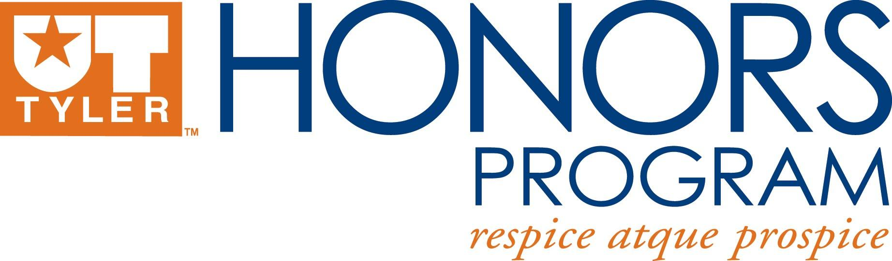

Honors Research Project Handbook

Prompt from the Honors Student Handbook:

During the final year of the undergraduate degree, each Honors student will
investigate a research question in the fall and spring semesters, and compose either a paper for submission to an undergraduate research journal or make a presentation at an undergraduate research conference. The project is the culmination of the writing and research that the Honors student will have done in major courses. Typically, the Honors Research Project is developed under the mentorship of a faculty member in the student’s major field.

The Honors Research Project is meant to complement existing junior-level Honors contract courses and senior-level capstone classes in the major. Students are encouraged to use existing capstone or contract course work as a start for their research project.

Submission to a Research Journal:
This writing project requires students to select a journal that accepts undergraduate research and draft an article for submission to that journal. The process includes writing, formatting, and vetting the article to the specifications outlined in the journal. Students are encouraged to use existing capstone or contract course work as a start for this journal article. For help finding a journal, please contact the Honors Program staff or speak with a professor in your field. Students choosing this option must submit a receipt of submission to an academic journal, and proof of three drafts with faculty signatures, no later than the first of April. Acceptance in the research journal is not required for completion of this requirement.

Submission to a Conference
In lieu of submitting to an undergraduate research journal, an Honors student may satisfy the Honors Research Project requirement by submitting an abstract to an undergraduate research conference and presenting either a poster or making an oral presentation at that conference. The conference may be local (i.e. at UT Tyler), regional (i.e. the West Texas Entomological Association), or national (i.e. National Collegiate Honors Council).

Presentation at the Lyceum
Before graduation, all Honors students at UT Tyler must present their research projects (either posters, creative, or oral presentations) at the annual Lyceum Student Research Showcase sponsored by the Honors Program every April. Students graduating in August or December must present at the Lyceum held the spring before they graduate.

Other Policies:
In the event that multiple students are working together on a senior Honors Research Project, submission of a group journal article or a group poster will satisfy the requirement for all involved students, provided that each student contributes an equal and significant amount of work to the project.

Students wishing to compose a performance-based or “creative” project (i.e. a music recital, the writing of a novel, an art exhibition, etc.) may do so with the approval of the Director of the Honors Program and a faculty member in the student’s department. If a student pursues such a project, an accompanying series of reflective essays or a journal detailing the creation of the project will be required. For details, please consult the Honors Program staff.

If a student desires to pursue a project that falls outside of the above policies, an Honors Program staff member must approve it within the first four weeks of the fall semester of the student’s senior year.

Students will be asked to submit an Honors Research Project Mentor Contract at the end of their junior year (for those graduating in December, it is before spring break of their junior year). The student and Honors mentor will fill out the contract together. The mentor should be a faculty member within the student’s department. In the event the Honors Research Project is interdisciplinary, the student should select a faculty member from each relevant department.

In order to keep students on track to complete the Honors Research Project, they will be required to submit updates on their work at specific intervals. The corresponding timetable below outlines the Honors Research Project schedule.

Fall Semester
- Review and update HRP Mentor Contract during the first 2 weeks of the semester
- Check Point #1: November 1st, 2018
  - Provide an update on research and/or project, include recap notes from meeting with faculty mentor
- If graduating in the fall, proof of submission: November 28th, 2018

Spring Semester
- Check Point #2: February 1st, 2019
  - Provide an update on research and/or project
- Submit Abstract to Lyceum: April 1st, 2019
- Posters due April 11th
- Lyceum is April 19th
- Proof of submission to Honors Staff and Faculty Mentor: April 1st, 2019

