Personal Digital Certificate

Installation Guide

Register and download your certificate

- Invitation received by user via email:
Figure 1
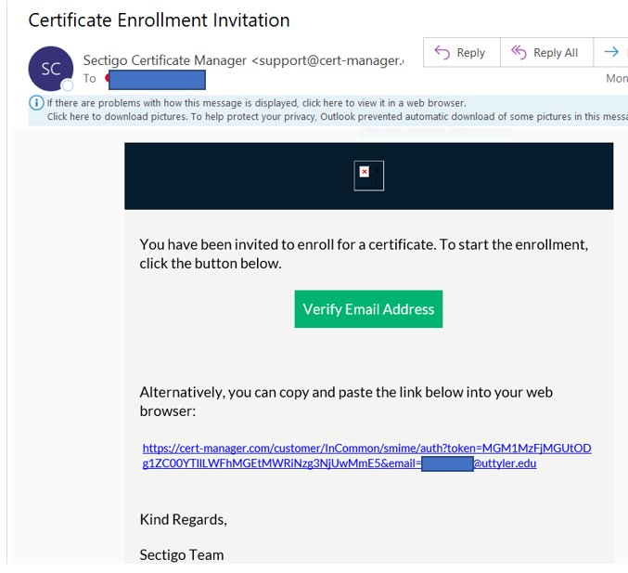

- Validate your email by entering your email address via the prompt and clicking Submit
- You will receive a second email as shown below – click on the link to complete authentication (note that this link may only be used once)
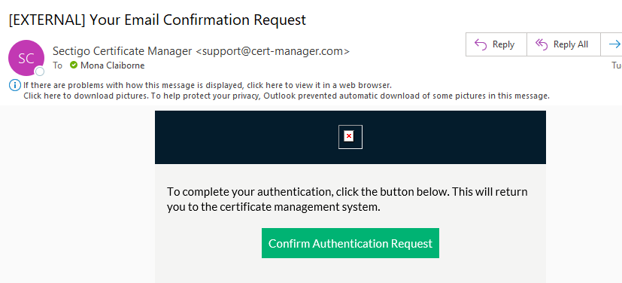
- If you receive the screen shown below – click on first certificate and choose “Enroll Certificate”:
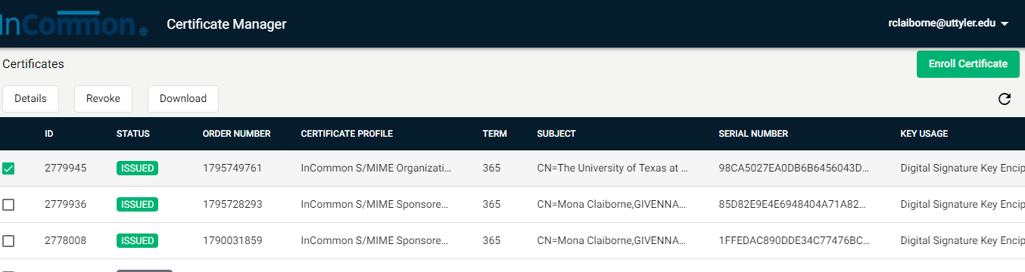
- Accept the defaults and “Submit” to begin downloading the certificate – (may take several minutes)
- The following screen will appear:

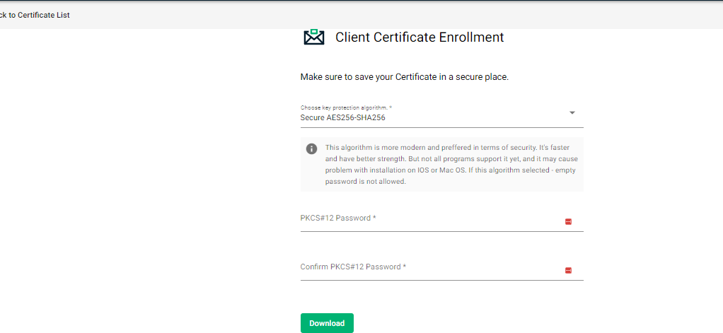

  - Click the down arrow and choose the “Compatible TripleDES-SHA1” option
  - Enter and confirm a password (keep the password secure as you may use it later to revoke or re-download the certificate). It is recommended to use at least a 6 digit alpha numeric password.
  - Click Download
  - The file should automatically save to your downloads folder

Install the Certificate:

- Double click” on the downloaded file and proceed with the steps shown below “Double click” on the downloaded file and proceed with the steps shown below
- Select Current user as shown in Figure 2 and click Next.
Figure 2
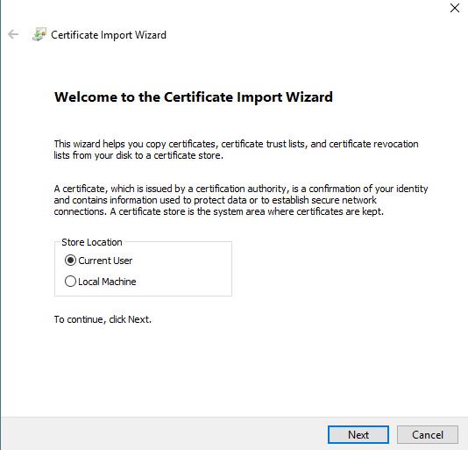

- Browse to locate the file from the location where you saved it on your local machine and select next:
Figure 3
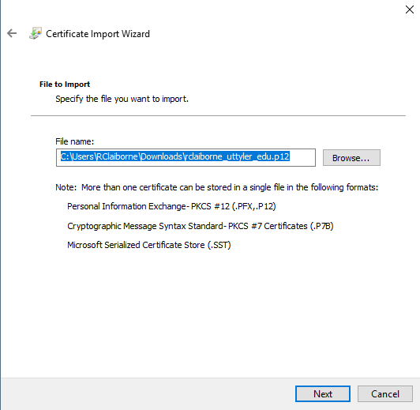
- Enter the certificate password (this is the password you used during registration), select the other options shown in Figure 4 and click Next to continue.
Figure 4
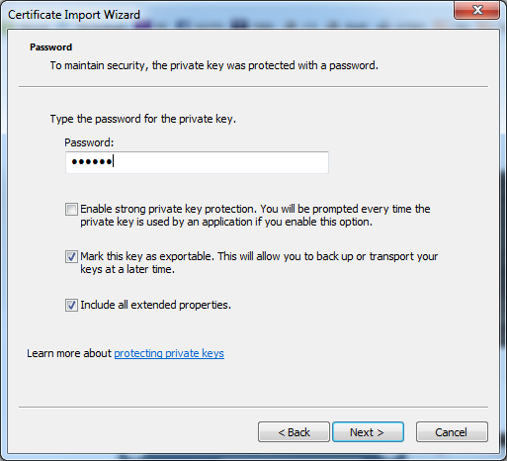

- In Figure 5, select the option to “Place all certificates in the following store” and click Browse.
Figure 5
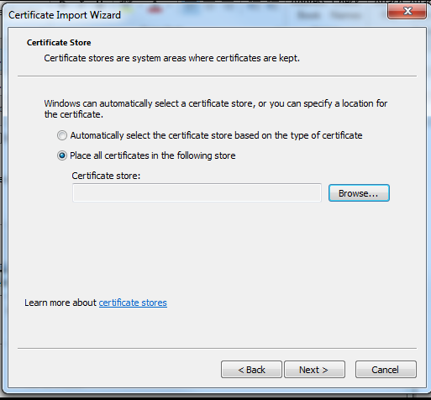

- As shown in Figure 6, select the “Personal” store and OK to continue.
Figure 6
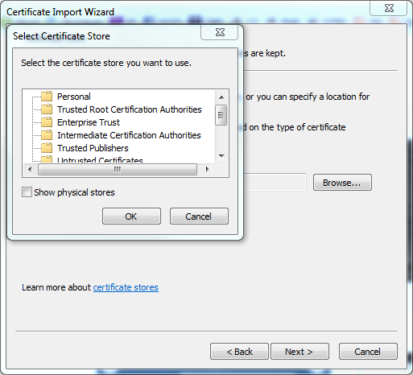

- Ensure Personal is noted as the Certificate Store and click Next to continue

Figure 7
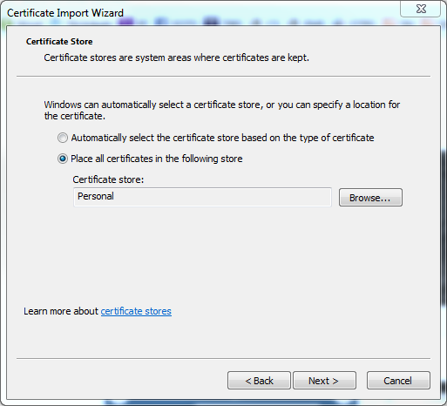

- Click “Finish”. A confirmation window will appear indicating the Import process was successful as shown in figures 8 and 9.
Figure 8
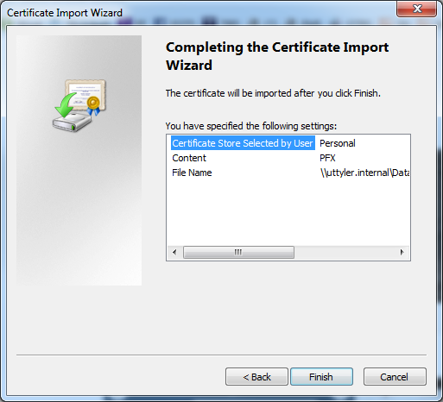

Figure 9
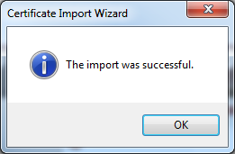

Using Your Digital Certificate

- Signing and encrypting email messages
a. Install the certificate in your email client
    - In your Outlook client, go to File, Options, Trust Center, Trust Center Settings, and Email Security
Figure 10
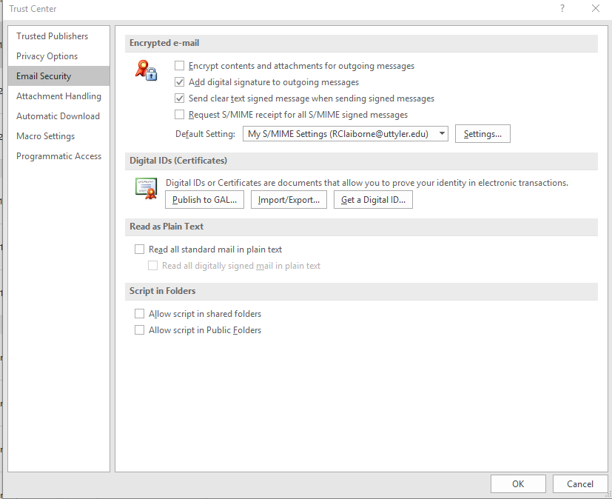

    - Click on Settings, Click on Choose (adjacent to both Signing and Encrypting)
Figure 11
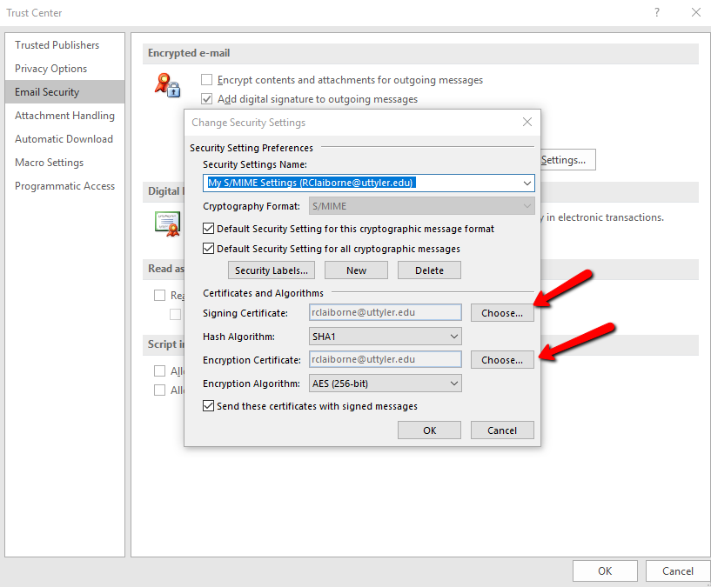

    - Select the certificate with the latest date (It will most likely contain your email address in the name) and select OK

Figure 12
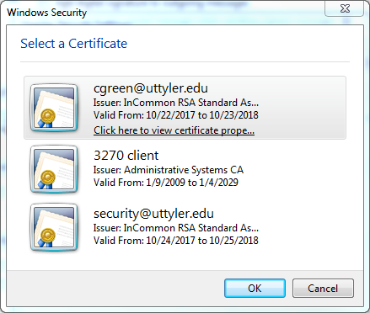

- The signature names will appear in the dialog box as shown in Figure 13. Click Ok to continue.

Figure 13
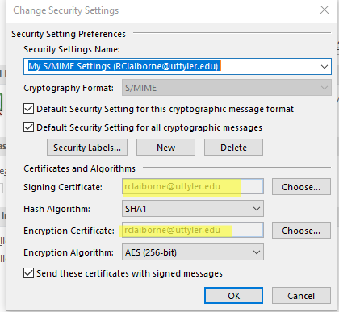

- If you would like all of your emails to be automatically signed: select the “Add digital signatures to outgoing messages” checkbox.

Figure 14
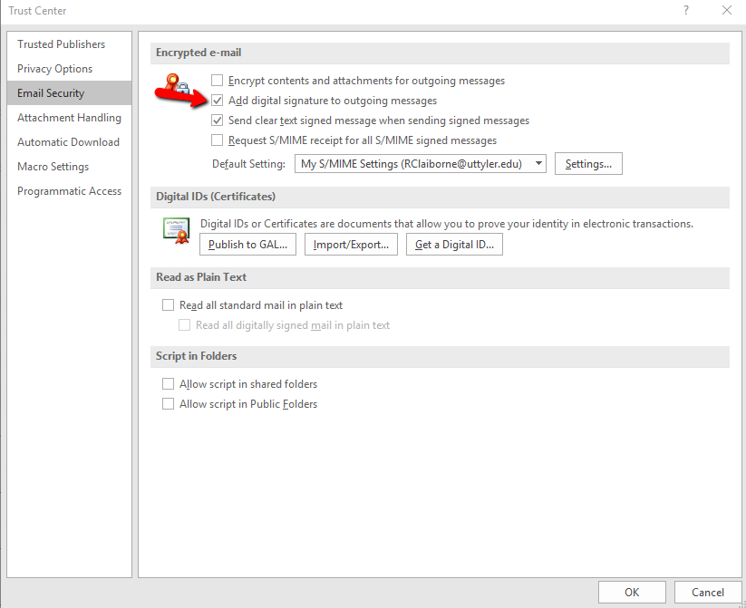

- Click on ‘OK’ (a few times) to return to your email window. Dependant on your version of Windows, you may receive a message indicating your certificates were published correctly.

Using your digital signature in outgoing emails

NOTE: If you did not choose the option in the previous step to automatically sign emails, then you will manually digitally sign each email message, as indicated below

  - Open a new email message
  - Click on ‘Options’ then click on ‘Sign’ in the Permission Section

Figure 15
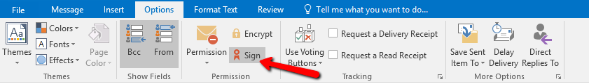

NOTE: As you compose an email, there won’t be anything in the email that indicates the digital signature is being applied. To confirm this is working correctly, you can verify the signature ribbon is present by clicking on your sent email box and previewing the outgoing mail

- When the Email recipient opens the email, the Red ribbon icon shown below indicates the email has been digitally signed. The recipient can click on the ribbon icon to view details about the digital signature

Figure 16
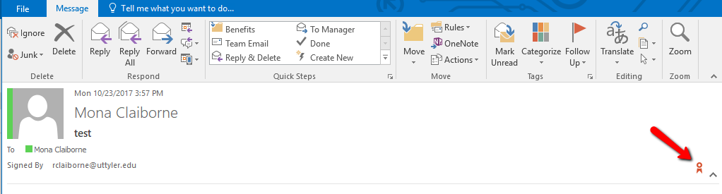

Signing documents, spreadsheets, presentations
- Open the document you wish to protect
- Select File, Info, click on ‘Protect Workbook’ (for Excel).
- Two options are available for digital signature protection, “:Mark as Final” and “add a digital signature”. Choose the appropriate option.
The Mark as Final option will let the email recipient know that editing commands, typing, etc are disabled and the document is read only.

Figure 17
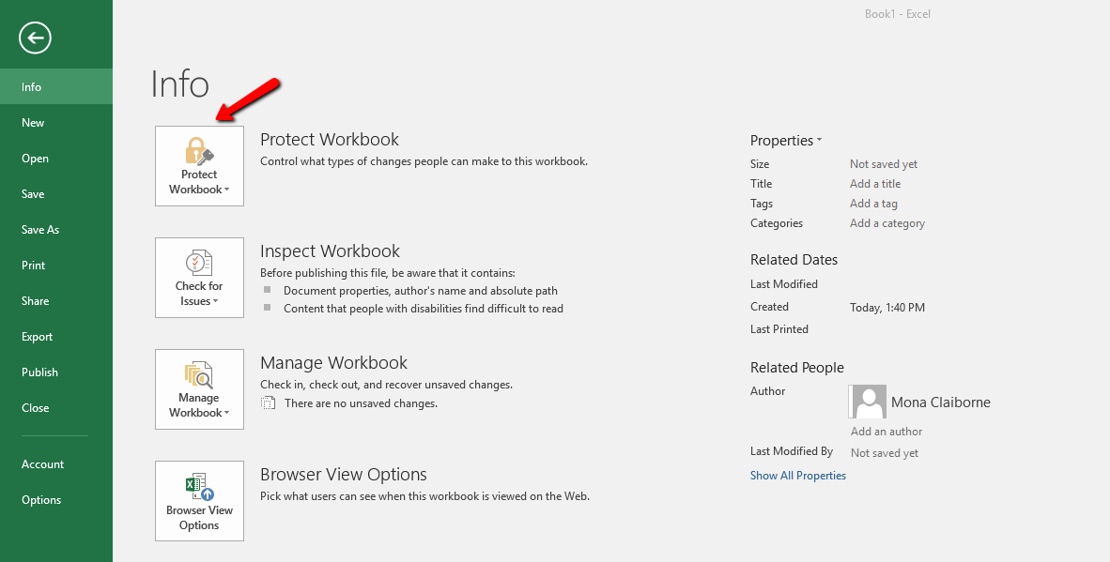

Figure 18
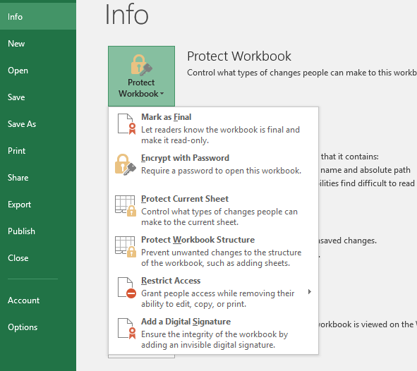

- A verification window indicating your document will be protected in the manner you selected will be displayed - Click OK and click OK a second time to proceed.

- For Word, and PowerPoint, the protection process is similar. You may be prompted to select your personal certificate the first time you attempt to digitally sign a document, following the installation of the certificate.
Figure 19
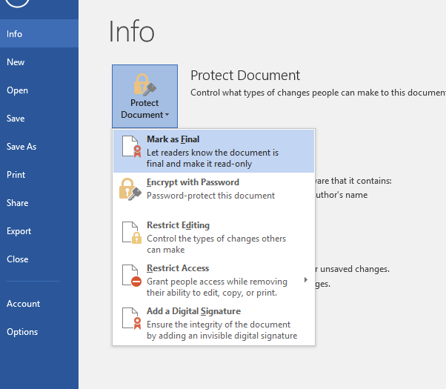

Issues during the certificate registration process:

- If you click “Cancel” during the certificate registration process, the link from the email is no longer valid and you will see an error message as shown in Figure 20.

- If this occurs, Email the Information Security department (security@uttyler.edu)to have the Certificate Administrator send a new Invitation.
Figure 20
