▐ American Realism
ENGL 4350-001// SPRING 2019
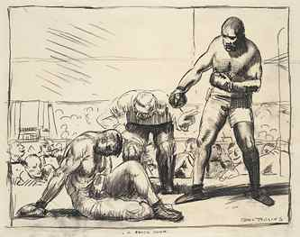
FACULTY: Dr. Anett Jessop
CLASS SCHEDULE: T/R 11:00 am - 12:20 pm
CLASSROOM: HPR 248
OFFICE: CAS 103C
OFFICE HOURS: T/R 1:00-2:30pm & by appointment
EMAIL: ajessop@uttyler.edu
George Bellows
▐ COURSE DESCRIPTION & GOALS
Welcome! In this course, we will study a selection of later-19th- and early-20th-century American fiction representing American Realism. Historically, this period (c. 1865-1920) spans important transitions in the development of U.S. nationhood, including post-Civil War Reconstruction, The Gilded Age, and The Progressive Era, as well as continuing westward expansion, immigration, industrialization, and urbanization. Pressured by a developing capitalist economy, this period faced sweeping social transformations, to include labor disputes, class struggle, and women’s suffrage movements.
The American Realist movement was an aesthetic response that redefined literature as well as the visual arts, music, and journalism. Literary Realism was a reaction and response to romantic and sentimental modes of the past and its writers experimented with new approaches for representing cultural changes, to include genre choice, subject matter, new characterizations of different social classes, language differences and dialects, and expanded regional representations beyond New England. Many of the topics and struggles represented in the literature are familiar to present-day Americans, such as issues of race, gender, economic and social class, immigration, and regional dominance. We will investigate how this literary movement interpreted the ‘realities’ of its historical moment—and to what explicit and implicit goals and outcomes.
Pedagogically, I am committed to your appreciation and enriched understanding of the aesthetic and cultural contexts for this body of literature as well as to your further development as sophisticated readers, critical thinkers, and writers about literary texts. In written assignments, you will practice close reading skills as well as synthesize and interpret patterns and themes toward developing strong claims and polished essays. As you are an advanced body of readers and writers, this class will function like a proto-graduate seminar wherein you will be leading discussions and thereby practicing your abilities to analyze a text and to present it to peers in an organized format.
Learning Objectives
► Students will learn to situate Literary Realism within the larger context of American literature, as well as to better understand the cultural pressures and developments during this period in U.S. history;
► Students will engage—in both written and oral forms—in close readings of complex literary texts and, as a result, will hone skills in nuanced analysis, cogent writing, and thoughtful discussion and debate;
► Students will deepen their thinking about the relationships between and among history, culture, and literature as well as the relationships between identities (individual, regional, national, international) and historically shifting ideas about difference (gender, sexual identity, race/ethnicity, socioeconomic class).
These outcomes will be demonstrated through class discussions, discussion leadership, writing assignments, analytical essays and creative writing, all aimed to elicit objective analysis and substantive oral and written responses.
▐ TEXTBOOKS
• Barrish, Phillip, ed. Cambridge Introduction to American Literary Realism. Cambridge UP, 2011.
ISBN-13: 978-0521050104
• Chopin, Kate. The Awakening and Selected Stories. [1899] Penguin Classics, 2003.
ISBN: 9780142437322
• Hopkins, Pauline E. Contending Forces: A Romance Illustrative of Negro Life North and South. [1900] Oxford UP, 1991. ISBN-13: 9780195067859
• Howells, William Dean. A Hazard of New Fortunes. [1890] Penguin Classics, 2001. ISBN-13: 9780140439236
• Jewett, Sarah Orne. The Country of the Pointed Firs. [1896] Dover Publications, 2011. ISBN-13: 9780486281964
• London, Jack. The Sea-Wolf. [1904] SeaWolf Press, 2017. ISBN-13: 9781948132350
• Paredes, Americo. George Washington Gomez: A Mexicotexan Novel. [1936-1940] Arte Publico Pr, 1990. ISBN-13: 9781558850125
• Wharton, Edith. The House of Mirth. [1905] Penguin Classics. ISBN 9780140187298
▐ DIGITAL ARCHIVES & RESOURCES
Brief overviews: http://public.wsu.edu/~campbelld/amlit/realism.htm
https://public.wsu.edu/~campbelld/howells/realism.htm
Online Archive of 19th-Century U.S. Women's Writings: http://www.facstaff.bucknell.edu/gcarr/19cUSWW/
Cornell University journal archive: http://ebooks.library.cornell.edu/m/moa/browse.html
Visual Art: https://www.artsy.net/gene/american-realism
UTT Writing Center: http://www.uttyler.edu/writingcenter/
▐ POLICIES & REQUIREMENTS
PREPARATION, ATTENDANCE & PARTICIPATION: My teaching methods emphasize individual preparation, group discussion and collaborative learning. Class members will be expected to share insights and to encourage others to do so. This course is reading-, discussion-, and writing-intensive and students will engage in various writing assignments—both graded and ungraded—as a means to making discoveries and articulating insights about the literary and critical texts we read. Participation is crucial to your success in this class, which operates on the basis of a thoughtful interaction between teacher and student and among students.
Everyone is expected to attend all classes, arrive on time, turn off cellphones and laptops (unless you are working from a digital text) and store them in backpacks. Attention to the cellphone instead of class and peers will be counted as an absence. You will often work in small groups and are always expected to participate in discussions of the assignments. Please bring books under discussion to class as we will be reading from the texts during class time. Quizzes may be given at any time and may not be made up.
I will allow for three absences, excused or unexcused, during the semester, after which your “Class Contribution” grade will be compromised. I will keep track of late arrivals and these will also affect your grade. (A late arrival is defined as more than ten minutes after the beginning of the class time slot.) If you are late, assume you have been marked absent until you talk to me. If you are ill or have an emergency, please email me in order to turn in homework. Questions concerning grades, assignments, and paper drafts, however, should be addressed during my office hours rather than by email. I will be available by appointment in case of a time conflict.
►ASSIGNMENTS

Reading & Discussion

ASSIGNED READINGS: Complete all assigned readings by the calendar due date so that you can participate in classroom discussion and learning activities.
DISCUSSION LEADERSHIP: Across the semester, each student will be responsible for initiating at least one class discussion of the assigned readings. A sign-up sheet will be distributed during the first weeks of class.
For the novels: Briefly summarize the plot arc for the day’s reading and then deepen the discussion by considering the ways in which the novel illustrates Realist techniques, subjects, and goals. Consider the novel’s historical context as you evaluate the protagonists’ opportunities and challenges. It is often effective to offer the class a passage or two to dissect in a close reading. Feel free to make connections across our critical and literary readings to that point.
Analytical & Creative Writing
PROSPECTUS // Research Paper Design: There will be 4 “prospectus” assignments for which students will map out a claim for a literary-critical paper, to include a fully articulated thesis argument paragraph followed by a set of supporting passages (from the novels and relevant scholarship) and a rationale statement for how these would be used to support the thesis. You are free to choose your own topic of analysis as you explore more deeply works under review during the period of the term leading up to the due date. Word count should be a minimum of 600+. More information will be provided early in the semester.
CFP: American Literary Realism FINAL PAPER & PRESENTATION: Expand upon and/or revise one of the prospectus assignments already submitted or design a new paper topic that explores an aspect of the American Realist movement through the semester’s creative and critical readings. Your research findings will be presented in summary during the final week of the semester in a mini-conference format (3-5 minutes).
PAPER: In a minimum of 1200 words, engage the novel/s and deploy arguments we’ve read and discussed throughout the semester in order to offer a focused reading and critical evaluation. Your essay must be typed and formatted according to the “Homework & Paper Format” description below. Submit the final paper by email (ajessop@uttyler.edu) as a Word attachment from your Patriots email account.

Success Tip! I recommend that students meet with me during office hours as you are conceptualizing your prospectuses and essays and visit the Writing Center for support in drafting and revising the paper.

CREATIVE VARIATION & EXPLICATION:
PART I: To test your engagement with this literary movement’s strategies and aims, you will write an original creative work (dialogue exchange, scene/setting vignette, a character portrait, short-short fiction) inspired by American Realist authors. This effort will not be letter-graded.
PART II: In an attached explication (500+ words), explain the premises for your creative work and discuss the ways in which you engage the literary-critical categories of Realist fiction. This explication will be graded.
HOMEWORK & PAPER FORMAT: All written assignments should be typed, double-spaced, use normal margins and readable font, and be stapled. Paper headings should include your name, date, course title, and professor’s name. Each page should include page number and your last name. A final word count should appear following the concluding paragraph for all written assignments: e.g., [1521 words]. Use MLA documentation to cite sources and include a Works Cited page.
DUE DATE POLICY: Assignments must be turned in on the day they are due at the time I collect them. Work turned in late without a compelling reason will be lowered one-third of a grade per day. If you do decide to turn in a paper late, you may email it to me and I will count it turned in. I will not grade the paper, however, until you turn in a hard copy in class (with the exception of the final paper). Always save copies of your work. I do accept late work but it will receive a lowered grade as described above.

GRADES & FINAL EVALUATION: Final course grades will be based on the weighted average grades based on the following percentages. The final grade will include my assessment of your overall contribution and progress in the class and may or may not conform to the Canvas quantifications. Feel free to speak with me at any time about your grades.
Discussion Leadership/Participation/Attendance 20%
Prospecti (4) 40%
Creative Variation 10%
Final Paper 30%

Excellent (A) papers have clear theses and soundly organized arguments that reflect detailed, nuanced understanding of the text. They are precisely and concisely written and have few if any mechanical problems—even minor ones. They weave quotations into their arguments smoothly and forcefully. A vital, graceful voice animates such essays; they say something compelling in a compelling way.
Good (B) papers have clear theses and are thoughtfully and reasonably organized. They may be marred by a few infelicities (inappropriateness) of style, but they will have no major mechanical problems—and not many minor ones either. These are solid, disciplined papers that make a definite point in a logical, coherent manner to a definite audience.
Satisfactory (C) papers have a thesis supported by evidence. The writing is clean and properly proofed, but not always compelling; it may be marred by some minor mechanical problems and one or two major ones (like fragments or run-ons). While their arguments may not be particularly cogent, these papers do say something interesting, and they say it in a comprehensible and responsible way.

Poor (D) papers, while giving evidence of effort on the part of the writer, lack a thesis, have major mechanical problems, poor organization, betray serious misreadings of the text, and show little sense of subject or audience.
Failing (F) papers have weaknesses even graver than those indicated for poor papers. They usually betray a lack of effort on the part of the writer. Any evidence of plagiarism (intentional or otherwise) will result in a failing grade—and referral to the Academic Conduct Committee.
UT TYLER WRITING CENTER: Located in CAS 202, the Writing Center provides professional writing tutoring for all students in all disciplines. If you wish to use the Writing Center, you should plan for a minimum of two hour-long tutorials per assignment: the first to provide an initial consultation and drafting plan, and the second to follow up. Be prepared to take an active role in your learning--you will be expected write and/or discuss your work during your tutorial. While Writing Center tutors are happy to provide constructive criticism and teach effective writing techniques, under no circumstances will they fix your paper for you. Appointments: (903) 565-5995. More information: www.uttyler.edu/writingcenter.

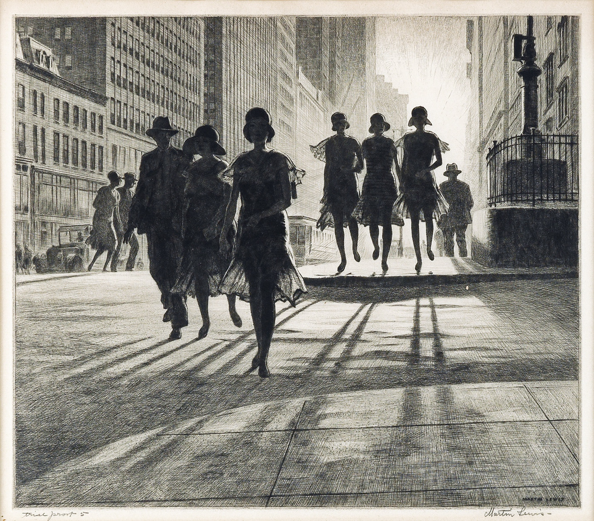

Martin Lewis, Shadow Dance, drypoint and sand-ground, 1930

▐ UNIVERSITY POLICIES
UT Tyler Honor Code: Every member of the UT Tyler community joins together to embrace: Honor and integrity that will not allow me to lie, cheat, or steal, nor to accept the actions of those who do.
Students Rights and Responsibilities: To know and understand the policies that affect your rights and responsibilities as a student at UT Tyler, please follow this link: http://www.uttyler.edu/wellness/rightsresponsibilities.php
Student Standards of Academic Conduct: Disciplinary proceedings may be initiated against any student who engages in scholastic dishonesty, including, but not limited to, cheating, plagiarism, collusion, the submission for credit of any work or materials that are attributable in whole or in part to another person, taking an examination for another person, any act designed to give unfair advantage to a student or the attempt to commit such acts. “CHEATING” includes, but is not limited to: copying from another student’s test paper; using, during a test, materials not authorized by the person giving the test; failure to comply with instructions given by the person administering the test; possession during a test of materials which are not authorized by the person giving the test, such as class notes or specifically designed “crib notes”. The presence of textbooks constitutes a violation if they have been specifically prohibited by the person administering the test; using, buying, stealing, transporting, or soliciting in whole or part the contents of an unadministered test, test key, homework solution, or computer program; collaborating with or seeking aid from another student during a test or other assignment without authority; discussing the contents of an examination with another student who will take the examination; divulging the contents of an examination, for the purpose of preserving questions for use by another, when the instructors has designated that the examination is not to be removed from the examination room or not to be returned or to be kept by the student; substituting for another person, or permitting another person to substitute for oneself to take a course, a test, or any course-related assignment; paying or offering money or other valuable thing to, or coercing another person to obtain an unadministered test, test key, homework solution, or computer program or information about an unadministered test, test key, home solution or computer program; falsifying research data, laboratory reports, and/or other academic work offered for credit; taking, keeping, misplacing, or damaging the property of The University of Texas at Tyler, or of another, if the student knows or reasonably should know that an unfair academic advantage would be gained by such conduct; and misrepresenting facts, including providing false grades or resumes, for the purpose of obtaining an academic or financial benefit or injuring another student academically or financially. “PLAGIARISM” includes, but is not limited to, the appropriation, buying, receiving as a gift, or obtaining by any means another’s work and the submission of it as one’s own academic work offered for credit. “COLLUSION” includes, but is not limited to, the unauthorized collaboration with another person in preparing academic assignments offered for credit or collaboration with another person to commit a violation of any section of the rules on scholastic dishonesty. All written work that is submitted will be subject to review by plagiarism software.
Relevant UT Tyler Resources for Students
UT Tyler Writing Center (903.565.5995), writingcenter@uttyler.edu
UT Tyler Tutoring Center (903.565.5964), tutoring@uttyler.edu
UT Tyler Counseling Center (903.566.7254)
Grade Replacement/Forgiveness and Census Date Policies: Students repeating a course for grade forgiveness (grade replacement) must file a Grade Replacement Contract with the Enrollment Services Center (ADM 230) on or before the Census Date of the semester in which the course will be repeated. Grade Replacement Contracts are available in the Enrollment Services Center or at http://www.uttyler.edu/registrar. Each semester’s Census Date can be found on the Contract itself, on the Academic Calendar, or in the information pamphlets published each semester by the Office of the Registrar. Failure to file a Grade Replacement Contract will result in both the original and repeated grade being used to calculate your overall grade point average. Undergraduates are eligible to exercise grade replacement for only three course repeats during their career at UT Tyler; graduates are eligible for two grade replacements. Full policy details are printed on each Grade Replacement Contract.
The Census Date is the deadline for many forms and enrollment actions that students need to be aware of. These include:
• Submitting Grade Replacement Contracts, Transient Forms, requests to withhold directory information, approvals for taking courses as Audit, Pass/Fail or Credit/No Credit.
• Receiving 100% refunds for partial withdrawals. (There is no refund for these after the Census Date.)
• Schedule adjustments (section changes, adding a new class, dropping without a “W” grade)
• Being reinstated or re-enrolled in classes after being dropped for non-payment.
• Completing the process for tuition exemptions or waivers through Financial Aid.
State-Mandated Course Drop Policy: Texas law prohibits a student who began college for the first time in Fall 2007 or thereafter from dropping more than six courses during their entire undergraduate career. This includes courses dropped at another 2-year or 4-year Texas public college or university. For purposes of this rule, a dropped course is any course that is dropped after the census date (See Academic Calendar for the specific date). Exceptions to the 6-drop rule may be found in the catalog. Petitions for exemptions must be submitted to the Enrollment Services Center and must be accompanied by documentation of the extenuating circumstance. Please contact the Enrollment Services Center if you have any questions.
Disability/Accessibility Services: In accordance with Section 504 of the Rehabilitation Act, Americans with Disabilities Act (ADA) and the ADA Amendments Act (ADAAA) the University of Tyler at Texas offers accommodations to students with learning, physical and/or psychological disabilities. If you have a disability, including non-visible a diagnosis such as a learning disorder, chronic illness, TBI, PTSD, ADHD, or you have a history of modifications or accommodations in a previous educational environment, you are encouraged to visit https://hood.accessiblelearning.com/UTTyler and fill out the New Student application. The Student Accessibility and Resources (SAR) office will contact you when your application has been submitted and an appointment with Cynthia Lowery, Assistant Director Student Services/ADA Coordinator. For more information, including filling out an application for services, please visit the SAR webpage at http://www.uttyler.edu/disabilityservices, the SAR office located in the University Center, # 3150 or call 903.566.7079.
Student Absence due to Religious Observance: Students who anticipate being absent from class due to a religious observance are requested to inform the instructor of such absences by the second class meeting of the semester.
Student Absence for University-Sponsored Events and Activities: If you intend to be absent for a university-sponsored event or activity, you (or the event sponsor) must notify the instructor at least two weeks prior to the date of the planned absence. At that time the instructor will set a date and time when make-up assignments will be completed.
Social Security and FERPA Statement: It is the policy of The University of Texas at Tyler to protect the confidential nature of social security numbers. The University has changed its computer programming so that all students have an identification number. The electronic transmission of grades (e.g., via e-mail) risks violation of the Family Educational Rights and Privacy Act; grades will not be transmitted electronically.
Emergency Exits and Evacuation: Everyone is required to exit the building when a fire alarm goes off. Follow your instructor’s directions regarding the appropriate exit. If you require assistance during an evacuation, inform your instructor in the first week of class. Do not re-enter the building unless given permission by University Police, Fire department, or Fire Prevention Services.
UT Tyler a Tobacco-Free University: All forms of tobacco will not be permitted on the UT Tyler main campus, branch campuses, and any property owned by UT Tyler. This applies to all members of the University community, including students, faculty, staff, University affiliates, contractors, and visitors. Forms of tobacco not permitted include cigarettes, cigars, pipes, water pipes (hookah), bidis, kreteks, electronic cigarettes, smokeless tobacco, snuff, chewing tobacco, and all other tobacco products. There are several cessation programs available to students looking to quit smoking, including counseling, quitlines, and group support. For more information on cessation programs please visit www.uttyler.edu/tobacco-free.
Campus-Carry: “We respect the right and privacy of students 21 and over who are duly licensed to carry concealed weapons in this class. License holders are expected to behave responsibly and keep a handgun secure and concealed. More information is available at http://www.uttyler.edu/about/campus-carry/index.php.”

