The University of Texas at Tyler

UT SHARE / PEOPLESOFT

Payment Voucher Procedures for

Budget Authority or Other Approver

Financial Services highly recommends that you choose Chrome as your browser for entry, review and approval in UT Share/PeopleSoft.

Voucher Terms and Concepts:
Originator (Requester) – At the start of the Voucher Entry workflow process, the department originator enters, edits and submits the voucher document.
Purchase Order (PO) Voucher – Involves funds that were encumbered on a Purchase Order and approved by the Budget Authority at the Requisition stage.

*Note: Since requisitions are approved by Budget Authorities, the associated PO Vouchers will not route to the Budget Authority for approval of the same transaction a second time. However, PO Vouchers paid from grant or capital project funds will route to the grant PI, Central Grants Office, and/or the Central Capital Projects team.

Non-PO Voucher – Involves funds for which a Purchase Order was not required. Non-PO Vouchers include travel credit card payments.

Workflow – The automation of a UT Share / PeopleSoft business process (e.g. Voucher and Requisition approval). Work is electronically passed from one participant in the process to the next.

Worklist – The automated to-do list of pending electronic transaction documents. A UT Share / PeopleSoft tool that enables a participant to view document tasks which require attention.

Approver – During the Voucher Entry workflow process, the assigned Approver reviews vouchers and attached supporting documentation submitted for approval by originators. The Approver determines whether to insert an Ad Hoc Approver, to click on the action button to mark the voucher as Approved, Denied (which returns the document to the originator), or to Hold the voucher.

Ad Hoc Approver – An Approver manually added to a workflow path. For internal audit purposes, insertion of Ad Hoc Approvers is required for travel credit card payments where the cardholder is a department Budget Authority.

In general the electronic Payment Voucher workflow path is as follows:

- Voucher is created by a department administrative assistant or other support staff.
- Non-PO Voucher* routes forward to one or more Approvers depending on funding.
- Voucher routes forward to Grants Central Office if grant funding is assigned.
- Voucher routes forward to Disbursements & Travel for final review and approval.

Pending Vouchers may be accessed in one of two ways:

- The Approver will be notified by email.

Once the Voucher has been submitted by the creator, the Budget Authority or other approver will receive a notification email similar to the following.

Note: The email address that is on file with Human Resources is used to generate the email notification.

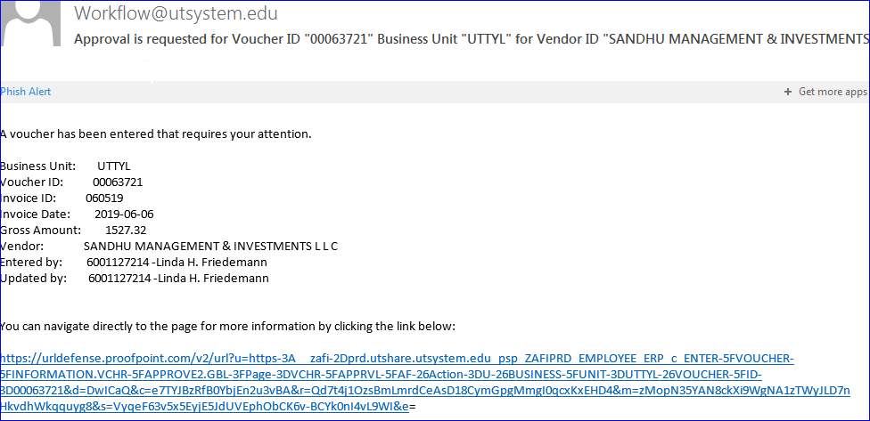

Click on the blue hyperlink at the bottom of the email to navigate directly to the payment Voucher. Enter your entire email address and university single sign-on password if you are not already logged into UT Share / PeopleSoft.

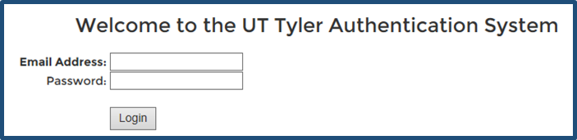

- If you deleted or cannot find the email notification, you may also login directly to UT Share / PeopleSoft using the university single sign-on user ID and password. You will be directed to the UT Share / PeopleSoft Home screen.

After you have logged in, click on the Worklist hyperlink in the upper-right corner of the screen.

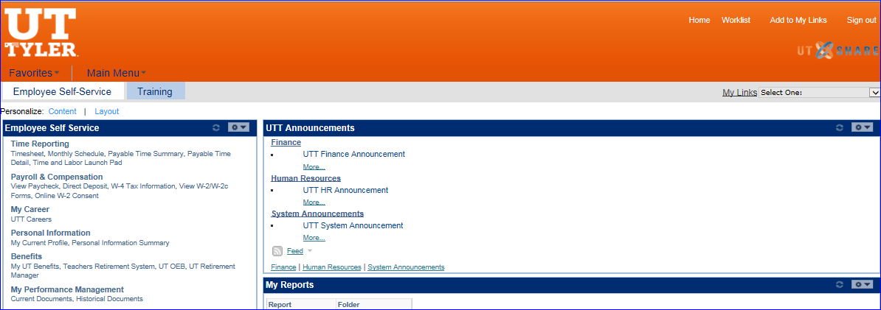

If you have any documents pending in your approval queue the Worklist screen will populate similar to the below example.

Click on the hyperlink beside the number for the Voucher which requires approval.

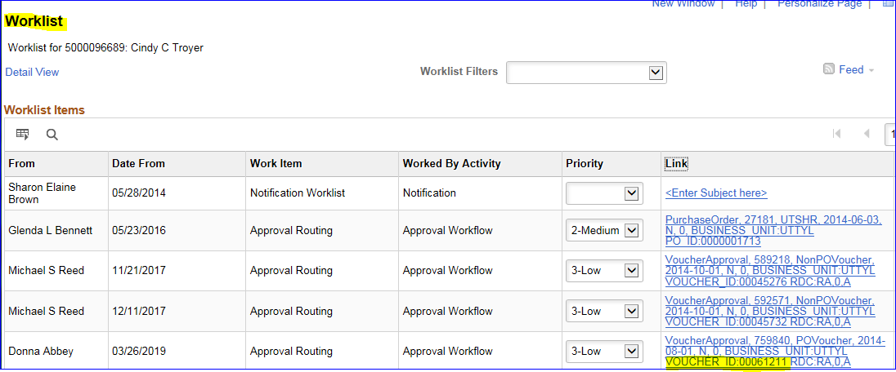

The Voucher document will populate on your computer screen similar to the below example screen shot.

Voucher review:
Review the payment detail in the Voucher Summary section. The Summary section includes basic information about the payment.

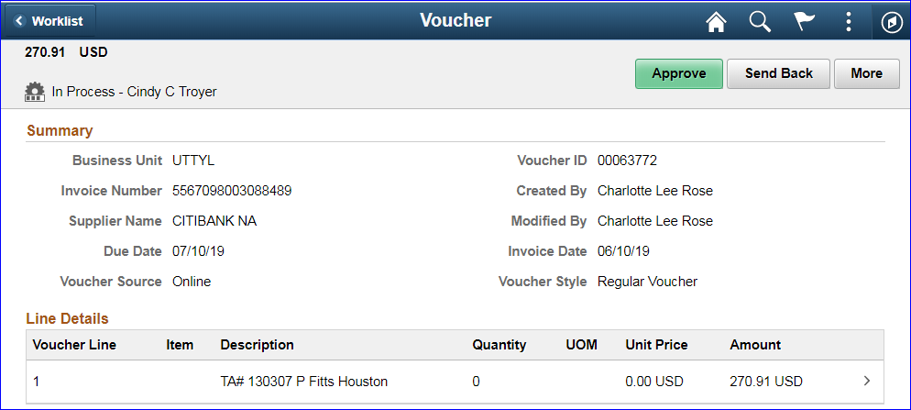

Review the Line Details section for all items listed. If payment is for more than one item you may need to click the arrow to the left of the Lines label to expand the section for review.

By scrolling over the box for one of the Line Details, the whole box becomes a “button”.

Click anywhere in the box to access the Distributions popup window.

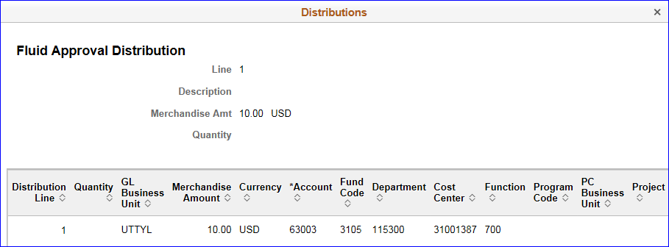

Review the chart field data for appropriateness – Is this where you want the expense paid from? If the funding is not correct, you will need to send the Voucher back to the creator.

Click the “X” in the upper right corner to close the popup window for the accounting information.

All Vouchers are required to have transaction supporting documentation attached.

Attachments are found under the section labeled More Information. You may need to click the arrow to the left of the More Information label to expand the section for review.

By scrolling over the box for View Attachments, the whole box becomes a “button”.

Click anywhere in the box to access the View Attachments popup window.
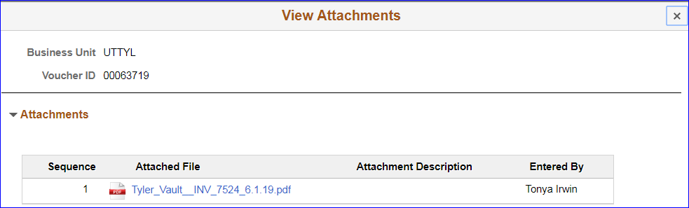
Open and review each attachment to verify appropriateness, document accuracy, and compliance.

Close the popup window by clicking on the “X” in the top right corner of the window.

The Approver Comments section is found in the More Information section below View Attachments.
Note: Any action other than approval of the document will require that comments be entered in the Approver Comments section of the document. In addition, you may also optionally enter comments when you are approving the document prior to clicking the Approve button.

Below the Approver Comments section is the Approval Chain section.

The Approval Chain section shows where the document is in the electronic approvals routing path and where else the document will route prior to final approval.

Click anywhere in the box to access the Approval Chain popup window.

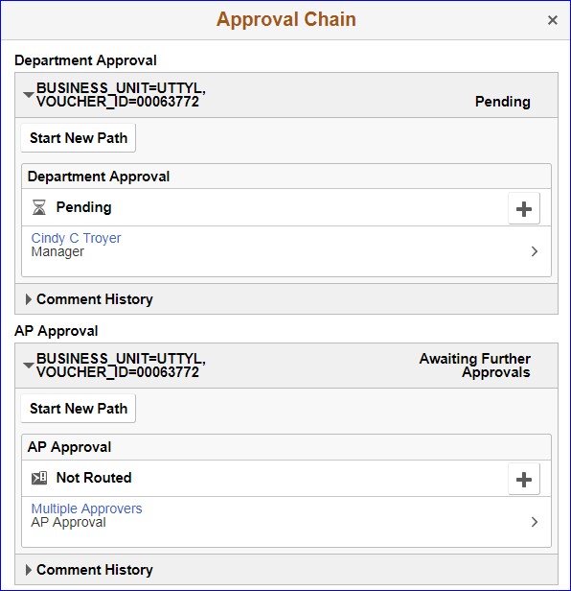

Close the popup window by clicking on the “X” in the top right corner of the window.

For internal audit purposes, travel credit card vouchers processed for a department Budget Authority’s credit card must be routed to his or her direct supervisor.
In the Department Approval section (as shown above), click the button to insert the required supervisor “Approver” into the workflow cycle. This action is called “Ad Hoc” approval.
Manually enter a User ID or click on the magnifying glass search icon to search by name.

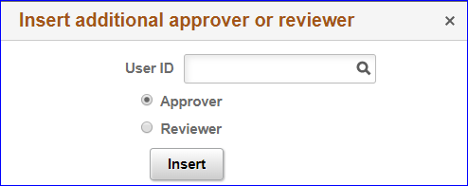

Type in a first name or part of a first name then click the Search button to narrow down the list of names. Click on the person’s name in the resulting list to select that person.

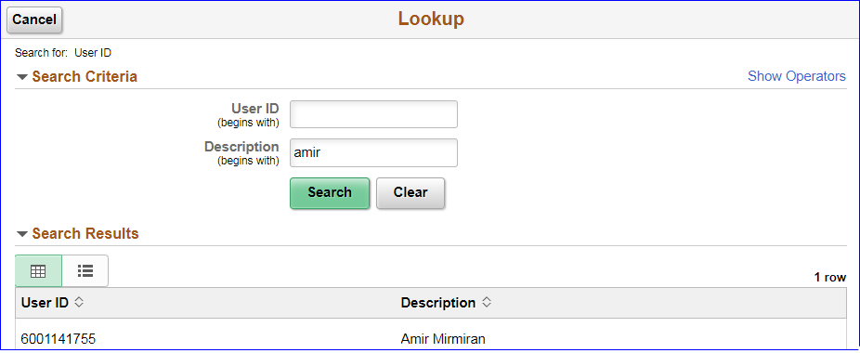

Click the Insert button to complete the action.

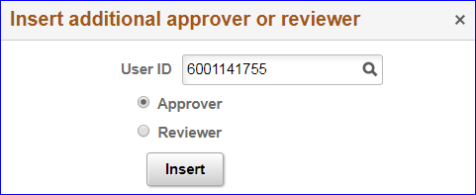

Close the popup window by clicking on the “X” in the top right corner of the window.

Please note, you must select a person who has been assigned the appropriate security in UT Share / PeopleSoft for Voucher Approvals.

Whether or not you insert an additional Approver for the particular voucher, scroll to the top of the Voucher home screen and click on one of the action buttons.

Click the More button to see the other two action options.

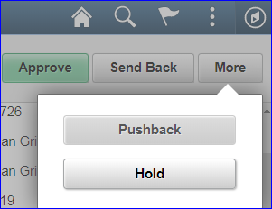

- Approve: Document is approved and routed to the next workflow approver. You are not required to enter Comments when clicking the Approve button but may do so at your discretion.
- Sendback: Document is sent back to the creator for changes or corrections from any workflow approver in the routing path. Action requires a Comment. Documents sent back generate an email for the creator.
- Pushback: Document is sent back to the previous person in the workflow approver path. Action requires a Comment.
- Hold: Clicking the Hold button keeps the Voucher in your Worklist while you ask questions or otherwise research the Voucher information. The status above the approver name will change from Pending to On Hold until further action is taken on the Voucher. The approver must take the document off Hold to move the document forward or back.

If the Voucher is funded with Grant funds, the Voucher will route to the Grants Central Office for review and approval.

All Vouchers route to the Accounts Payable / Disbursements Office for review and final approval.

To return to the document Worklist, first click on the Home icon at the top right corner of the screen, then click on the Worklist hyperlink.

Please email Accounts_Payable@uttyler.edu if you have questions about Voucher workflow or if you experience difficulty approving Vouchers.

