If awarded the extension, you will need to go to docusign and search for the word INTERNAL. You will see this screen and select the one highlighted here

Click the blue box with the word USE printed on it.

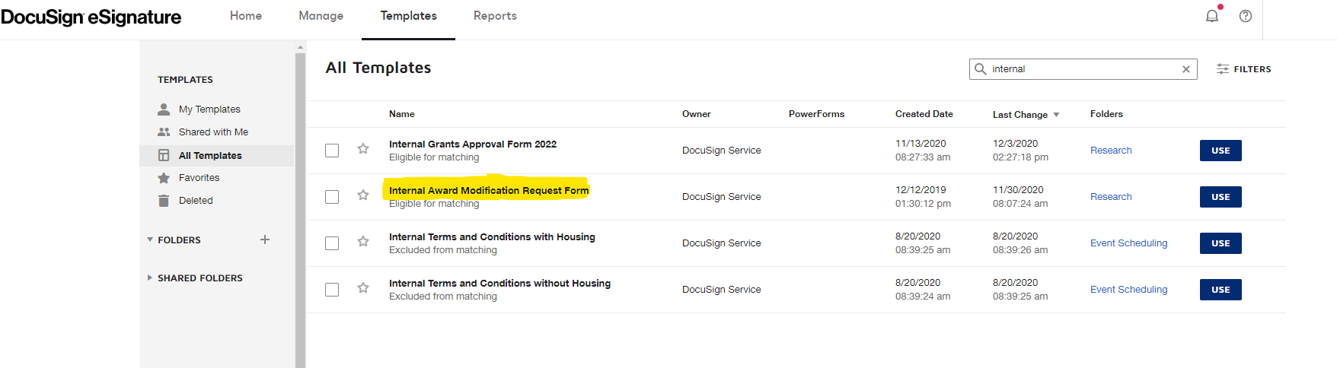

Enter your name in the first box and your email address in the second box.

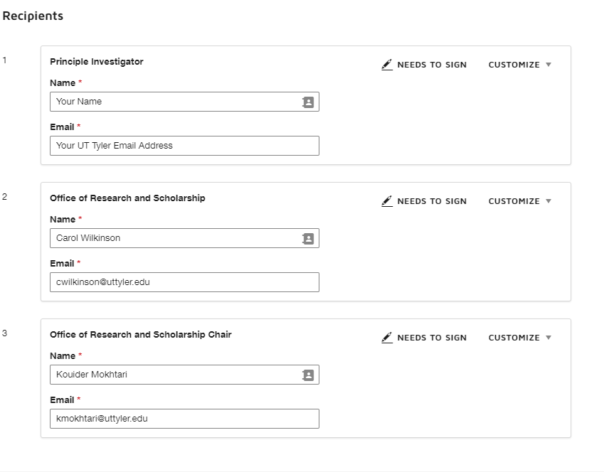

In the Email Subject Box please type: YOUR NAME Requesting FY21 External Grant Extension

In the Email Message Box please type: YOUR NAME is requesting a no cost extension to the FY21 Internal Grant.

Click the SEND BUTTON and when prompted sign it now.

The form will appear on your screen for your completion. Then add a brief synopsis of the reasons you are requesting your Internal Grant Extension.

Please call Carol (extension 5867 or cell 512-433-9780) for assistance. I am happy to help you.

