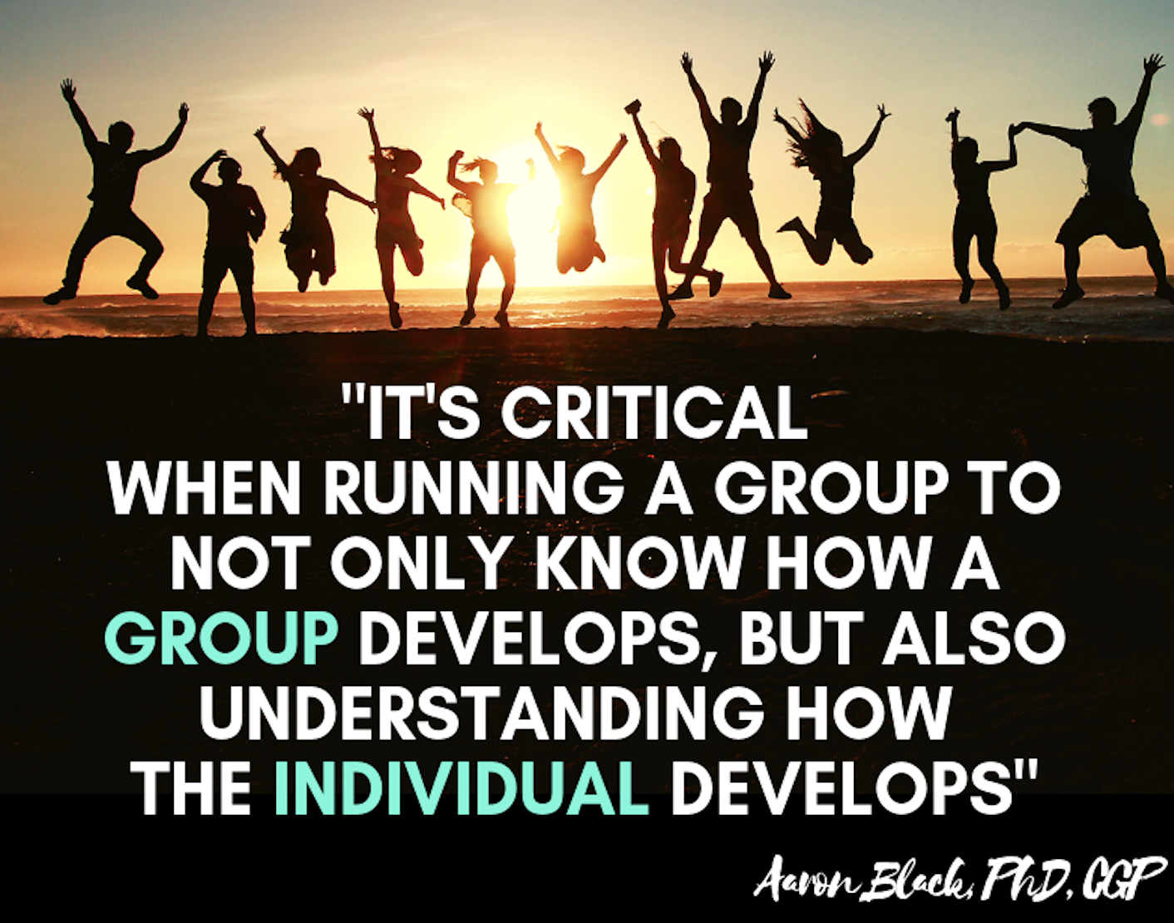

SOCW 4333: Social Work Group Practice

Fall 2022

Instructor Information

Instructor:
Ericka Freeman, LCSW
Associate Professor in Practice

Office:
College of Arts and Sciences (CAS) 152B

Telephone Number: 817-774-8420 (voice and text)

Email Address (preferred method of communication): efreeman@uttyler.edu

Classroom: HPR #253 (Tuesdays)
In-Person Office Hours:
Tuesdays, 12:30 – 2 p.m., Thursdays 9 a.m. – 12 p.m., and by appointment.
Virtual Office Hours via Zoom: By appointment only.

Course Information

Time and Place of Class Meetings: Hybrid Format

On Campus Component: Tuesdays are in-person class meetings, 11 a.m. – 12:20 p.m.in the Hudnall-Pirtle-Roosth Building (HPR), room #253.

Off Campus Components:
Online course material, including group planning sessions, may be accessed at any time and should be completed according to the due dates listed in this syllabus.

Participation at the East Texas Crisis Center, which will serve as both volunteer hours and class assignment(s), will be determined based on the student and Center’s availabilities.

Description of Course Content: This course examines a broad range of groups, with emphasis on group theory, the nature and uses of therapeutic and task groups, including: group development, dynamics, facilitation skills, group assessments and outcome evaluation. Prerequisite: Acceptance into the UT Tyler BSW program.
Course Overview: The purpose of this course is to teach students the basics of social work group practice by helping them build competencies, demonstrate simulated practice behaviors, and apply critical thinking. Students will utilize the steps in the generalist intervention model when working with clients at a micro and mezzo level.

Student Learning Outcomes for SOCW 4333:
Upon successful completion of this course, students will be able to demonstrate the following outcomes as progression in the noted areas of the nine Core Competencies established by the Council on Social Work Education (EPAS 2015):

- Discuss the role of social workers in the history of the philosophical, institutional, and methodological development of group work. Demonstrate personal reflection, self-modulation and professional communication and demeanor in the professional role of group facilitator; commitment to own education and professional development; and demonstrate effective use of supervision, consultation and constructive feedback from colleagues. Competency 1: Demonstrate Ethical and Professional Behavior

- Demonstrate the ability to use ethical reasoning through the application of ethical decision-making tools and techniques and tolerate the ambiguity inherent in ethical issues; practice within the Code of Ethics of the National Association of Social Workers and relevant laws; recognize personal values and allow professional values to guide practice. Competency 1: Demonstrate Ethical and Professional Behavior

- Apply critical thinking, logic, scientific inquiry, and discernment. Demonstrate creativity and ability to communicate relevant information to others. Competency 7: Assess Individuals, Families, Groups, Organizations, and Communities

- Recognize the value of human diversity and describe how economic and socio-cultural forces, such as race, ethnicity, class, gender, sexual orientation, immigration status, religious and political ideology and rural context of practice influence group development and processes, group participants, social work leadership roles, and the use of groups as an intervention; Demonstrate multicultural competence through application of multicultural counseling techniques; Demonstrate self-awareness to eliminate influence of personal biases and values in group work with diverse individuals and ensure mutual respect and equitable treatment of group members. . Competency 2: Engage Diversity and Difference in Practice

- Engage in practice that enhances human and civil rights, social and economic justice and mitigates the impact of oppression. Establish group rules, norms and boundaries that maintain respect for all group members regardless of difference. Advocate for equitable treatment in organizations and social institutions regardless of diagnosis or diversity factors. Competency 3: Advance Human Rights and Social, Economic, and Environmental Justice

- Describe the mutual relationship between scientific inquiry and practice experience and the importance of empirically based research in evaluation of one’s own practice and establishment of best practices for intervention and social policy development. Competency 4: Engage in Practice Informed Research and Research-Informed Practice

- Apply knowledge of human behavior in social environments and ways social systems promote or deter human growth, individual development and health and well-being. Integrate and apply several theoretical paradigms of group work to practice with groups and identify various types of groups with regard to purpose, goals, worker roles, group development, and use as an intervention, specifically support groups, psycho-educational groups, therapeutic groups, task groups, and network/social action groups. Competency 6: Engage with Individuals, Families, Groups, Organizations, and Communities; Competency 7: Assess Individuals, Families, Groups, Organizations, and Communities; Competency 8: Intervene with Individuals, Families, Groups, Organizations, and Communities; Competency 9: Evaluate Practice with Individuals, Families, Groups, Organizations and Communities

- Discuss the impact of social policy and political processes on the availability of therapeutic treatment options and engage with and on behalf of clients to advocate for parity in mental health treatment. Recognize the efficacy of group work as a treatment of choice for many individuals rather than or in addition to efficiency and cost containment by organizations. Competency 6: Engage with Individuals, Families, Groups, Organizations, and Communities; Competency 7: Assess Individuals, Families, Groups, Organizations, and Communities; Competency 8: Intervene with Individuals, Families, Groups, Organizations, and Communities; Competency 9: Evaluate Practice with Individuals, Families, Groups, Organizations and Communities

- Identify factors related to context of practice, particularly those unique to rural areas, that impact purpose, goals, process, social work roles, group development, and use of groups as an intervention; attend to the impact of change in social and demographic trends in specific locales on clients; explain the impact of rural practice on confidentiality concerns of group members and dual relationships in practice. Demonstrate ability to manage these factors in group leadership. Competency 7: Assess Individuals, Families, Groups, Organizations, and Communities

- Describe principles and processes related to selection and preparation of group members, including data collection and assessment of potential members; engagement and establishment of rapport, clarification of expectations, and norms; develop appropriate goals and focus of treatment and desired outcomes with clients; utilize strength- based assessment, identify client challenges, concerns, and limitations; develop a beginning level understanding of assessment tools used in the profession (i.e. the DSM V- TR., MAST, Meyers-Briggs, MMPI.); identify the phases and processes of group development related to beginning, middle, and termination phases of group work; interpret client participation and progress of individuals and group as a whole; identify the reasons for resistance and techniques to intervene; facilitate transitions and terminations. Competency 6: Engage with Individuals, Families, Groups, Organizations, and Communities; Competency 7: Assess Individuals, Families, Groups, Organizations, and Communities; Competency 8: Intervene with Individuals, Families, Groups, Organizations, and Communities; Competency 9: Evaluate Practice with Individuals, Families, Groups, Organizations and Communities

Required Textbook and Other Course Material:

Toseland, R.W. & Rivas, R.F. (2017). An introduction to group work practice (8th ed.)

Boston, MA: Allyn & Bacon.

ISBN-13: 9780134058962

Additional readings and videos will be posted on Canvas.

Descriptions of Assignments:

Participation and In-Class Group Simulation Activities (10% Final Grade)

On a number of occasions throughout the semester, we will practice group skills and techniques in class as simulated exercises. Students are expected to participate fully as part of their class participation. The goal of these exercises is for you, the future practitioner, to become increasingly comfortable with yourself, to improve your skills and to learn from others.

The instructor will act as group facilitator. As a group member, participation in the exercises are required as part of your class participation grade.

PLEASE NOTE: Each student is allowed up to two (2) absences without grade reduction penalty. Each absence after the second (2nd) absence will result in a 10-point reduction in participation grade per absence. (e.g. absence #3 = 90, absence #4=80, etc.) In addition, it is important for students to come to class prepared to take part in class . Participation grades will reflect accordingly.

Quizzes (20% Final Grade):
Students are to complete 10 quizzes during the semester. Quizzes are formulated from the text and are posted in the module due. Each quiz will open on a Sunday at 12:00 a.m. and close at 11:59 pm (a stroke before midnight) on the following Sunday. Instructions on number of questions, point values and due dates are listed in each quiz on Canvas. The due date for each quiz is also listed in the syllabus’ Course Schedule section. Students may easily access any quiz by either going to the “Quiz” tab in Canvas or selecting it under the “Demonstrate” portion of the module in which it is due.

Scaffolding a Group (15% Final Grade)
In this multi-phased assignment, students, in their assigned groups: Group Experience 1 or Group Experience 2, are to submit, throughout the semester, plans of action for their Group Experience Demonstration, which will serve as the capstone assignment for this course. Plans of action due dates are listed in the syllabus' Course Schedule section. Only one (1) plan of action per group per due date should be submitted.

Students will choose a group leader who will upload the plan of action to Canvas. Full instructions for each plan of action can be found in Canvas under the “Assignments” tab or by selecting it under the “Demonstrate” portion of the module in which it is due.

Group Experience Demonstration (30%): At the beginning of the semester, students will be divided into smaller groups: Group Experience 1 and Group Experience 2. Each group will contain 6-7 members. Each group will demonstrate a group session of their choice that follows the plans of action submitted in their Scaffolding a Group assignments, Students have the option of demonstrating the session live and in person or demonstrating this through a videoed group session that will be shown to the class. Groups should plan on meeting outside of class to work on this assignment. Students may choose to meet via Zoom, Face Time or in-person. Group memberships are listed in Canvas. This assignment is due on the last day of class, during finals week, in lieu of a final exam. Additional Instructions for this assignment can be found in Canvas under the “Assignment” tab.

Community Agency Exploration (25%):
Partnering with The East Texas Crisis Center students will explore group-based opportunities, such as :
- preparing topics (as visitor speakers) and co-facilitating a session with our group facilitators.
- attending a group as a shadow participant.
- coordinating a day of services for shelter residents on a weekday or over the weekend.
- assisting with outreach events in the community.
- planning an activity on the ETCC campus for Domestic Violence Awareness Month.
- touring the ETCC facility and learning more about the services they provide

Students must participate in at least three (3) activities with ETCC. Any hours accrued during participation will count toward the required 40 volunteer hours for the Social Work Professional Program.

Following each exploration experience, students will submit a brief journal reflection of their impression of the experience. Each reflection should include the following information:
● the date of the experience;
● a brief synopsis of what occurred;
● If attending a group, what was overall theme of session? If not attending a group, what role did (or could) group work play? and,
● your overall impressions of the experience.

Journal pages should be 1-2 pages in length and use correct grammar, demonstrating professional and succinct writing skills. Additional Instructions for this assignment can be found in Canvas under the “Assignment” tab.

Grading Information

Grading:
Assignment | %
In-Class Group Simulation Exercises | 10
Quizzes (10 @ 2 % each) | 20
Scaffolding (5 % 3% each) | 15
Group Experience Demonstration | 30
Community Agency Exploration | 25
Total | 100

All written assignments must be grammatically correct using APA style. Assignments with many grammatical errors, misspellings, and/or evidence of plagiarism (e.g., high Unicheck score) will not receive a satisfactory grade. All written assignments will be due on the date listed on the course schedule.

Ten points will be deducted for late assignments.
No assignment will be accepted after five days late.

90 and Above =A
80 - 89.9 = B
70 –79.9 = C
60 - 69.9 = D
Below 60 =F

A grade of incomplete will not be given for this class.

Make-Up Assignments:
Late assignments (including quizzes) are strongly discouraged. There will be 10 points (total) deducted for each late assignment or quiz*. No assignment or quiz will be accepted after 5 days following the due date. *

The Group Experience Demonstration is NOT available for late submission.

It is the student's responsibility to ensure that work is completed on time and submitted correctly.

Expectations for Out-of-Class Study:
Beyond the time required to attend each class meeting, students enrolled in this course should expect to spend at least an additional 9 hours per week of their own time in course-related activities, including reading required materials, completing assignments, preparing for quizzes, etc.

Attendance:
Engaged and timely participation in all assignments constitutes "attendance" for purposes of this course. This course is taught in a hybrid format, meaning some course time will be spent in the classroom while other time will be spent online. Preparation for COVID-19 compliance will be addressed via UT Tyler email and in Canvas prior to the first day of class.

The Census Date for the semester is September 2, 2022. This is the last day students may withdraw from the course without penalty.

Course Schedule
As the instructor for this course, I reserve the right to adjust this schedule in any way that serves the educational needs of the students enrolled in this course. Any changes will be communicated in a timely manner through UT Tyler email and announcement(s) in Canvas.

This course is organized by modules. Each module begins on a Sunday, at 12 a.m., and ends on the following Sunday, at 11:59 p.m. Any assignment due in a module must be submitted by the corresponding Sunday.

Module | Dates | Topics | Required Readings/  Activities | Assignments Due
Getting  Started | 8/22 – 8/28 | Course Overview and Introductions | Syllabus, Acquire textbook, Review semester ahead and Group memberships
1 | 8/28 – 9/4 | Group Work, Types and History | Chapter 1, Chapter 2  Class activity TBD | Quiz 1
2 | 9/4 – 9/11 | Introduction to Group Dynamics | Chapter 3  Class activity TBD | Quiz 2
3 | 9/11- 9/18 | Group Leadership | Chapter 4  Class activity TBD | Quiz 3  Scaffolding Plan #1
4 | 9/18 – 9/25 | Group Leadership and Diversity | Chapter 5  Class activity TBD | Quiz 4
5 | 9/25 – 10/2 | Planning the Group | Chapter 6  Class activity TBD | Quiz 5  Scaffolding Plan #2
6 | 10/2 – 10/9 | Beginning the Group | Chapter 7  Class activity TBD | Quiz 6  Scaffolding Plan #3
7 | 10/9 – 10/16 | Assessing for Group | Chapter 8  Class activity TBD | Quiz 7
8 | 10/16 – 10/23 | Treatment Groups I | Chapter 9  Class activity TBD | Quiz 8  Scaffolding Plan #4
9 | 10/23 – 10/30 | Treatment Groups II | Chapter 10  Class activity TBD | Quiz 9  Scaffolding Plan #5
10 | 10/30 – 11/6 | Task Groups I | Chapter 11  Class activity TBD | Community  Journal #1
11 | 11/6 – 11/13 | Task Groups II | Chapter 12  Class activity TBD | Community  Journal #2
12 | 11/13 – 11/20 | Group Termination | Chapter 13  Class activity TBD | Community  Journal #3
13 | 11/20 – 11/27 | Thanksgiving Break |  | Enjoy your break!
14 | 11/27 – 12/3 | Outcome Evaluation | Chapter 14  Class activity TBD
15 | 12/3 – 12/10 |  |  | Group  Experience  Demonstration  (in lieu of Final Exam)

Institutional Information

Important Covid-19 Information for Classrooms and Laboratories at UT Tyler

Students who are feeling ill or experiencing symptoms such as sneezing, coughing, or a higher than normal temperature will be excused from class and should stay at home and may join the class remotely. Students who have difficulty adhering to the Covid-19 safety policies for health reasons are also encouraged to join the class remotely. Students needing additional accommodations may contact the Office of Student Accessibility and Resources at University Center 3150, or call (903) 566-7079 or email saroffice@uttyler.edu.

Recording of Class Sessions
Class sessions may be recorded by the instructor for use by students enrolled in this course. Recordings that contain personally identifiable information or other information subject to FERPA shall not be shared with individuals not enrolled in this course unless appropriate consent is obtained from all relevant students. Class recordings are reserved only for the use of students enrolled in the course and only for educational purposes. Course recordings should not be shared outside of the course in any form without express permission.
UT Tyler Honor Code
Every member of the UT Tyler community joins together to embrace: Honor and integrity that will not allow me to lie, cheat, or steal, nor to accept the actions of those who do.

Students Rights and Responsibilities
To know and understand the policies that affect your rights and responsibilities as a student at UT Tyler, please follow this link: http://www.uttyler.edu/wellness/rightsresponsibilities.php

Campus Carry
We respect the right and privacy of students 21 and over who are duly licensed to carry concealed weapons in this class. License holders are expected to behave responsibly and keep a handgun secure and concealed. More information is available at http://www.uttyler.edu/about/campus-carry/index.php

UT Tyler a Tobacco-Free University
All forms of tobacco will not be permitted on the UT Tyler main campus, branch campuses, and any property owned by UT Tyler. This applies to all members of the University community, including students, faculty, staff, University affiliates, contractors, and visitors.
Forms of tobacco not permitted include cigarettes, cigars, pipes, water pipes (hookah), bidis, kreteks, electronic cigarettes, smokeless tobacco, snuff, chewing tobacco, and all other tobacco products.
There are several cessation programs available to students looking to quit smoking, including counseling, quitlines, and group support. For more information on cessation programs please visit www.uttyler.edu/tobacco-free.

Grade Replacement/Forgiveness and Census Date Policies
Students repeating a course for grade forgiveness (grade replacement) must file a Grade Replacement Contract with the Enrollment Services Center (ADM 230) on or before the Census Date of the semester in which the course will be repeated. Grade Replacement Contracts are available in the Enrollment Services Center or at http://www.uttyler.edu/registrar. Each semester’s Census Date can be found on the Contract itself, on the Academic Calendar, or in the information pamphlets published each semester by the Office of the Registrar.
Failure to file a Grade Replacement Contract will result in both the original and repeated grade being used to calculate your overall grade point average. Undergraduates are eligible to exercise grade replacement for only three course repeats during their career at UT Tyler; graduates are eligible for two grade replacements. Full policy details are printed on each Grade Replacement Contract.
The Census Date is the deadline for many forms and enrollment actions of which students need to be aware. These include:
- Submitting Grade Replacement Contracts, Transient Forms, requests to withhold directory information, approvals for taking courses as Audit, Pass/Fail or Credit/No Credit.
- Receiving 100% refunds for partial withdrawals. (There is no refund for these after the Census Date)
- Schedule adjustments (section changes, adding a new class, dropping without a “W” grade)
- Being reinstated or re-enrolled in classes after being dropped for non-payment
- Completing the process for tuition exemptions or waiver through Financial Aid State-Mandated
Course Drop Policy
Texas law prohibits a student who began college for the first time in Fall 2007 or thereafter from dropping more than six courses during their entire undergraduate career. This includes courses dropped at another 2-year or 4-year Texas public college or university. For purposes of this rule, a dropped course is any course that is dropped after the census date (See Academic Calendar for the specific date).
Exceptions to the 6-drop rule may be found in the catalog. Petitions for exemptions must be submitted to the Enrollment Services Center and must be accompanied by documentation of the extenuating circumstance. Please contact the Enrollment Services Center if you have any questions.

Disability/Accessibility Services
In accordance with Section 504 of the Rehabilitation Act, Americans with Disabilities Act (ADA) and the ADA Amendments Act (ADAAA) the University of Texas at Tyler offers accommodations to students with learning, physical and/or psychological disabilities. If you have a disability, including a non-visible diagnosis such as a learning disorder, chronic illness, TBI, PTSD, ADHD, or you have a history of modifications or accommodations in a previous educational environment, you are encouraged to visit https://hood.accessiblelearning.com/UTTyler and fill out the New Student application.

The Student Accessibility and Resources (SAR) office will contact you when your application has been submitted and an appointment with Cynthia Lowery, Assistant Director of Student Services/ADA Coordinator. For more information, including filling out an application for services, please visit the SAR webpage at http://www.uttyler.edu/disabilityservices, the SAR office located in the University Center, # 3150 or call 903.566.7079.

Student Absence due to Religious Observance
Students who anticipate being absent from class due to a religious observance are requested to inform the instructor of such absences by the second class meeting of the semester.

Student Absence for University-Sponsored Events and Activities
If you intend to be absent for a university-sponsored event or activity, you (or the event sponsor) must notify the instructor at least two weeks prior to the date of the planned absence. At that time the instructor will set a date and time when make-up assignments will be completed.

Social Security and FERPA Statement
It is the policy of The University of Texas at Tyler to protect the confidential nature of social security numbers. The University has changed its computer programming so that all students have an identification number. The electronic transmission of grades (e.g., via e-mail) risks violation of the Family Educational Rights and Privacy Act; grades will not be transmitted electronically.

Emergency Exits and Evacuation
Everyone is required to exit the building when a fire alarm goes off. Follow your instructor’s directions regarding the appropriate exit. If you require assistance during an evacuation, inform your instructor in the first week of class. Do not re-enter the building unless given permission by University Police, Fire department, or Fire Prevention Services.

Student Standards of Academic Conduct
Disciplinary proceedings may be initiated against any student who engages in scholastic dishonesty, including, but not limited to, cheating, plagiarism, collusion, the submission for credit of any work or materials that are attributable in whole or in part to another person, taking an examination for another person, any act designed to give unfair advantage to a student or the attempt to commit such acts.
- “Cheating” includes, but is not limited to:
  - copying from another student’s test paper;
  - using, during a test, materials not authorized by the person giving the test;
  - failure to comply with instructions given by the person administering the test;
  - possession during a test of materials which are not authorized by the person giving the test, such as class notes or specifically designed “crib notes”. The presence of textbooks constitutes a violation if they have been specifically prohibited by the person administering the test;
  - using, buying, stealing, transporting, or soliciting in whole or part the contents of an unadministered test, test key, homework solution, or computer program;
  - collaborating with or seeking aid from another student during a test or other assignment without authority;
  - discussing the contents of an examination with another student who will take the examination;
  - divulging the contents of an examination, for the purpose of preserving questions for use by another, when the instructors has designated that the examination is not to be removed from the examination room or not to be returned or to be kept by the student;
  - substituting for another person, or permitting another person to substitute for oneself to take a course, a test, or any course-related assignment;
  - paying or offering money or other valuable thing to, or coercing another person to obtain an unadministered test, test key, homework solution, or computer program or information about an unadministered test, test key, home solution or computer program;
  - falsifying research data, laboratory reports, and/or other academic work offered for credit;
  - taking, keeping, misplacing, or damaging the property of The University of Texas at Tyler, or of another, if the student knows or reasonably should know that an unfair academic advantage would be gained by such conduct; and
  - misrepresenting facts, including providing false grades or resumes, for the purpose of obtaining an academic or financial benefit or injuring another student academically or financially.
- “Plagiarism” includes, but is not limited to, the appropriation, buying, receiving as a gift, or obtaining by any means another’s work and the submission of it as one’s own academic work offered for credit.
- “Collusion” includes, but is not limited to, the unauthorized collaboration with another person in preparing academic assignments offered for credit or collaboration with another person to commit a violation of any section of the rules on scholastic dishonesty.
- All written work that is submitted will be subject to review by plagiarism software.

UT Tyler Resources for Students
  - UT Tyler Writing Center (903.565.5995), writingcenter@uttyler.edu
  - UT Tyler Tutoring Center (903.565.5964), tutoring@uttyler.edu
  - The Mathematics Learning Center, RBN 4021, this is the open access computer lab for math students, with tutors on duty to assist students who are enrolled in early-career courses.
  - UT Tyler Counseling Center (903.566.7254)

